PLANNING PROPOSAL

Gateway Version

Reclassification of Community Land to Operational Land at Various Sites

2022 Housekeeping Amendment

Amendment to
Lake Macquarie Local Environmental Plan 2014

Prepared by
LAKE MACQUARIE CITY COUNCIL

Subject lands:
60-62 Main Road, Boolaroo
Part of 27C First Street, Cardiff South, South of Ada Street
27 First Street, Cardiff South & part of 27C First Street, Cardiff South, North of Ada Street
21 Narara Road, Cooranbong
48 Oakdale Road, Gateshead
4a Clare Street, Glendale
62A Graham Street, Glendale
16 Skye Street, Morisset
38 Alison Street, Redhead
20 Ruttleys Road, Wyee

CONTENTS

INTRODUCTION
PART 1 Objectives and Intended Outcomes
PART 2 Explanation of Provisions
PART 3 Justification of Strategic and Site-specific Merit
Section A: Need for the Planning Proposal
Section B: Relationship to Strategic Planning Framework
Section C: Environmental, Social and Economic Impact
Section D: Is there adequate Public Infrastructure for the Planning Proposal
Section E: State and Commonwealth Interests
Section F: Special Considerations for Identified Community Land
PART 4 Maps
PART 5 Community Consultation
PART 6 Project Timeline

APPENDIX:
Annex A Maps
Annex B SEPP Assessment
Annex C Ministerial Directions Assessment
Annex D Council Resolutions
Annex E Changes to Schedule 4 of Lake Macquarie Local Environmental Plan 2014
Annex F Public Authorities Submissions
Annex G Independent Facilitator’s Report for Public Hearing
Annex H Supporting Information
- Title Searches & Interests in Land
Annex I Gateway Approval

Planning Proposal
2022 Housekeeping Amendment
Draft Amendment F2019/00233 to Lake Macquarie Local Environmental Plan 2014
Gateway Version
Local Government Area: | Lake Macquarie City Council (LMCC)
Name of Draft LEP: | Draft Amendment F2019/00233 to Lake Macquarie Local Environment Plan 2014
Subject Land: | The planning proposal includes the following 10 items:  Item 1 - 60-62 Main Road, Boolaroo  Item 2 – Part of 27C First Street, Cardiff South, South of Ada Street  Item 3 - 27 First Street, Cardiff South & part of 27C First Street, Cardiff South, North of Ada Street  Item 4 - 21 Narara Road, Cooranbong  Item 5 - 48 Oakdale Road, Gateshead  Item 6 - 4a Clare Street, Glendale  Item 7 - 62A Graham Street, Glendale  Item 8 - 16 Skye Street, Morisset  Item 9 - 38 Alison Street, Redhead  Item 10 - 20 Ruttleys Road, Wyee  (Refer to Appendix A for further details)
Land Owners: | Lake Macquarie City Council (LMCC)
Applicant: | Lake Macquarie City Council (LMCC)
Department of Planning and Environment reference number: | PP-2022-2811
Council Reference Number: | F2019/00233
Date: | March 2022
Author: | Joanne Marshall – Statutory Property Officer

INTRODUCTION
This Planning Proposal provides an explanation of the intended effect and justification for the following proposed amendments to the Lake Macquarie Local Environmental Plan:
Reclassification only of the following Council owned sites from Community Land to Operational Land:
Item 1 - 60-62 Main Road, Boolaroo, Lot 4 & 5 Sec E DP 3494
Item 2 – Part of 27C First Street, Cardiff South, Lot 30 DP 196, South of Ada Street
Item 5 - 48 Oakdale Road, Gateshead, Lot 20 DP 1115790
Item 8 - 16 Skye Street, Morisset, Lot 1 Section 12 DP 758707
Reclassification of the following Council owned sites from Community Land to Operational Land and make a range of associated zoning and development standard changes:
Item 3 – 27 First Street, Cardiff South, Lot 1 DP 190522 & 27C First Street, Cardiff South, Lot 30 DP 196, North of Ada Street
Item 4 - 21 Narara Road, Cooranbong, Lots 4, 5, 6 & 7 Section O DP 724
Item 6 - 4a Clare Street, Glendale, Lot 103 DP 553828
Item 7 - 62A Graham Street, Glendale, Lot 62 DP 247342
Item 9 - 38 Alison Street, Redhead, Lot 50 DP 844457
Rezone the following Council owned site and make a range of associated zoning and development standard changes:

Item 10 - 20 Ruttleys Road, Wyee, Lot 495 DP 755242

The Planning Proposal has been prepared in accordance with section 3.33 of the Environmental Planning and Assessment Act 1979 and the format specified within the relevant Department of Planning Guidelines including ‘Local Environmental Plan Making Guideline, Dec 2021’ Making and Amending LEPs - (nsw.gov.au) and LEP Practice Note PN 19-001. classification-and-reclassification-of-public-land-through-a-local-environmental-plan-2016-10-05.pdf (nsw.gov.au)

Part 1 – Objectives and Intended Outcomes
Objective and Intended Outcomes:
The Planning Proposal seeks to amend Schedule 4 of the Lake Macquarie Local Environmental Plan 2014 to enable the reclassification of nine of the ten items in this planning proposal, from Community land (detailed in the below tables within Part 2) to Operational land. Item 10 is already classified operational land, but requires a rezoning. The intended outcome for the 10 items in this planning proposal are as follows:

Item No. | Address | Intended Outcomes:
1 | 60-62 Main Road, Boolaroo, Lot 4 & 5 Sec E DP 3494 | Commercially lease the whole of the property
2 | Part of 27C First Street, Cardiff South, Lot 30 DP 196, South of Ada Street | Dedicate as road
3 | 27 First Street, Cardiff South, Lot 1 DP 190522 & 27C First Street, Cardiff South, Lot 30 DP 196, North of Ada Street | Close the road, redevelop and sell to the public
4 | 21 Narara Road, Cooranbong, Lots 4, 5, 6 & 7 Section O DP 724 | Redevelop and sell to the public
5 | 48 Oakdale Road, Gateshead, Lot 20 DP 1115790 | Commercially lease the whole of the property
6 | 4a Clare Street, Glendale, Lot 103 DP 553828 | Redevelop and sell to the public
7 | 62A Graham Street, Glendale, Lot 62 DP 247342 | Redevelop and sell to the public
8 | 16 Skye Street, Morisset, Lot 1 Section 12 DP 758707 | Redevelop and sell to the public
9 | 38 Alison Street, Redhead, Lot 50 DP 844457 | Redevelop and sell to the public
10 | 20 Ruttleys Road, Wyee, Lot 495 DP 755242 | Redevelop and sell to the public

Part 2 – Explanation of Provisions
The provisions in this planning proposal will amend LMLEP 2014 as outlined below:
Item No. | Explanation of provisions
1 | - Reclassify the subject land from Community to Operational Land (Include within Schedule 4)  - The Land Zoning Map is currently B1 Neighbourhood Centre and will not change  - The Height of Buildings Map is currently 10m and will not change  - It does not appear on the Lot Size Map and will not change
2 | - Reclassify the subject land from Community to Operational Land (Include within Schedule 4)  - The Land Zoning Map is currently R2 Low Density Residential and will not change  - The Height of Buildings Map is currently 8.5m and will not change  - The Lot Size map is currently 450sqm and will not change
3 | - Reclassify the subject land from Community to Operational Land (Include within Schedule 4)  - The Land Zoning Map is currently R2 Low Density Residential and will change to R3 Medium Density Residential  - The Height of Buildings Map is currently 8.5m and will change to 10m  - The Lot Size map is currently 450sqm and will change to 900sqm
4 | - Reclassify the subject land from Community to Operational Land (Include within Schedule 4)  - The Land Zoning Map is currently RE1 Public Recreation and will change to R2 Low Density Residential  - The Height of Buildings Map is currently 8.5m and will not change  - It does not appear on the Lot Size map but will change to 450sqm
5 | - Reclassify the subject land from Community to Operational Land (Include within Schedule 4)  - The Land Zoning Map is currently IN2 Light Industrial and will not change  - The Height of Buildings Map is currently 15m and will not change  - The Lot Size map is currently 1500sqm and will not change
6 | - Reclassify the subject land from Community to Operational Land (Include within Schedule 4)  - The Land Zoning Map is currently RE1 Public Recreation and will change to R3 Medium Density Residential  - The Height of Buildings Map is currently 8.5m and will change to 10m  - It does not appear on the Lot Size map but will change to 900sqm
7 | - Reclassify the subject land from Community to Operational Land (Include within Schedule 4)  - The Land Zoning Map is currently RE1 Public Recreation and will change to R2 Low Density Residential  - The Height of Buildings Map is currently 8.5m and will not change  - It does not appear on the Lot Size map but will change to 450sqm
8 | - Reclassify the subject land from Community to Operational Land (Include within Schedule 4)  - The Land Zoning Map is currently R3 Medium Density Residential and will not change  - The Height of Buildings Map is currently 10m and will not change  - The Lot Size map is currently 900sqm and will not change
9 | - Reclassify the subject land from Community to Operational Land (Include within Schedule 4)  - The Land Zoning Map is currently RE1 Public Recreation and will change to R2 Low Density Residential  - The Height of Buildings Map is currently 8.5m and will not change  - It does not appear on the Lot Size map but will change to 450sqm
10 | - The subject land is currently classified Operational Land and will not change  - The land currently has a split zoning. Part of the land is currently zoned C2 Environmental Conservation and will remain. The remainder of the land is zoned RU6 Transition and will change to C4 Environmental Living  - The Height of Buildings Map is also currently split with 5.5m and 8.5m that will not change  - The Lot Size Map is also split with the 40ha remaining, and the 200ha will change to 2ha.

Part 3 – Justification of Strategic and Site-specific Merit
Section A - Need for the Planning Proposal
- Is the planning proposal a result of an endorsed LSPS, strategic study or report?
The Planning Proposal has not been prepared following any outcomes of a Local Strategic Planning Statement (LSPS), a study or report relevant to the subject properties. These properties have been identified through routine administrative tasks as either administrative anomalies, or as being inappropriate for their current classification, such as difficulties which have been identified relating to access, the size of land having regard to its proposed use (eg. for residential purposes or as public open space), or to align development standards appropriately with the use of the land.
Investigations were undertaken in relation to each property to determine their appropriateness for reclassification. The outcomes of these investigations and reasoning to pursue the proposed amendments are outlined below.
- ITEM 1: 60-62 Main Road, Boolaroo Lot 4 & 5 Sec E DP 3494

This land, which is comprised of lots 4 and 5 as shown in diagram A below, was originally acquired in 1948.

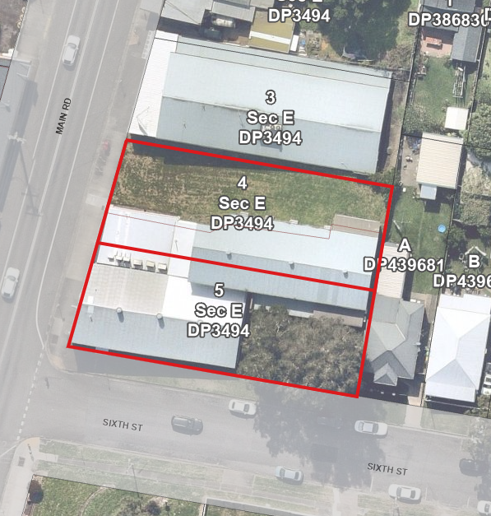
Diagram A – Lots 4 & 5

When the Local Government Act 1993 (the “LG Act”) commenced, part of Lot 4 was vacant open space, and the remainder of Lots 4 and 5 were leased partly as a cinema and partly as a pensioner’s hall. The lease for a cinema has continued since that time, and the part formerly leased as a pensioner’s hall is now leased for use by a disability aid and services provider. A diagram showing the various uses of the land is shown in diagram B below.

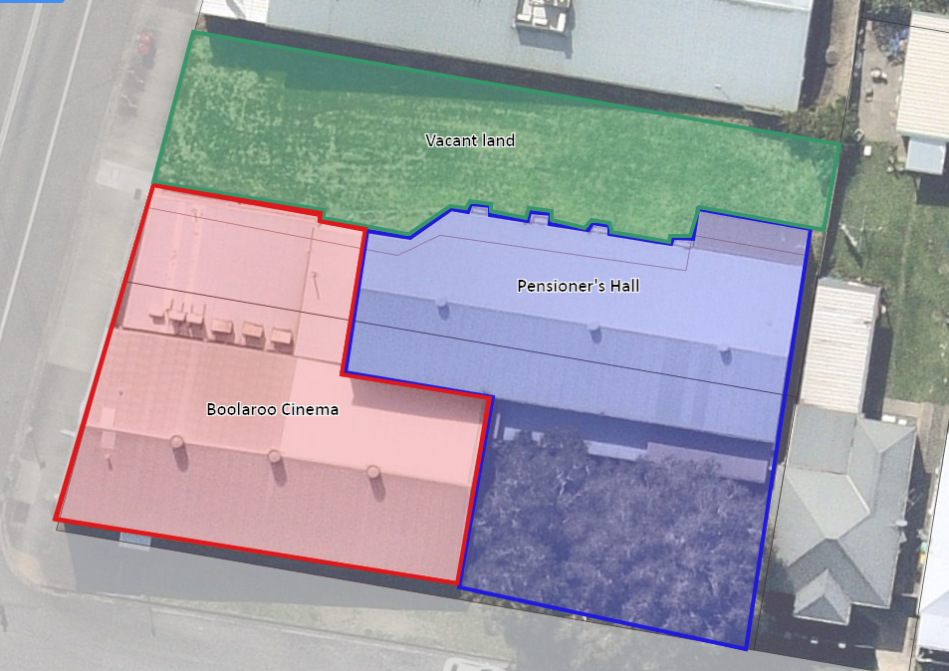
Diagram B – Uses on land

When the LG Act commenced, land which was not classified by Council as operational land became classified as community land automatically under the provisions of that legislation.

Following Council resolution made on 26 July 1993, a statutory notice was published on 1 September 1993 to classify various lands as operational. That notice included reference to the following land:
Part 4/E/3494 60 Main Road, Speers Point
Part 4/3494 60 Main Road, Boolaroo
Part 4/E/3494 62 Main Road, Boolaroo

The references as published contain typographical errors in the title references, and do not adequately describe the land having regard to the use of the land at the time. This has resulted in uncertainty regarding the classification of the land. It is considered likely that the error in the references as published may have resulted from attempting to cater for the different parts of the land (vacant land, cinema and pensioners hall).

Accordingly, this proposal seeks to confirm the classification of both lots 4 and 5 as operational in order to rectify such administrative anomaly, and to appropriately reflect the classification of the land having regard to the existing and proposed continuing use of the land.

The land is currently categorised a General Community Use. Part of this site accommodates both the Boolaroo Pensioners Hall and the Boolaroo Cinema whilst the remainder is unused open space. Due to the very small size of this open space, approximately 417m2, the ability for it to be used as meaningful parkland by the community is extremely limited. The reclassification of this land from Community to Operational will not have a detrimental impact on the provision of open space to this local community.

- ITEM 2: 27C First Street, Cardiff South, Part of Lot 30 DP 196, South of Ada Street.

The land comprises part of a long narrow strip being the piece south of Ada Street, which is located along the western edge of DP 196, subdivided in 1888, less than 4m wide x 180m long.

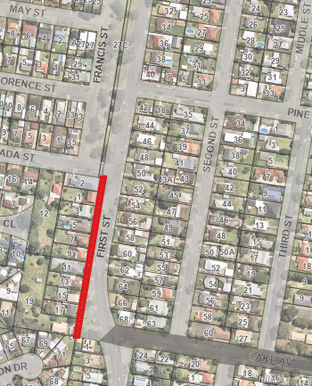
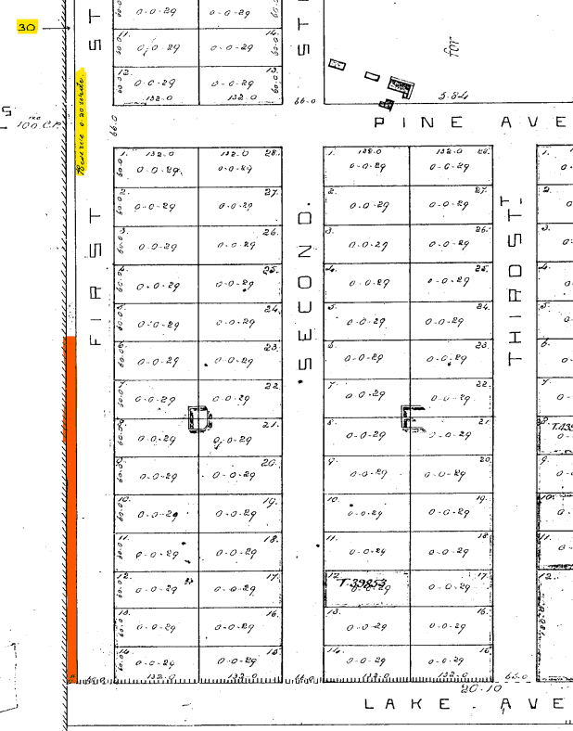
Subject Land
Extract of DP 196 Aerial 2022
It is believed that this land may have been originally formed as part of a spite strip to stop adjoining subdivisions from using the adjoining registered roads thus maximising their housing yields. As the land was unclassified, in 1993 by default it has now automatically become a Community Land classification.

Today, however, this land is now effectively land locking the properties south of Ada Street that face First Street, Cardiff. It is now proposed to reclassify the land from Community Land to Operational Land, then dedicate it as road.

Due to the shape, small size of this open space together with its proximity between two road reserves, the ability for it to be used as meaningful parkland by the community is extremely limited. The reclassification of this land from Community to Operational and future incorporation within the road reserve will not have a detrimental impact on the provision of open space to this local community.

- ITEM 3: 27 First Street, Lot 1 DP 190522 & part of 27C First Street, Lot 30 DP 196, Cardiff South, North of Ada Street

The land comprises of two long narrow strips as follows:
- Part of DP 196, less than 4m wide x 483m long, runs down the western edge of DP 196.
- DP 2742, just over 0.3m wide x 450m long, runs down eastern edge of DP 2742 (now DP 190522)
Historically, these strips of land have prevented east/west vehicular movements and resulted in two roads, Francis and First Street, running parallel with each other. If the strips are removed, then some of the streets can run through to First Street, making Francis Street redundant and freeing up residential land for future development.
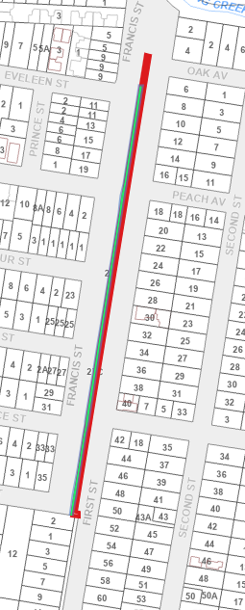
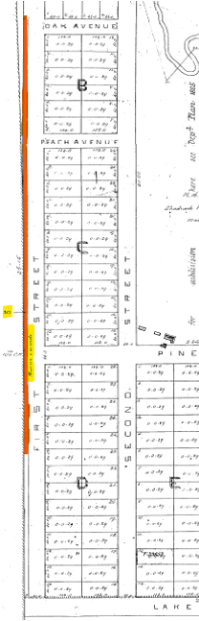
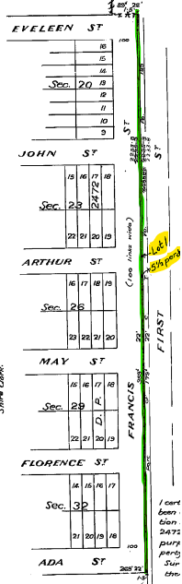
DPs Showing Proposed Land:
Subject Land
27c First St
DP 196
Subject Land
27 First St-Green
27c First St-Red
Subject Land
27 First Street
DP 190522
DP 190522 DP196 Current Cadastre plan

It is now proposed to close part of Francis Street, between Ada and John Streets, extending the residential land to the east to First Street for sale and/or future development. This will require reclassification of the land from Community Land to Operational Land, and rezoning changes to these strips of land to be compatible with the adjoining R3 residential land.

Possible new residential subdivision, shown in red below:
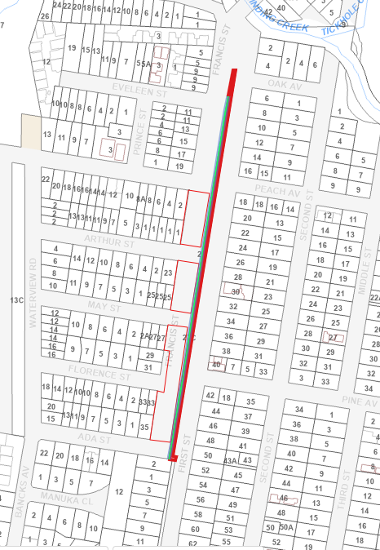
New residential land

Due to the shape, small size of this open space together with its proximity between two road reserves, the ability for it to be used as meaningful parkland by the community is extremely limited. The reclassification of this land from Community to Operational will not have a detrimental impact on the provision of open space to this local community.

- ITEM 4: 21 Narara Road, Cooranbong - Lots 4, 5, 6 and 7 Section O DP 724.

The land was transferred to Council in 2008 from the Federal Government, on the basis that “the lands are to be made available for the use and benefit by the people of Australia as a reserve for the preservation and study of wildlife and retained substantially in its natural state as a retreat for meditation and contemplation.” See Annex H.
The land has been subject to significant disturbance and weed proliferation and being 2,270 m², does not satisfy the minimum area recommended for local parks (5,000m²). It has been identified that the land is not specifically required for recreational purposes for the area.

Accordingly, Council is now considering a land swap for other land it owns nearby at 33 Narara Road which is currently operational land (shown orange) and adjoins existing community land (shown yellow).

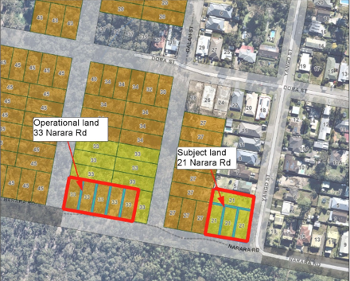

This reclassification land swap would enable the following:

- a single holding of community land with a total area of 7,322.4m². This consolidated site would result in a net increase of community land holding in the area by 354m² (being one housing lot) and provide sufficient area to potentially provide a useable local park for this growing community. The development of this proposed new park would be subject to environmental and development approvals.
- the residential development of the southern block between Yango and Gala Streets. After the formation of the southern end of Gala Street and part of Narara Road, this would provide thirteen new residential blocks, and assist in resolving bushfire and land management issues for the existing houses in that block.

The reclassification land swap will result in, and facilitate improved development, larger and more usable local open space and environmental outcomes.

- ITEM 5: 48 Oakdale Road, Gateshead, Lot 20 DP 1115790

Council purchased the land in 1994 (now known as 48 & 52 Oakdale Road) for a waste transfer station which was never developed. Instead a small business centre was developed on the site. Later Council subdivided the land and sold half the site to a private purchaser.
The subject land contains Council’s business growth centre which leases industrial units for up and coming small businesses. It contains several buildings housing an Administrative Centre which contains two training rooms, three office spaces, reception area, kitchen and toilet amenities. Also located on the land is 10 separate office spaces, 12 industrial sheds varying in size and approximately 41 carparking spaces.
It has recently been discovered that Council never classified the land upon its purchase in 1994, and accordingly the classification has reverted to Community land. It was clearly intended and has been used as Operational land and does not appear in Council’s generic Plan of Management (PoM) either.
Unfortunately, Council is not authorised to undertake any dealings on the land until it is either classified as Operational land or included in a Plan of Management. Council now proposes to reclassify the land from Community Land to Operational Land to facilitate the current leasing arrangements. Whist this reclassification will result in a loss of community land, it will not result in a reduction in community use of the site, but rather formalise the existing use.

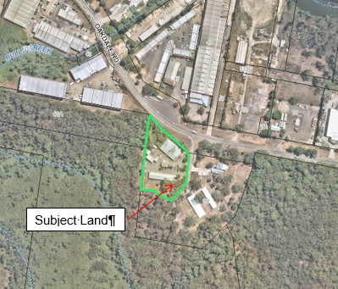

- ITEM 6 - 4a Clare Street, Glendale Lot 103 DP 553828.

This land was dedicated as public reserve under DP 553828 which was registered in 1971. It is unsure why this land was dedicated as public reserve with such a small access handle, being only 4m wide.
The land has been categorised as General Community Use, but no facilities have been provided on it. The properties to the north remain unfenced so it appears that the land is part of their yards. There is a row of scattered shrubs delineating the approximate boundary line and some temporary garden beds, thought to be owned by the residences in front, which are located in the south east corner.
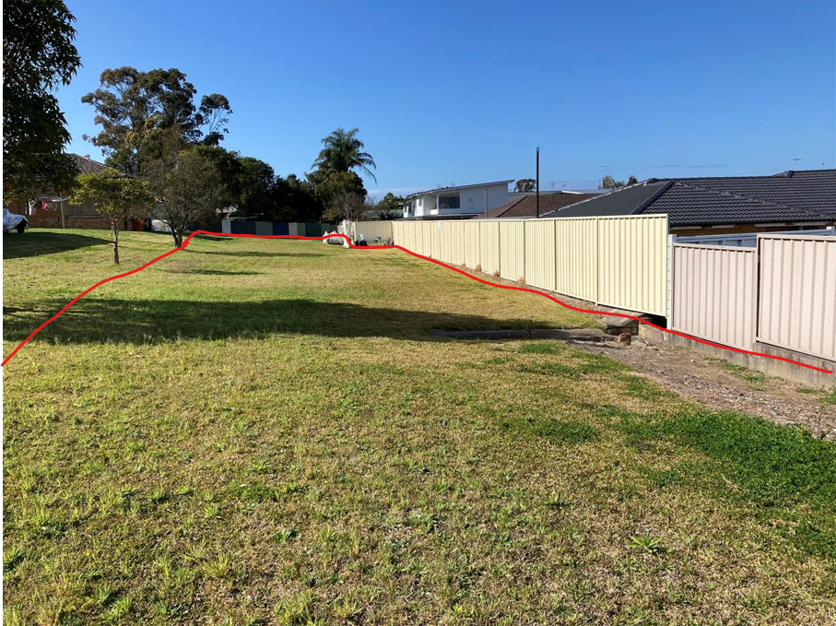
Subject land
Outlined in red
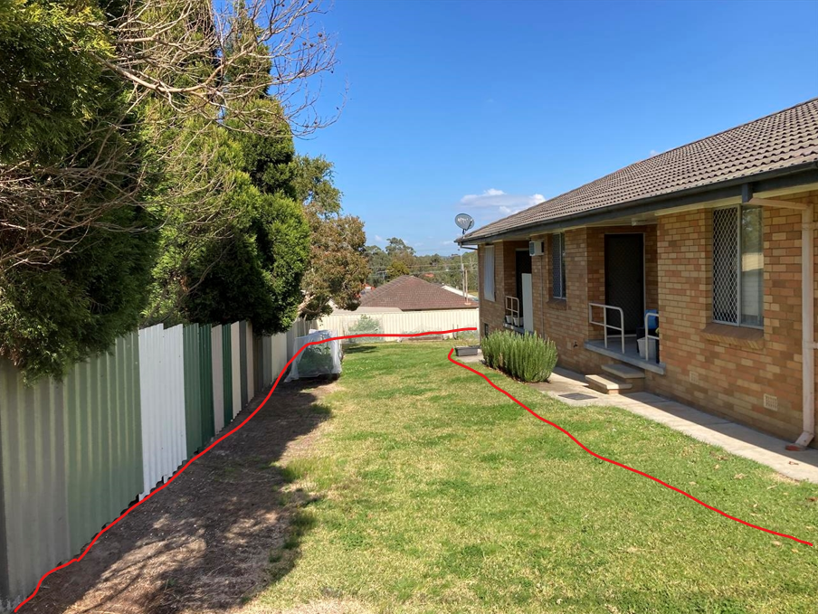
Adjoining owners
Garden beds
4m Access
Due to the shape, battle-axe entry, lack of street frontage and passive surveillance opportunities, its location at the rear of residential properties together with its small area of 1,290m2, the ability for this site to be used as meaningful parkland by the community is extremely limited. It is proposed the land be sold to adjoining owners for residential development. This will require a rezone of the land from RE1 Public Recreation to R3 Medium Density Residential and a reclassification of the land from Community to Operational land. The reclassification of this land will not have a detrimental impact on the provision of open space to this local community.

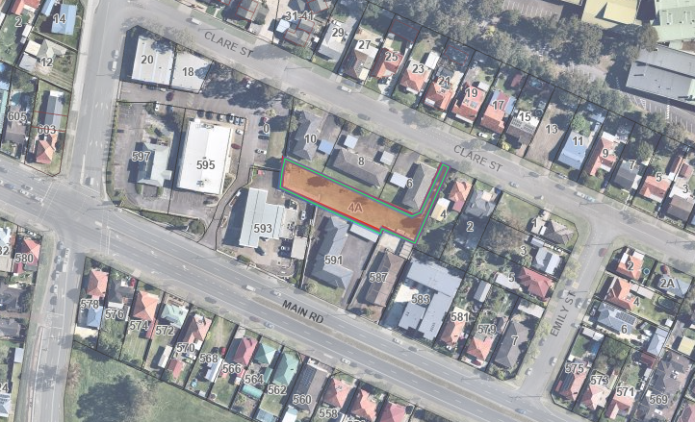
Subject Land

- ITEM 7: 62A Graham Street, Glendale, Lot 62 DP 247342.

The land was dedicated as public reserve under DP 247342. It is a triangular piece of land having an area of 840sqm and fenced in by nine adjoining owners. Its only access is via a long narrow handle, 4m wide by 36m long, between houses with no indication of public land at its end. It is vacant and contains several large trees with mown lawns beneath.

Due to the shape, battle-axe entry, lack of street frontage and passive surveillance opportunities, its location at the rear of residential properties together with the extremely small area of usable space, the ability for this site to be used as meaningful parkland by the community is significantly limited. Further, its location is separated from other bushland reserves by urban development which restricts its value as a natural area to a local value rather than being of city wide significance.
Accordingly, it is proposed to rezone the land for residential use in accordance with the surrounding area for sale or redevelopment. This will require a rezone of the land from RE1 Public Recreation to R2 Low Density Residential and a reclassification of the land from Community to Operational land. The reclassification of this land will not have a detrimental impact on the provision of open space to this local community.

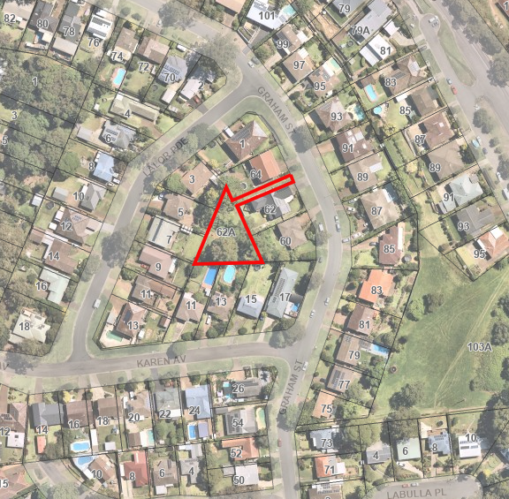
Subject land

- ITEM 8: 16 Skye Street, Morisset, Lot 1 Section 12 DP 758707

Council acquired the land known as 16 Skye Street, Morisset (Lots 1, 2 & 3, Section 12, DP 758707), over the period from 1966 through 1969, for non-payment of rates.
Until recently, the land had no road access and no services available to the site. Council has now approved a residential subdivision in the same street that has now provided both street access and services along the road corridor.

All three lots are surplus to Council’s requirements and were intended to be listed as Operational land in 1993. Unfortunately, Lot 1 Section 12 DP 758707 was not included in the advertisement and as a result automatically defaulted to Community Land classification. This administrative error is now proposed to be addressed through reclassification of Lot 1, Section 12, DP 758707 from Community Land to Operational Land, which will allow for sale and/or development of the land by Council.

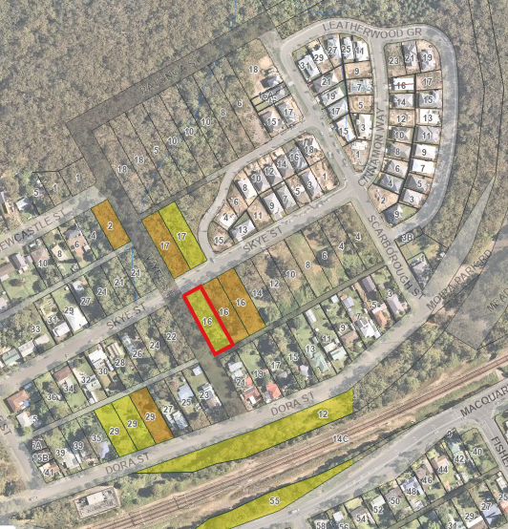
Recent subdivision
Subject land
Council owned land shown coloured. Yellow – Community land. Orange – Operational land.

As Lot 1 adjoins the unformed road of Wyee Street, it has several constraints that may stop construction on this land, but could aid in developing the adjoining two lots to the east if all sold together. These constraints include a riparian zone for water course running down Wyee Street, the need for an Asset Protection zone (bushfire threat shown by red arrows) and threatened ecological communities (shown black hatched):

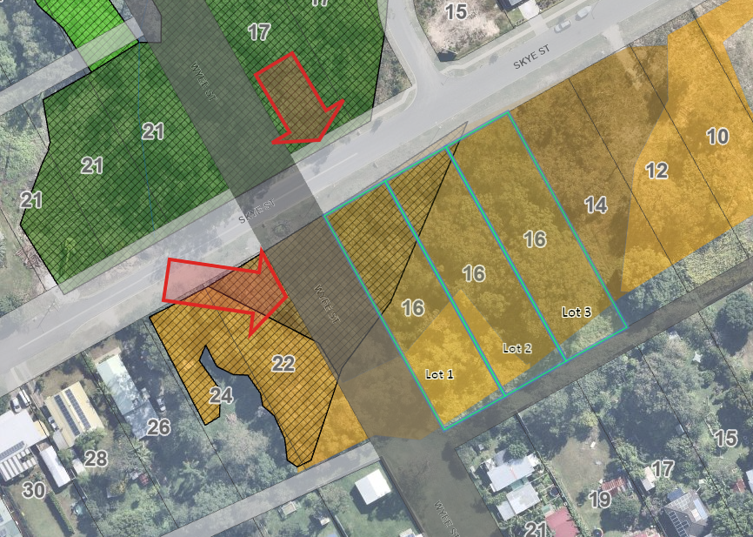

Whilst classified as Community land, the vegetated land parcel has not been used by the community over the past 50 years nor does it provide any opportunities for future recreational development. While the land appears to have some environmental value, it does not form part of an urban flora and fauna corridor and has been zoned for urban dwellings. The land is bounded on three sides by road reserves and reclassification will not have significant regional impacts on ecological values unless considered as part of the cumulative impacts of development in the area.

- ITEM 9: 38 Alison Street, Redhead Lot 50 DP 844457

This land originally was part of Scrubby Street which formed the southern extremity of the original subdivision plan created in 1894 being the Redhead Township plan DP 3109. In 1965 DP 3109 was connected to the adjoining subdivision DP 13639 on the western side of Freshwater Creek via Beach Road which was located further to the south at its Alison Street intersection. Later, around 1980, Scrubby Street was closed which left this residue piece of land, which by default has become community land as it was unclassified.
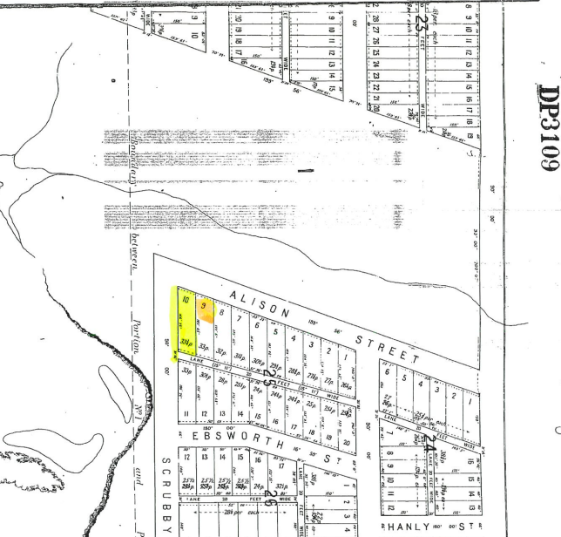
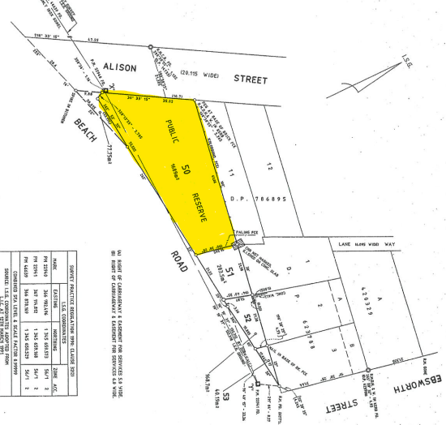
Extract from DP 844457 showing Beach Road and public reserve
This land is now surplus to Council’s recreational needs for the area and is proposed to be sold for residential development. This would require the land to be rezoned from RE1 Public Recreation to R2 Low Density Residential and reclassified from Community Land to Operational Land, which will allow for sale and/or development of the land by Council.
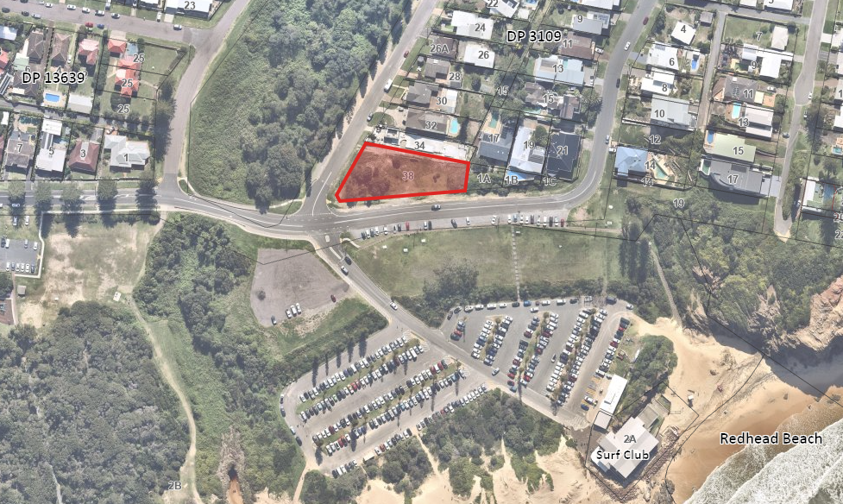
Subject land

The land is currently categorised a General Community Use. It is located opposite two local parks, including Webb Park and another large area of bushland. An assessment of the parkland provision within Redhead has identified an adequate provision of parkland currently exists within Redhead.
The rezoning from RE1 Public Recreation to R2 Low Density Residential and reclassified from Community Land to Operational Land, which will allow for sale and/or development of the land by Council. It will not have a detrimental impact on the provision of open space to this local community.

- ITEM 10: 20 Ruttleys Road, Wyee, Lot 495 DP 755242

The land was acquired by Council in the 1980s, and used as a septic tank effluent disposal area until the mid-1990s. It contained a ponding system and absorption beds located within the RU6 zoned land. These two areas are heavily disturbed with heavy weed infested regrowth.

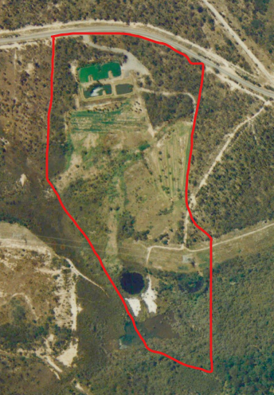
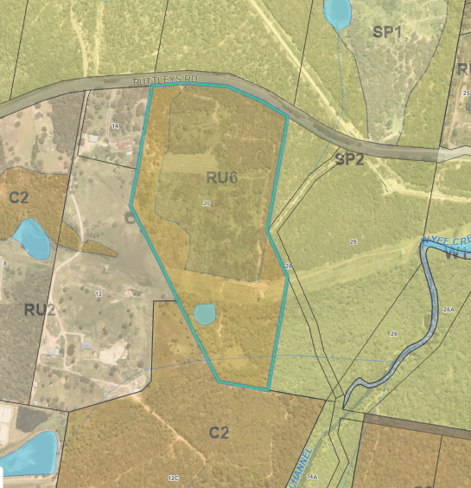
Subject land
Current zoning - RU6 Zone over previously disturbed area 1993 aerial showing septic tank effluent disposal area
The land has frontage to Ruttleys Road and has a sealed bitumen road linking the two disturbed areas. A transmission line easement (60.96m wide) crosses the land east/west, about 450m south of Ruttleys Road, separating the rear 180m of the site.
Outside of the disturbed areas, the northern part (closest to Ruttleys Road) contains Angophora inopina and Tetratheca juncea, while the southern part of the land contains EEC (Swamp Sclerophyll Forest over Floodplains). These areas are not impacted by the proposal.
A bushfire hazard assessment determined that future development on the site would be able to provide sufficient APZs within the disturbed areas to achieve BAL 29, without impacting valuable native vegetations areas around the disturbed areas.
A contamination assessment (including DSI and site audit) has determined the site is potentially suitable for rural residential development, subject to appropriate remediation.

This land is already operational land, however it is now proposed to rezone the land from RU6 Transition to C4 Environmental Living, which will maintain the land as a transition area between Wyee and Wyee Point. The C2 zoning on the land will remain.

- Is the planning proposal the best means of achieving the objectives or intended outcomes, or is there a better way?
The proposed Planning Proposal amendments are considered the best means of achieving the intended outcomes for each property. All the properties (except Item 10 which requires a rezone only) are classified as Community Land under the provisions of the Local Government Act which possess statutory limitations on their use. To achieve the long-term objective for each parcel, each must first be reclassified to Operational land.
Investigations reveal that none of the lands were dedicated to Council in lieu of section 7.11 contributions and therefore reclassification by way of a LEP amendment, pursuant to the provisions of the Environmental Planning and Assessment Act 1979, is the only action available to achieve the desired outcomes.

Section B - Relationship to the Strategic Planning Framework
3. Will the planning proposal give effect to the objectives and actions of the applicable regional or district plan or strategy (including any exhibited draft plans or strategies)?
Hunter Regional Plan 2036
The proposed reclassifications are consistent with the Hunter Regional Strategy 2036 (HRS), which has a focus on providing the Hunter region with a leading regional economy, a biodiversity-rich natural environment, thriving communities and greater housing choice and jobs.
The table below identifies which objective/action will be satisfied by each piece of land within the plan:

Obj No. | Objective | Item No. | Address
20.3 | Enhance the amenity and attractiveness of existing places [by revitalising existing communities - Boolaroo]. | 1 | 60-62 Main Road, Boolaroo
21.1 | Promote development that respects the landscape attributes and the character of the metropolitan areas, towns and villages | 10 | 20 Ruttleys Road, Wyee
21.2 | Focus development to create compact settlements in locations with established services and infrastructure such as Newcastle– Lake Macquarie Western Corridor growth area | 3 | 27 First Street, Cardiff South & part of 27C First Street, Cardiff South, North of Ada Street
 |  | 4 | 21 Narara Road, Cooranbong
 |  | 7 | 62A Graham Street, Glendale
 |  | 8 | 16 Skye Street, Morisset
 |  | 10 | 20 Ruttleys Road, Wyee
21.6 | Provide greater housing choice by delivering diverse housing, lot types and sizes, including small-lot housing in infill and greenfield locations | 10 | 20 Ruttleys Road, Wyee
21.7 | Promote new housing opportunities in urban areas to maximise the use of existing infrastructure | 3 | 27 First Street, Cardiff South & part of 27C First Street, Cardiff South, North of Ada Street
 |  | 4 | 21 Narara Road, Cooranbong
 |  | 6 | 4A Clare Street, Glendale
 |  | 7 | 62A Graham Street, Glendale
 |  | 8 | 16 Skye Street, Morisset
 |  | 9 | 38 Alison Street, Redhead
 |  | 10 | 20 Ruttleys Road, Wyee
23.5 | Focus commercial and retail development within existing centres and transport hubs | 1 | 60-62 Main Road, Boolaroo
Obj No. | Objective | Item No. | Address
26.1 | Align land use and infrastructure planning to maximise the use and capacity of existing infrastructure and the efficiency of new infrastructure | 2 | Part of 27C First Street, Cardiff South, South of Ada Street
 |  | 4 | 21 Narara Road, Cooranbong
 |  | 6 | 4A Clare Street, Glendale
 |  | 7 | 62A Graham Street, Glendale
 |  | 8 | 16 Skye Street, Morisset
 |  | 9 | 38 Alison Street, Redhead

Greater Newcastle Metropolitan Plan
The proposed reclassifications are consistent with the Greater Newcastle Metropolitan Plan 2036 (GNMP), which sets out strategies and actions that will drive sustainable growth across Cessnock City, Lake Macquarie City, Maitland City, Newcastle City and Port Stephens communities, which together make up Greater Newcastle.
The table below identifies which strategy/ies will be satisfied by each piece of land within the plan:
Strat No. | Strategy | Item No. | Address
9 | Plan for jobs closer to homes in the Metro frame | 5 | 48 Oakdale Road, Boolaroo
10 | Promote innovative approaches to the creative re-use of heritage places, ensuring good urban design preserves and renews historic buildings and places | 1 | 60-62 Main Road, Boolaroo
16 | Prioritise the delivery of infill housing opportunities within existing urban areas | 3 | 27 First Street, Cardiff South & part of 27C First Street, Cardiff South, North of Ada Street
 |  | 4 | 21 Narara Road, Cooranbong
 |  | 6 | 4A Clare Street, Glendale
 |  | 7 | 62A Graham Street, Glendale
 |  | 8 | 16 Skye Street, Morisset
 |  | 9 | 38 Alison Street, Redhead
 |  | 10 | 20 Ruttleys Road, Wyee
17 | Unlock housing supply through infrastructure coordination and delivery | 3 | 27 First Street, Cardiff South & part of 27C First Street, Cardiff South, North of Ada Street
 |  | 4 | 21 Narara Road, Cooranbong
 |  | 6 | 4A Clare Street, Glendale
 |  | 7 | 62A Graham Street, Glendale
 |  | 8 | 16 Skye Street, Morisset
 |  | 9 | 38 Alison Street, Redhead
 |  | 10 | 20 Ruttleys Road, Wyee

4. Is the planning proposal consistent with a council LSPS that has been endorsed by the Planning Secretary or GSC, or another endorsed local strategy or strategic plan?
Imagine Lake Mac, previously Lifestyle 2050 Strategy

The draft Lifestyle 2050 Strategy was adopted by Council on 11 June 2019, and is now known as Imagine Lake Mac Strategy, and accordingly must be considered for future planning purposes.

The table below identifies which strategy/ies will be satisfied by each piece of land within the plan:
Strategy | Item No. | Address | Growth Area
A city of vibrant centres  Our centres will play vital economic and social roles in the City, providing more opportunities to co-locate jobs, essential services, housing and transport options and recreational activities. | 1 | 60-62 Main Road, Boolaroo | Boolaroo-Speers Point Precinct
A city to call home  The City will provide opportunities for substantial growth in new housing, including a greater mix of housing types to accommodate our growing population. | 3 | 27 First Street, Cardiff South & part of 27C First Street, Cardiff South, North of Ada Street | Cardiff South
 | 4 | 21 Narara Road, Cooranbong | Cooranbong
 | 6 | 4A Clare Street, Glendale | Glendale
 | 7 | 62A Graham Street, Glendale | Glendale
 | 8 | 16 Skye Street, Morisset | Morisset
 | 9 | 38 Alison Street, Redhead
 | 10 | 20 Ruttleys Road, Wyee | Wyee
A city of prosperity  Our economy will transform, mature and evolve, capitalising on emerging industries, attracting new investment and broader employment opportunities and industries to create opportunity and prosperity. | 5 | 48 Oakdale Road, Gateshead
A city of progress and play  Our centres and neighbourhoods will provide a broader variety of inclusive and vibrant public spaces where locals and visitors come together to work, rest or play. | 4 | 21 Narara Road, Cooranbong | Cooranbong

5. Is the planning proposal consistent with any other applicable State and regional studies or strategies?
It is considered that the minor nature of this proposal will be consistent with any other relevant State or regional study or strategy – for example; Future Transport Strategy 2056.

- Is the planning proposal consistent with applicable state environmental planning policies (SEPPs)?
An assessment of the proposal against the relevant State Environmental Planning Policies (SEPPs) is provided within Appendix B.

- Is the planning proposal consistent with applicable Ministerial Directions?
An assessment of the proposal against the Section 9.1 Ministerial Directions is provided within Appendix C.
An assessment of these Directions shows that the following are inconsistent, potentially inconsistent or require approval from the Department of Planning and Environment:

- 3.1 Conservation Zones - Item 10 - 20 Ruttleys Road, Wyee, currently has a split zoning of C2 Environmental Conservation and RU6 Transition. The proposal is to keep the C2 zone and change the RU6 zone to C4 Environmental Living. It is considered to be consistent with this Ministerial Direction as it does not reduce the environmental protection standards that apply to the land.

- 4.1 Flooding - Only the southern part of Item 10 – 20 Ruttleys Road, Wyee, is identified as flood prone land, however this section of land is currently zoned C2 and will remain as C2. No other land is identified on the flood prone land map.
The planning proposal is in accordance with a floodplain risk management plan, and is considered to be in accordance with this Ministerial direction.

- 4.2 Coastal Management – Items 5, 6, 9 and 10 are all identified as being within the Coastal zone. Only item 5 - 48 Oakdale Road, Gateshead, has a small piece of coastal wetland identified in the north west corner of the site. As item 5 is for reclassification only it does not propose rezoning, an increase in development, nor a more intense use on the land and therefore is considered to be consistent with this direction.

- 4.3 Planning for Bushfire Protection – Items 4, 5, 8, 9 and 10 are located within land identified as Vegetation Category 1 (red) or Vegetation Buffer (yellow) under the Bushfire prone land map. The proposal to reclassify and/or rezone these lands will require consultation with the Rural Fire Service in accordance with this direction.

- 4.4 Remediation of Contaminated Land – Items 1, 6 and 10 are identified as being within an investigation area or containing previous development that may have contaminated the land. Item 1 is within the Pasminco Grid, but as the proposal is for reclassification only, a contamination study is not considered necessary. Item 6 adjoins a working service station, but as the subject land is uphill of the service station, no risk of spill exists. Item 10 was an old night soil site, which has had a site audit and remediation plan prepared and will be enacted whilst the planning proposal is being processed.

- 4.5 Acid Sulfate Soils – Items 1, 4, 6, 9 and 10 are identified in areas containing acid sulfate soils. All this land (except Item 10) is infill development within existing residential areas. The inconsistency with the Ministerial direction is considered to be of minor significance.

- 4.6 Mine Subsidence and Unstable Land – All Items except 1 and 4 are identified on either the Lake Macquarie or West Lake subsidence map. This will require consultation with Subsidence Advisory NSW in accordance with this direction.

- 6.1 Residential zones - Items 2, 3 and 8 are within existing residential zones, whilst items 4, 6, 7 and 9 are proposed to be rezoned to residential. As all these lands are infill development and all land is adequately serviced, the proposal is considered consistent with this Ministerial Direction.

- 7.1 Business and Industrial Zones – Items 1 and 5 are located within existing business and industrial zones. As these two properties are for reclassification only, the zone boundaries and provisions within the zone, will not change. Accordingly, the planning proposal is considered consistent with this Ministerial Direction.

- 9.1 Rural Zones - Item 10 – 20 Ruttleys Road, Wyee, is within an RU6 Transition zone. Preliminary studies have indicated that this land is now suitable to rezone to C4 Environmental Living which will not increase its permissible density and will maintain the sites environmental sensitivities. This is considered consistent with this Ministerial Direction.

Section C – Environmental, Social and Economic Impact
- Is there any likelihood that critical habitat or threatened species, populations or ecological communities, or their habitats, will be adversely affected as a result of the proposal?
Three sites have been identified as follows:
Item 5, 48 Oakdale Road, Gateshead. The north western corner of this land, outlined in red below, has identified Swamp Sclerophyll Forest on Coastal Floodplains which is a threatened ecological community. Accordingly, this section of the land remains untouched and no further work on this land is proposed in accordance with this proposal.

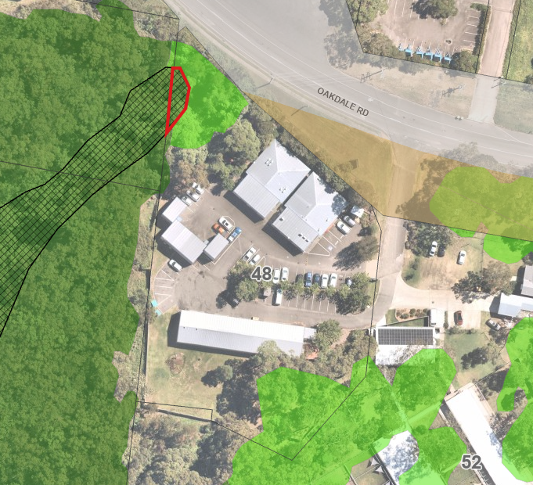
However, the dark green colouring shows that the vegetation on the land contributes significantly to movement and viability of flora and fauna in the area. The light green colouring has been partially cleared but still contributes significantly in the remnant vegetation and in the movement of flora and fauna in the area.

Item 8, 16 Skye Street, Morisset, also has identified threatened ecological communities, Swamp Mahogany – Paperbark on Coastal Plains, as identified in hatching below:
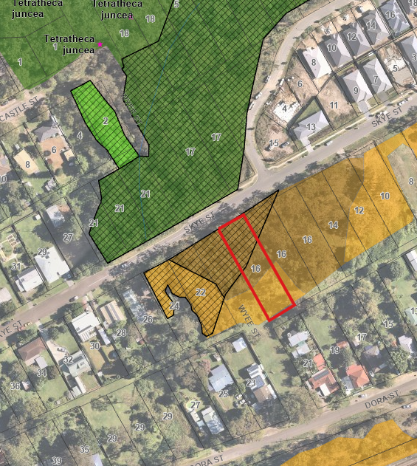
However, the orange colouring shows that the land has been partially cleared and has only a minor role in the remnant vegetation and in the movement of flora and fauna. The dark green colouring shows a major role.

Item 10, 20 Ruttleys Road, Wyee has identified threatened species and endangered ecological communities (EEC) as identified in pink below:
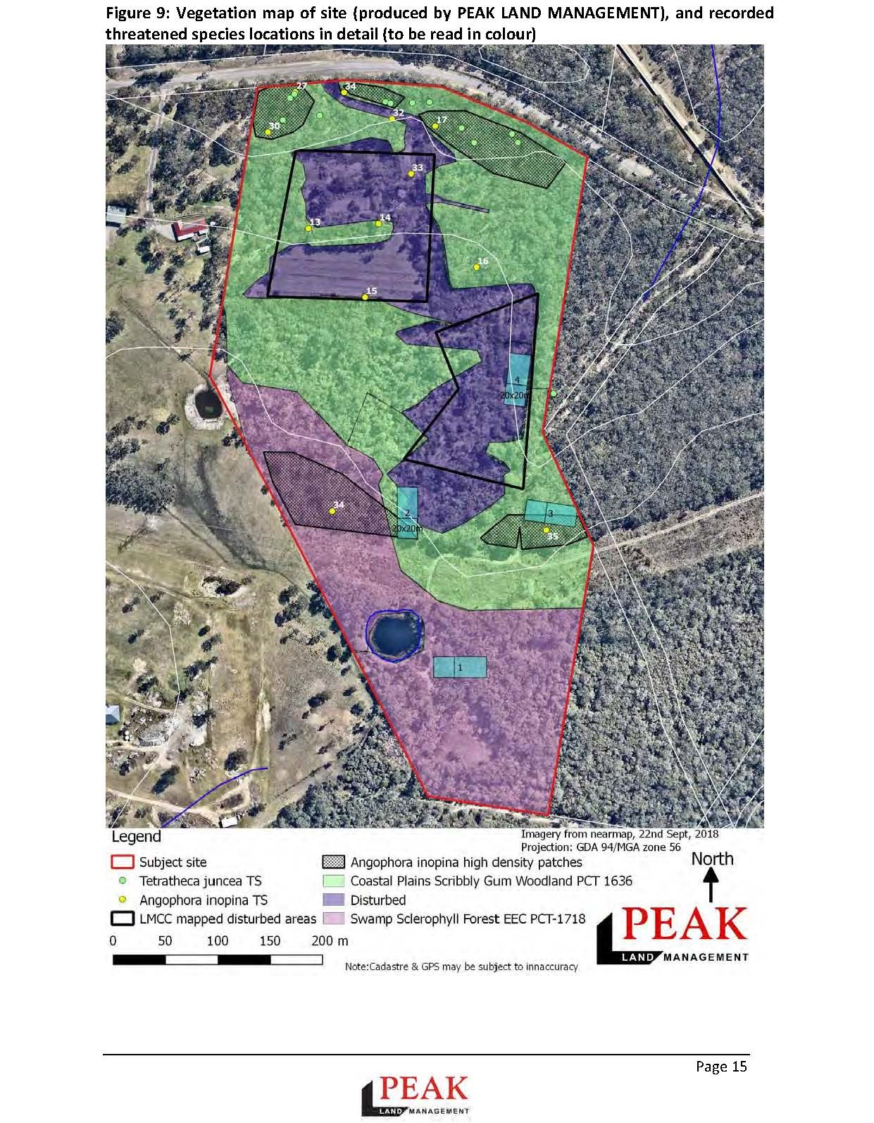
It was identified that outside of the disturbed areas, the north part (closest to Ruttleys Road) contains Angophora inopina and Tetratheca juncea, while the south part of the site contains EEC (Swamp Sclerophyll Forest over Floodplains). These areas are not impacted by the proposal and will retain the C2 zoning of Environmental Conservation.

- Are there any other likely environmental effects as a result of the planning proposal and how are they proposed to be managed?
Apart from the land identified in 8. above, two other sites have been identified with bushland, as follows:
Item 4, 21 Narara Road, Cooranbong, this land has been subject to significant disturbance and weed proliferation and does not contain any identified threatened or endangered species. To ensure the proposal does not reduce the amount of community land in the area, it is also proposed to reclassify operational land at 33 Narara Road to community land. This would adjoin existing Council owned community land, making a larger more useable space for community use.
Item 7, 62A Graham Street, Glendale, has some substantial trees on the land, but a cleared understorey. The land is isolated from other bushland areas and does not form any native vegetation or wildlife corridors.
All other land identified within this planning proposal is either cleared or highly disturbed.
- How has the planning proposal adequately addressed any social and economic effects?
Due to the minor nature of these proposed amendments, it is anticipated there will be no negative social or economic effects. However, this will be determined during the public notification period of the planning proposal and addressed at that stage.

Section D – Infrastructure (Local, State and Commonwealth)
- Is there adequate public infrastructure for the planning proposal?
The proposal will not require any changes to the delivery of public infrastructure to any of the lands included in the Planning Proposal. All land is either already developed or will be infill development containing existing infrastructure.

Section E – State and Commonwealth Interests
- What are the views of State and Commonwealth Public Authorities and Government Agencies consulted in order to inform the Gateway determination?
The Gateway determination will identify the public authorities to be consulted during the public exhibition period. It is expected that the following authorities will require notification:
- Subsidence Advisory NSW, and
- NSW Rural Fire Service.

Section F: Special Considerations for Reclassification of Public Land
See LEP Practice Note: PN 16-001, 16 October 2016.
- (a) If the provisions of the planning proposal include the extinguishment of any interests in the land, what are the reasons why the interests are proposed to be extinguished.
The proposal seeks to remove the following Public Reserve Notations, interests, covenants and restrictions pursuant to section 30 of the Local Government Act 1993:
Item No | Address | Classification of Land | Interests in land | Reason why interests are extinguished
1 | 60-62 Main Road, Boolaroo, Lot 4 & 5 Sec E DP 3494 | Community change to Operational to Lease whole of site | Crown Grant | Retain
 |  |  | 340997 | Retain – as it relates to rights to mine & minerals
 |  |  | 569262 | Retain – as it relates to rights to mine & minerals
 |  |  | G709484 | Remove – building and encroaching eaves now removed
 |  |  | AH466262 | Retain – Lease still current, renewal option taken up
2 | Part of 27C First Street, Cardiff South, Lot 30 DP 196, South of Ada Street | Community change to Operational for Road Dedication | Minerals & Crown Grant | Retain
3 | 27 First Street, Cardiff South, Lot 1 DP 190522 & 27C First Street, Cardiff South, Lot 30 DP 196, North of Ada Street | Community change to Operational and rezone for Medium Density Residential | Minerals & Crown Grant | Retain
4 | 21 Narara Road, Cooranbong, Lots 4, 5, 6 & 7 Section O DP 724 | Community change to Operational and rezone for Low Density Residential | Minerals & Crown Grant | Retain
5 | 48 Oakdale Road, Gateshead, Lot 20 DP 1115790 | Community change to Operational for Leasing purposes | Land excludes Minerals | Retain
 |  |  | DP1115790 | Retain Right of Carriageway
 |  |  | AE131867 | Remove – Lease expired
 |  |  | DP1217693 | Retain – easement to drain water
6 | 4a Clare Street, Glendale, Lot 103 DP 553828 | Community change to Operational and rezone for Medium Density Residential | Crown Grant | Retain
 |  |  | 2-D392881 | Retain – as it relates to rights to mine & minerals
 |  |  | 3-D439903 | Retain – as it relates to rights to mine & minerals
 |  |  | 4- D439903 | Remove – relates to erection of fences and noxious chemical businesses
 |  |  | 5- D392881 | Remove – relates to erection of fences and noxious chemical businesses
 |  |  | K200000P | Remove – relates to public reserves
7 | 62A Graham Street, Glendale, Lot 62 DP 247342 | Community change to Operational and rezone for Low Density Residential | Crown Grant | Retain
 |  |  | 2-A926932 | Retain – as it relates to rights to mine & minerals
 |  |  | 3- A926932 | A926932
 |  |  | K200000P | Remove – relates to public reserves
8 | 16 Skye Street, Morisset, Lot 1 Section 12 DP 758707 | Community change to Operational for residential development | Minerals & Crown Grant | Retain – as it relates to rights to mine & minerals
9 | 38 Alison Street, Redhead, Lot 50 DP 844457 | Community change to Operational and rezone for Low Density Residential | Crown Grant | Retain
 |  |  | Land within described as Public Reserve | Remove – relates to public reserves
10 | 20 Ruttleys Road, Wyee, Lot 495 DP 755242 | Rezone for Environmental Living | Minerals & Crown Grant | Retain – as it relates to rights to mine & minerals
 |  |  | V452290 | Retain - easement relating to transmission lines
 |  |  | O749325 | Retain - easement relating to transmission lines

NOTE: Crown Grant and Mineral rights have been retained pursuant to clause 5.2(5)(b) & (c) of Lake Macquarie Local Environmental Plan 2014.
Please see Annex E for proposed changes to Schedule 4 of Lake Macquarie Local Environmental Plan 2014.
(b) The concurrence of the landowner, where the land is not owned by the relevant planning authority.
Pursuant to section 28 of the Local Government Act 1993, Council may not forward a Planning Proposal which includes a proposal to classify or reclassify public land, without the approval of the owner of that land.
Lake Macquarie Council is the landowner for all of the sites the subject of this planning proposal.

(c) How funds obtained from any future sale of the land will be used.
The following table outlines where the funds from any future sale of the land will go:
Item No. | Address | Intended Outcomes: | Intended Proceeds to:
1 | 60-62 Main Road, Boolaroo | Commercially lease the whole of the property | Current lease proceeds go to the Strategic Property Reserve. This will remain the same once the land has been reclassified.
2 | Part of 27C First Street, Cardiff South, South of Ada Street | Dedicate as road | No proceeds expected
3 | 27 First Street, Cardiff South & 27C First Street, Cardiff South, North of Ada Street | Close the road, redevelop and sell to the public | No proceeds expected for land to remain as road  Roads & Drainage Fund for land previously road – Approx 6,500m²  Community Land Reserve for land previously RE1 – Approx 1,190m²
4 | 21 Narara Road, Cooranbong | Redevelop and sell to the public | Proposed reclassification land swap with 33 Narara Road
5 | 48 Oakdale Road, Gateshead | Commercially lease the whole of the property | Current lease proceeds go to the Strategic Property Reserve. This will remain the same once the land has been reclassified.
6 | 4a Clare Street, Glendale | Redevelop and sell to the public | Community Land Reserve
7 | 62A Graham Street, Glendale | Redevelop and sell to the public | Community Land Reserve
8 | 16 Skye Street, Morisset | Redevelop and sell to the public | No proceeds anticipated. This is one lot of three lots to be sold together, this lot is constrained due to an APZ and riparian zone, which would be required for the development of the other two lots.
9 | 38 Alison Street, Redhead | Redevelop and sell to the public | Community Land Reserve
10 | 20 Ruttleys Road, Wyee | Redevelop and sell to the public | Strategic Property Reserve

(d) The effect of the reclassification, including loss of open space, any discharge of interests, and/or removal of public reserve status.
Any discharge of interests, and/or removal of public reserve status, has been discussed in (a) above. The following table outlines the effect of the reclassification including the loss of open space/community land:

Item No. | Address | Is this land currently zoned RE1 Public Recreation? | Proposed change in Land area of open space/community land | Is area suitable as Open Space land
1 | 60-62 Main Road, Boolaroo | No – zoned B1 | Loss of 417m². | No – too small and wedged between two buildings
2 | Part of 27C First Street, Cardiff South, South of Ada Street | No – zoned R2 | Loss of 720m². Land used as road verge. | No – only 4m wide and has 11 driveway crossings over it.
3 | 27 First Street, Cardiff South & 27C First Street, Cardiff South, North of Ada Street | No – zoned R2 | Loss of 2,067m². Land is used as medium strip between roads | No - only 4m wide located between two parallel roads Francis and First Streets, Cardiff
4 | 21 Narara Road, Cooranbong | Yes – change to R2 | Net gain of 354m² of community land | Yes – but proposed land swap would enable a larger piece of community land in same location
5 | 48 Oakdale Road, Gateshead | No – zoned IN2 | Nil | Use of land will remain the same, but reclassification will enable Council to lease the existing facilities.
6 | 4a Clare Street, Glendale | Yes – change to R3 | Loss of 1290m² | No – due to shape, battle-axe entry, lack of street frontage and passive surveillance
7 | 62A Graham Street, Glendale | Yes – change to R2 | Loss of 978m² | No – due to shape, battle-axe entry, lack of street frontage and passive surveillance
8 | 16 Skye Street, Morisset | No – zoned R3 | Nil – Land area is 1,416 m² | No – administrative error missed the classification of this land in 1993.
9 | 38 Alison Street, Redhead | Yes – change to R2 | Loss of 1689m² | Not required as adjoins large beach front reserve and creek line corridor.
10 | 20 Ruttleys Road, Wyee | No – change from RU6 to C4 | Nil – land already operational | N/A
None of the land has any open space facilities provided on it, or is used by the public for recreational purposes to Council’s knowledge.
Part 4- Maps
The maps proposed to be included as part of the LEP Amendment are outlined within Part 2 of this Planning Proposal and are attached within Annex A.

Part 5- Community Consultation
Community consultation will be undertaken in accordance with the requirements of the Gateway determination and Schedule 1 clause 4 of the Environmental Planning and Assessment Act 1979, section 29 of the Local Government Act 1993 and the Department’s LEP guideline “Local Environmental Plan Making Guideline, Dec 2021” Local Environmental Plan Making Guideline (nsw.gov.au).

Exhibition
The planning proposal will be exhibited for 20 days in accordance with stage 5 of the Department’s LEP guideline, as it contains reclassification of public land. The exhibition will be notified on Council’s website, on the Planning Portal and in writing to affected landowners and adjoining landowners.

Public Hearing
In accordance with section 29 of the Local Government Act 1993, a public hearing will be held. The public hearing will be undertaken in accordance with stage 5 of the Department’s LEP guideline.

Part 6 – Project Timeline
The following table provides an indicative timeline for the Draft Local Environmental Plan:
Task | Timeline
Consideration by Council | 14 June 2022
Council decision | 27 June 2022
Gateway Determination | 14 September 2022
Pre-exhibition | 17 October 2022
Commencement and completion of exhibition period (20 working days) | 6 March 2023
Public Hearing | 22 May 2023
Consideration of submissions & prepare report on Public Hearing | 5 June 2023
Post-exhibition review and report to Council | 26 June 2023
Submission to Department for finalisation | 31 July 2023
Gazettal of LEP amendment | 9 November 2023
ANNEX A – MAPS
Item 1: 60-62 Main Road, Boolaroo, Lot 4 & 5 Sec E DP 3494
Figure 1 – Aerial Map
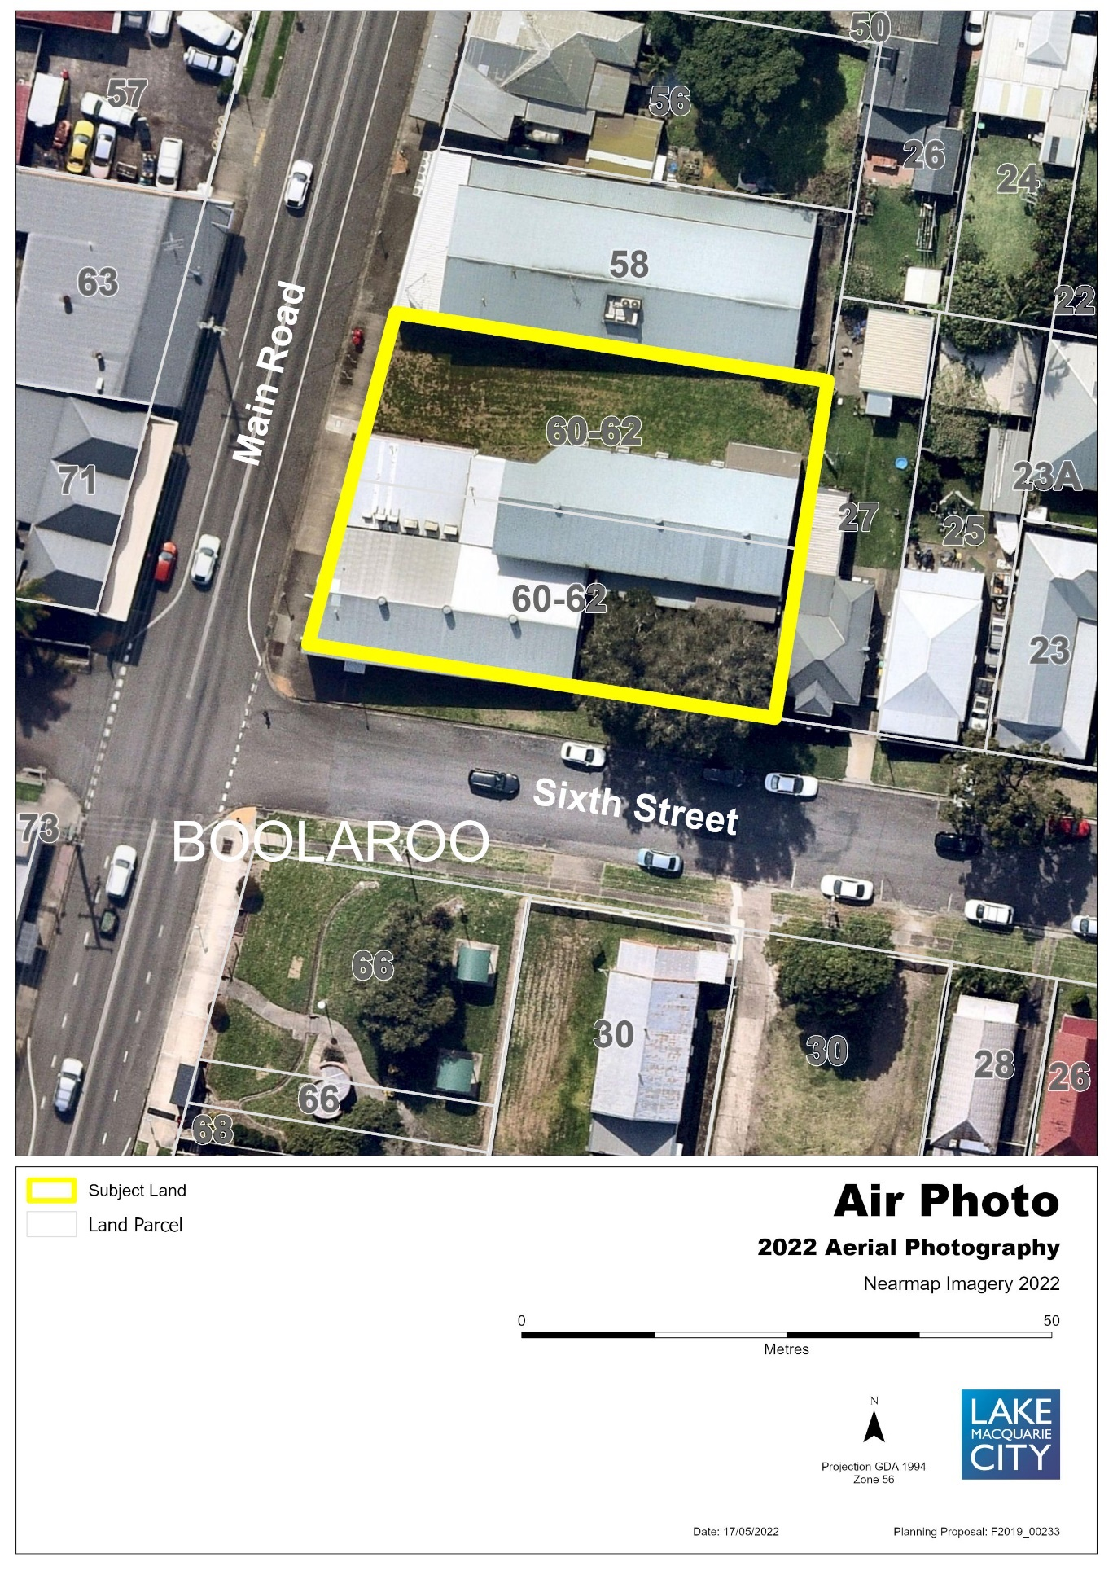
Figure 2 – Existing Zone under LMLEP 2014
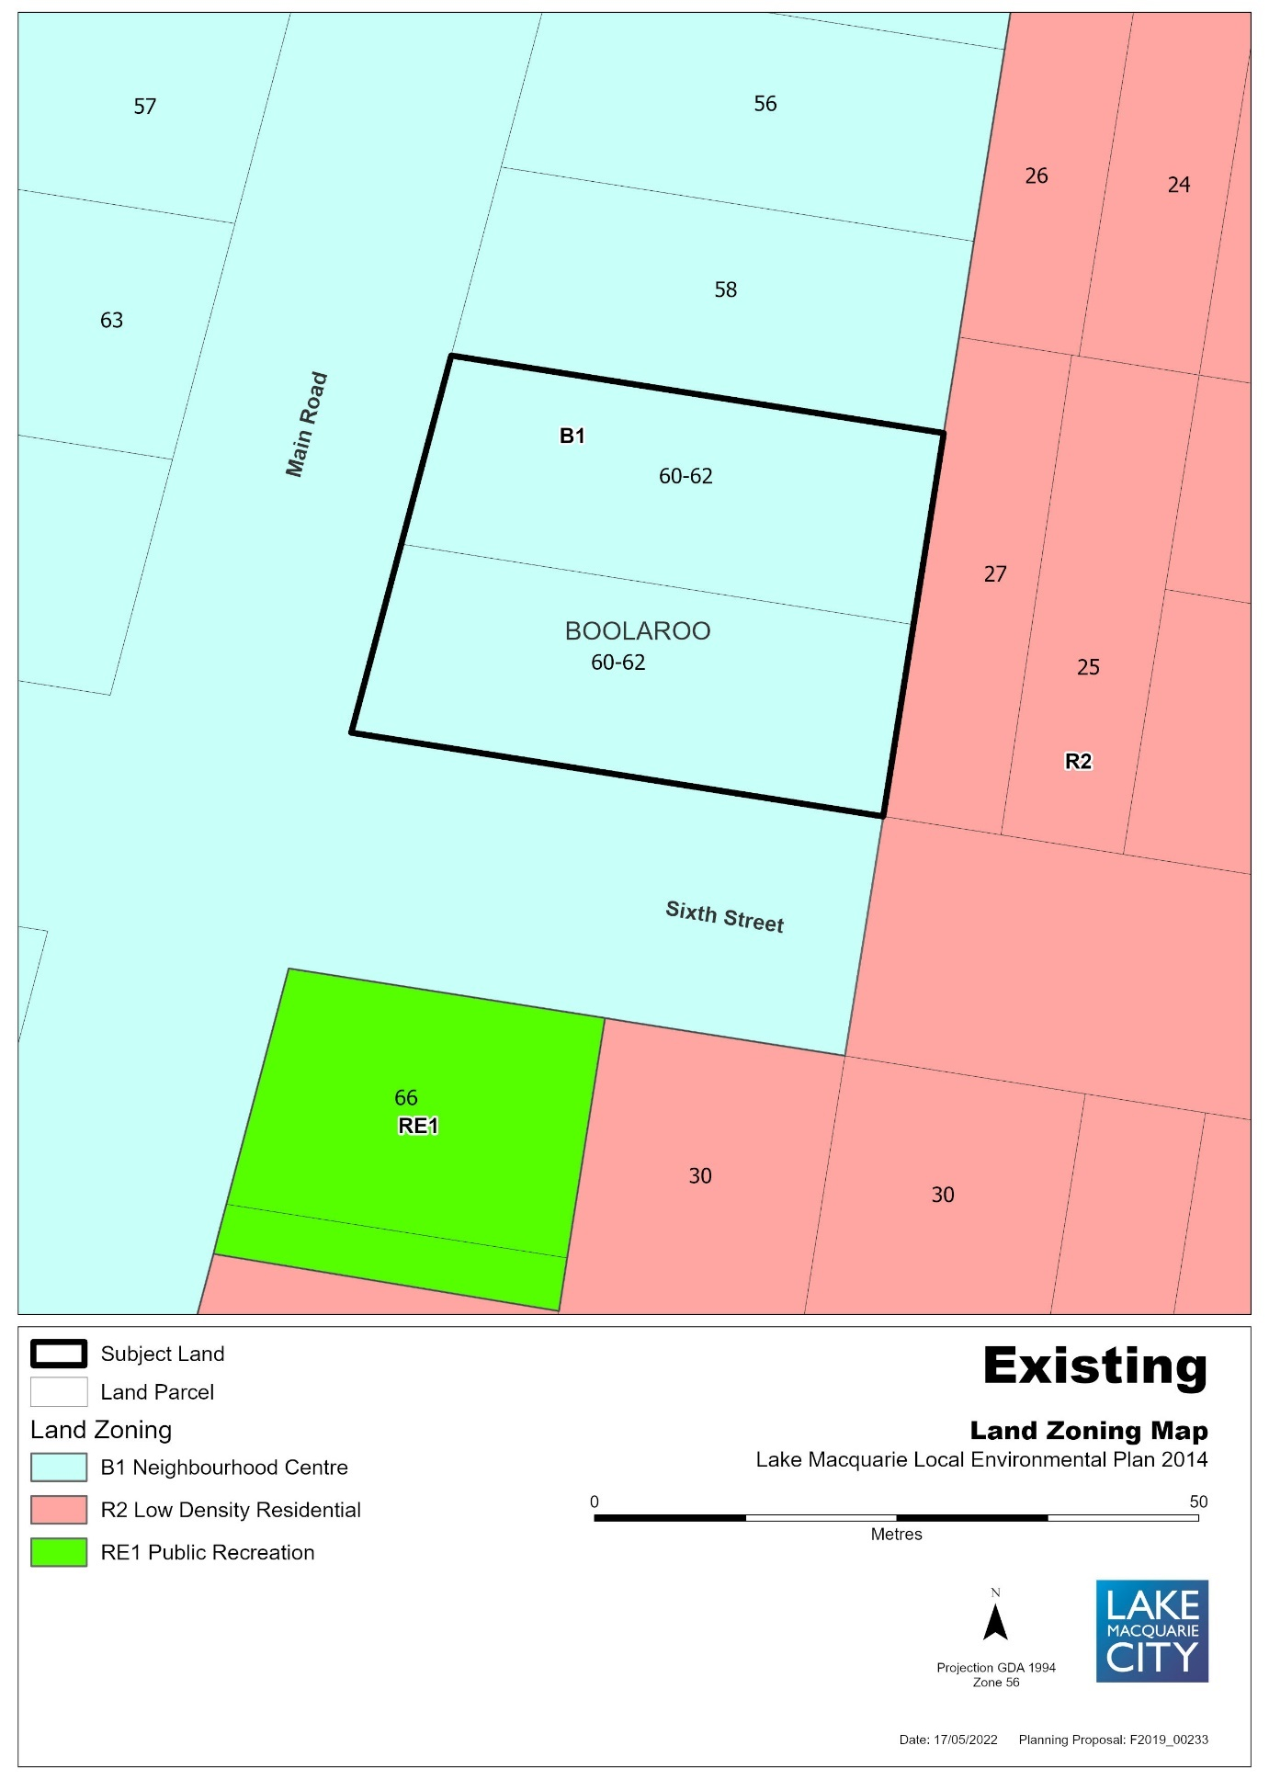

Figure 3 – Draft Land Reclassification Map under LMLEP 2014
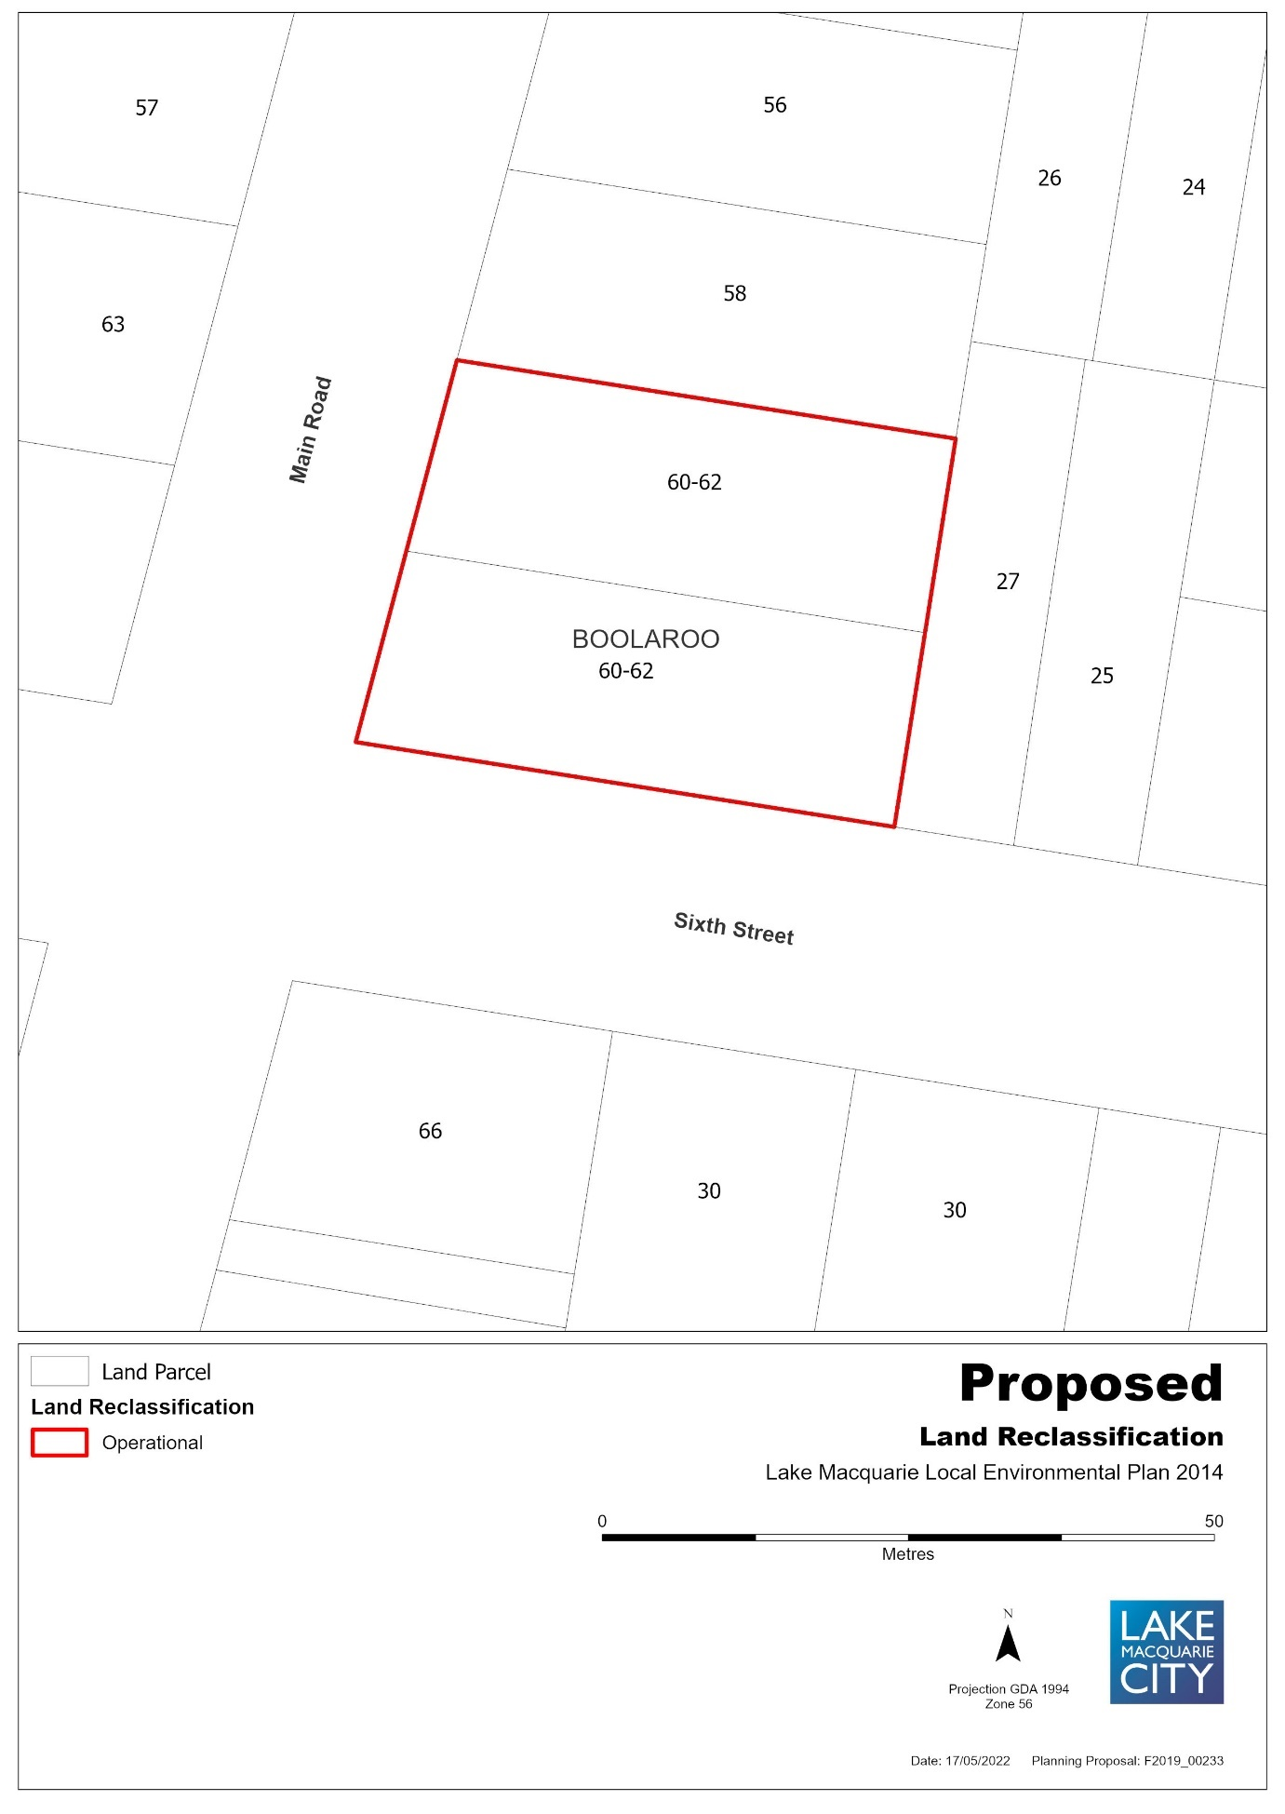

ITEM 2: Part of 27C First Street, Cardiff South, Lot 30 DP 196, South of Ada Street
Figure 1 – Aerial Map
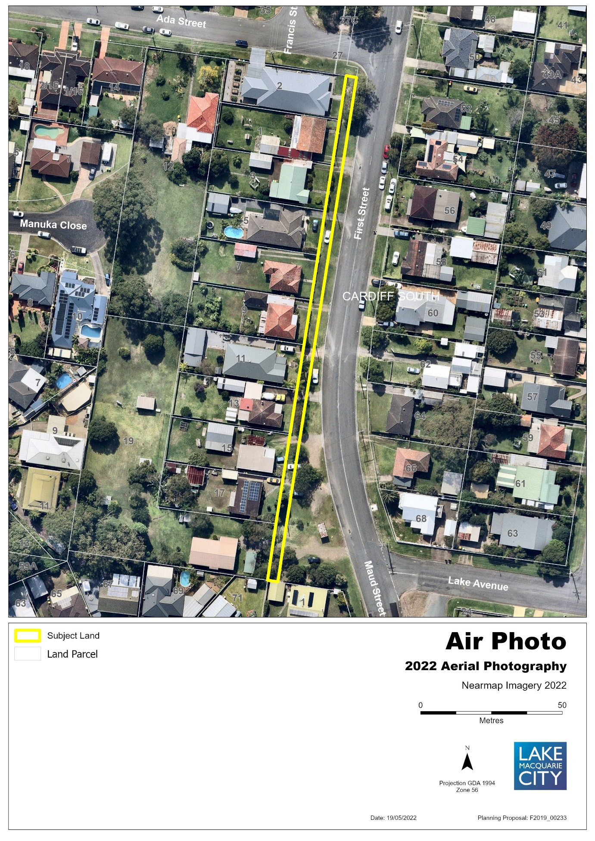
Figure 2 – Existing Zone under LMLEP 2014
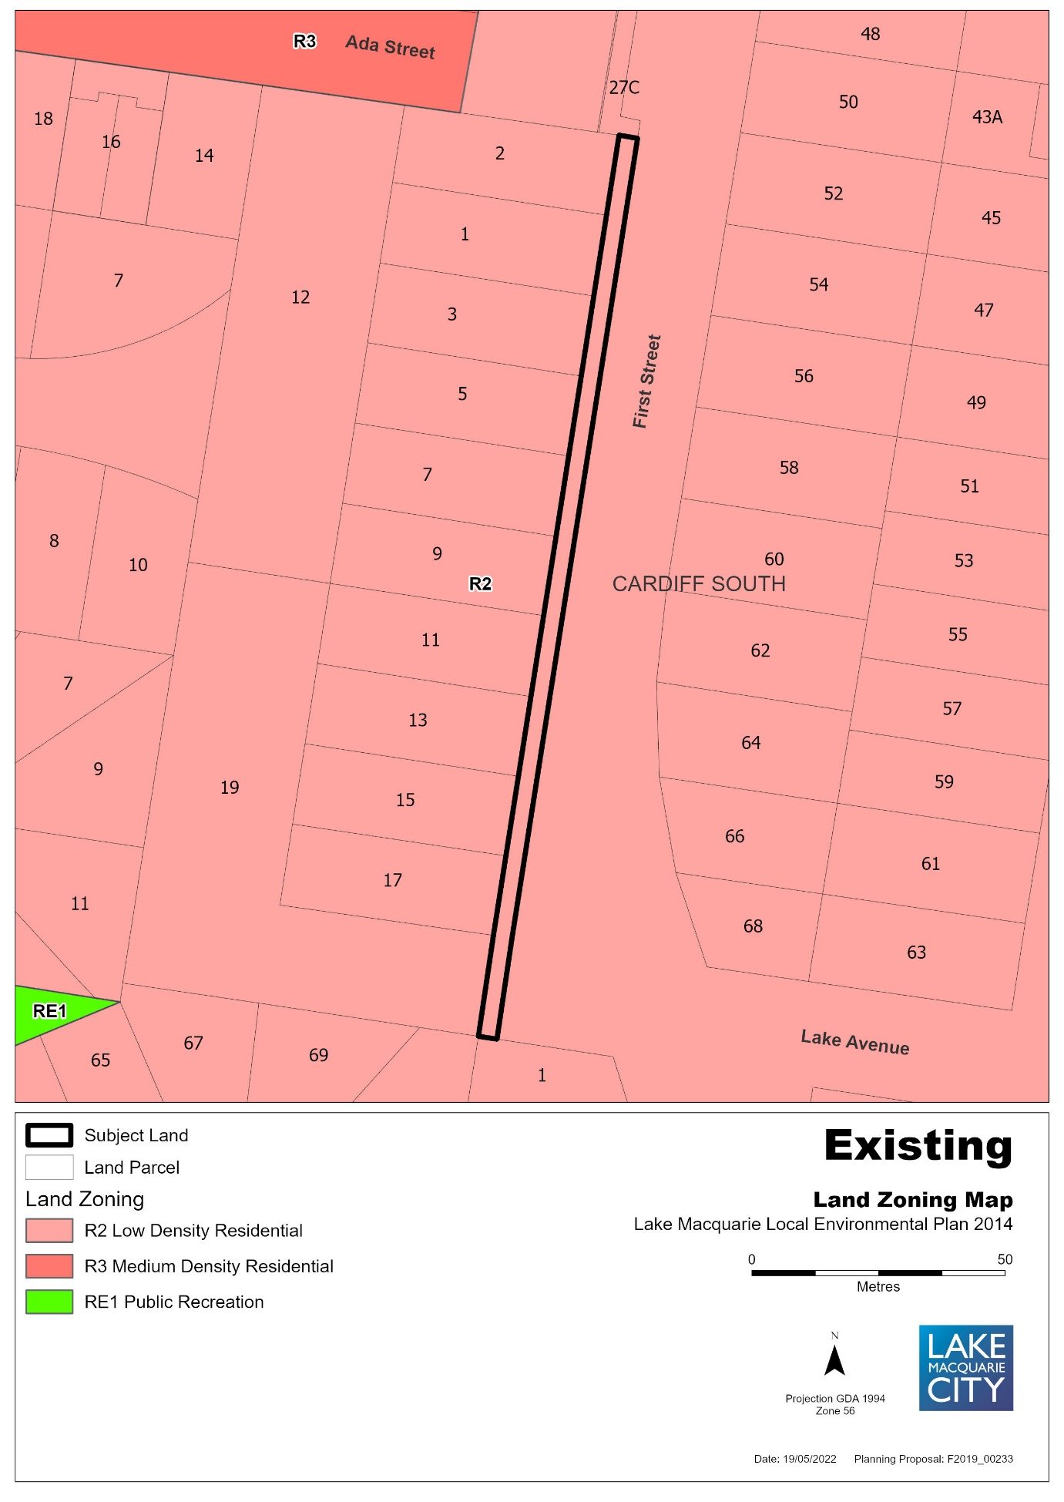

Figure 3 – Draft Land Reclassification Map under LMLEP 2014
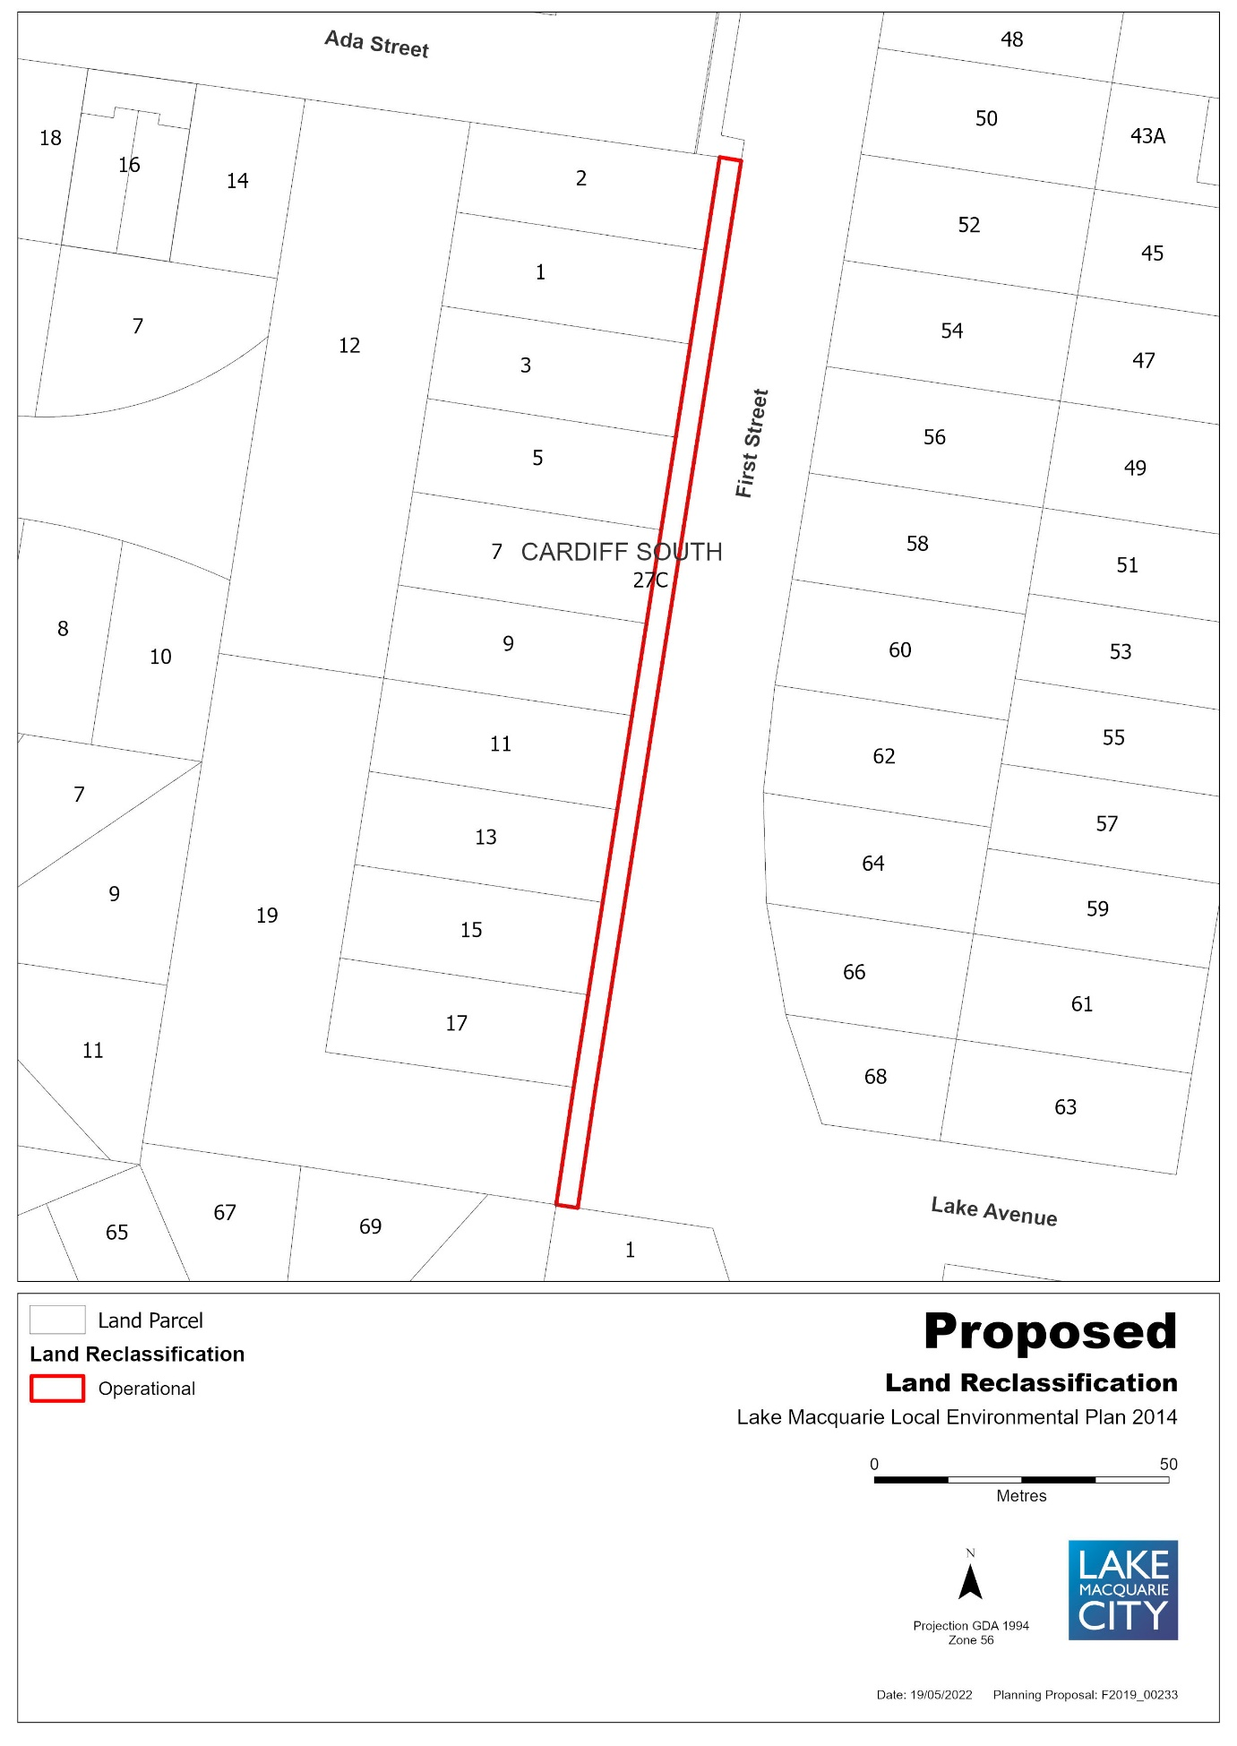

ITEM 3: 27 First Street, Cardiff South, Lot 1 DP 190522 & 27C First Street, Cardiff South, Lot 30 DP 196, North of Ada Street
Figure 1 – Aerial Map
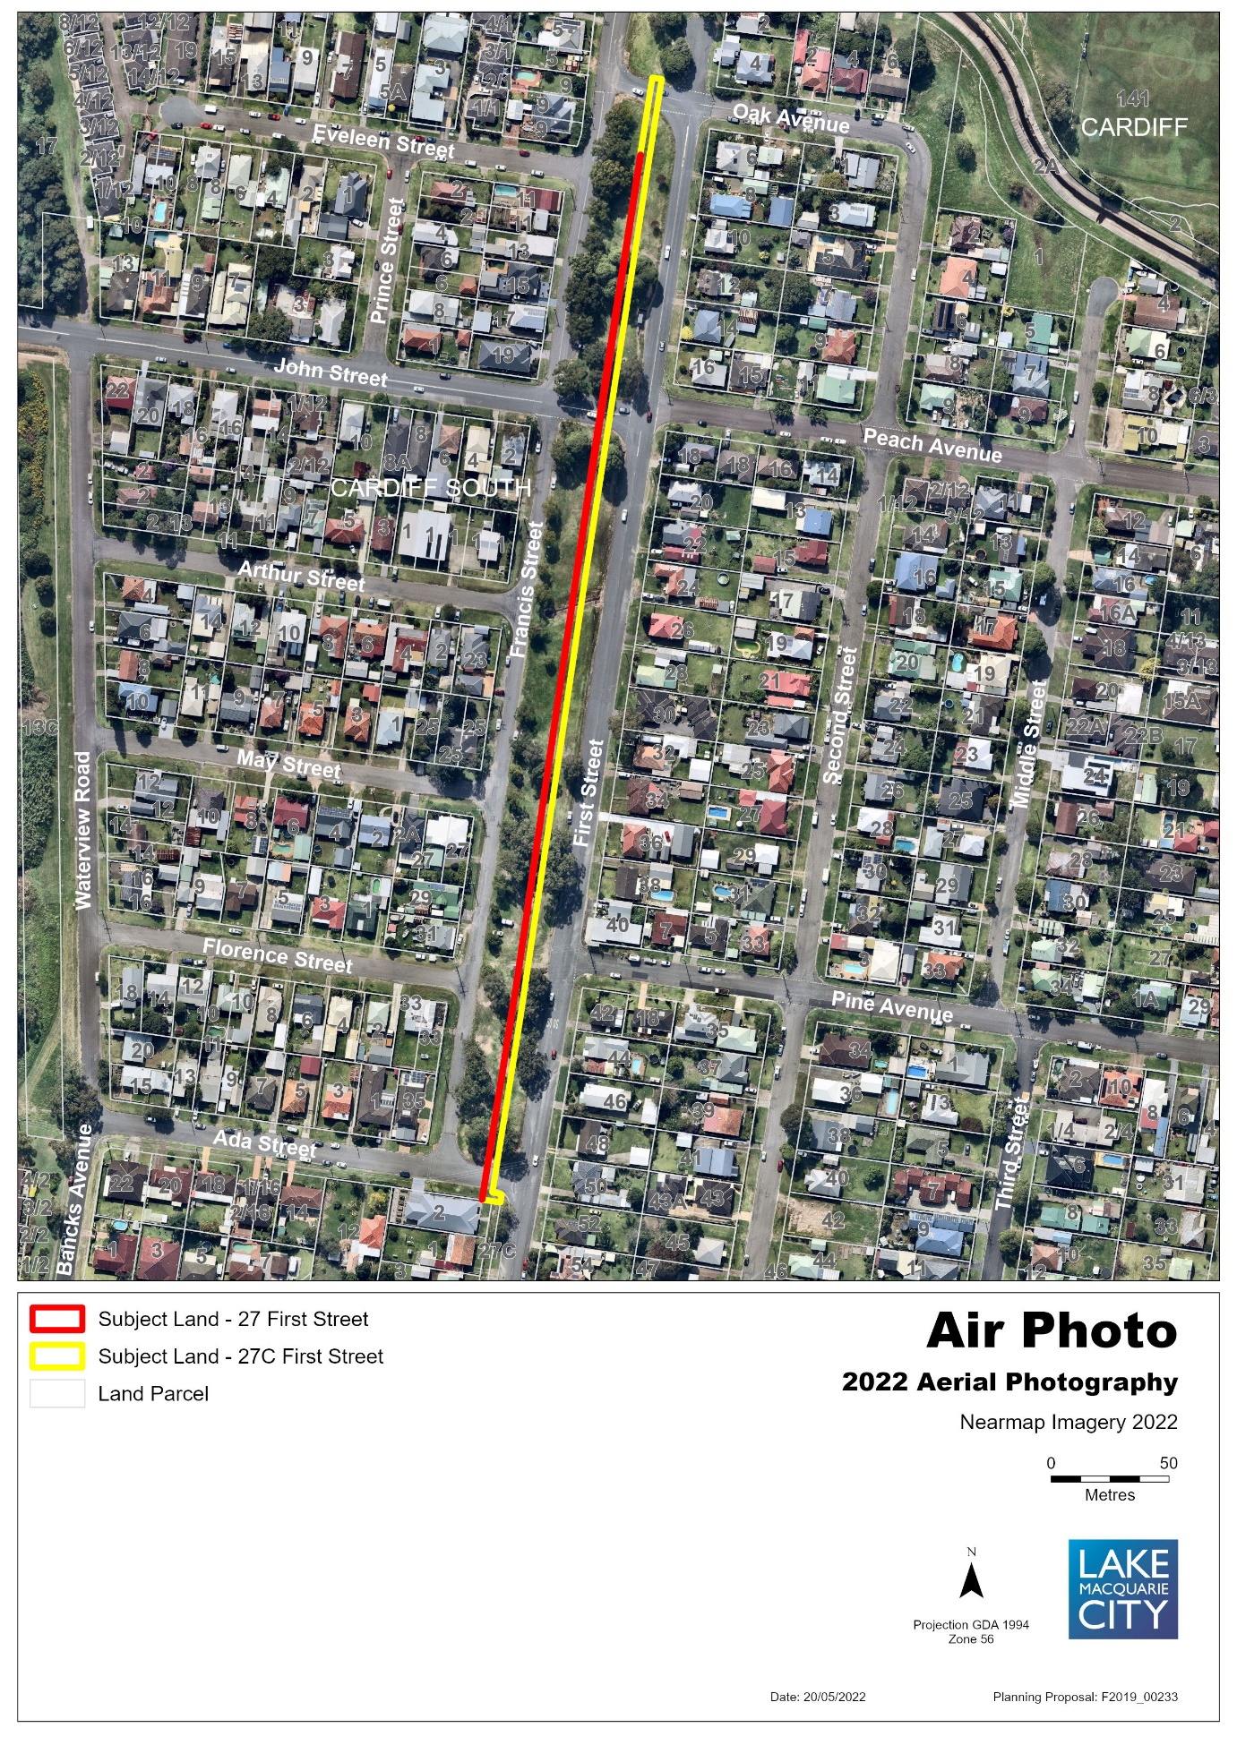
Figure 2 – Existing Zone under LMLEP 2014
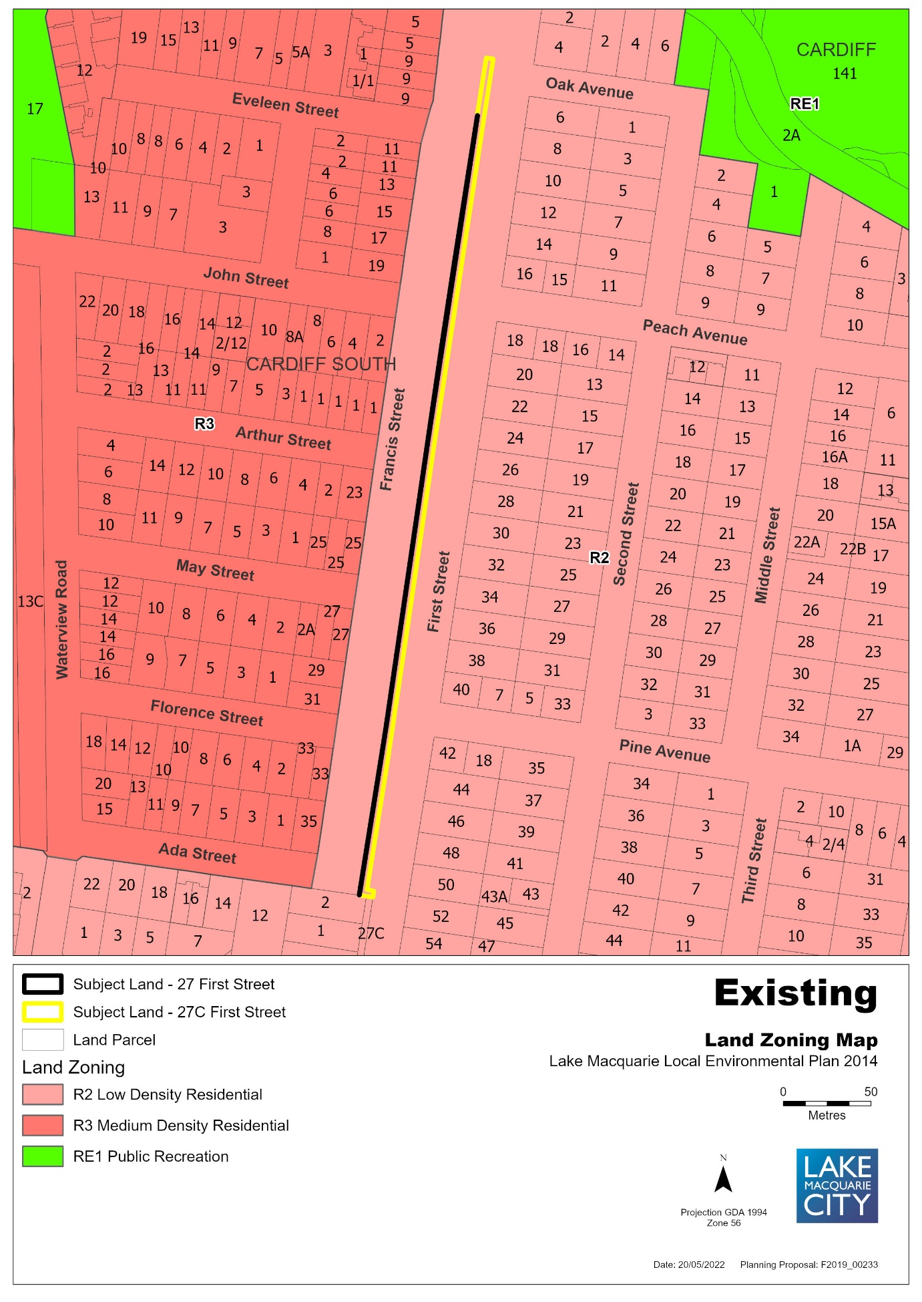

Figure 3 – Proposed Zone under LMLEP 2014
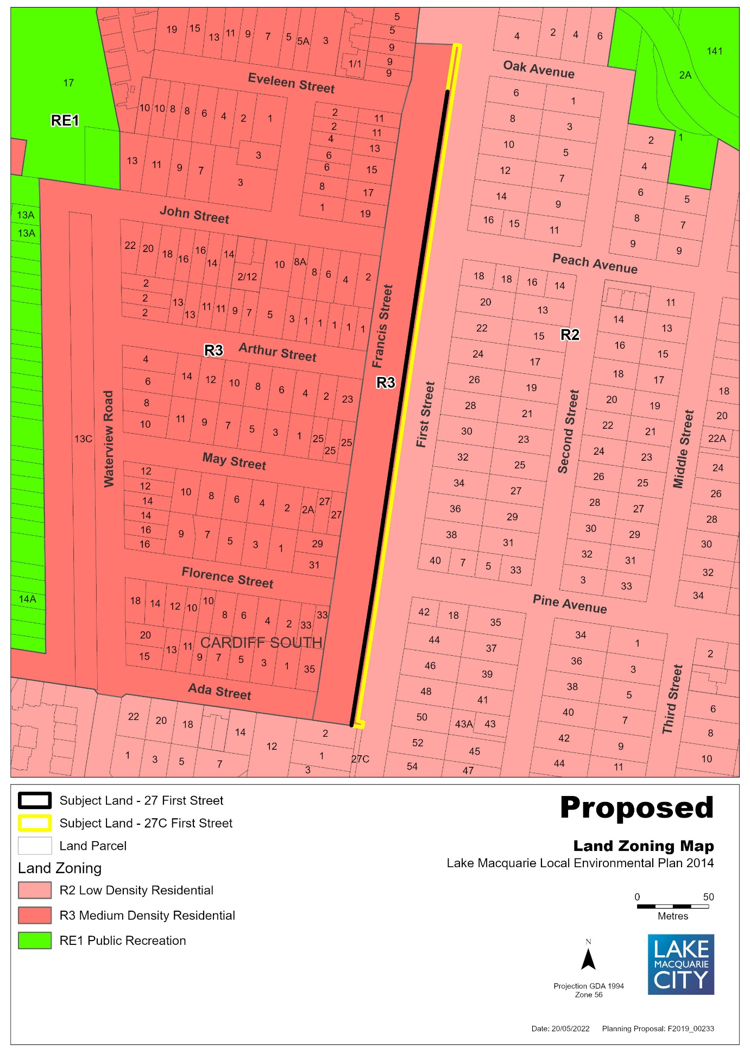

Figure 4 – Existing Lot Size Map
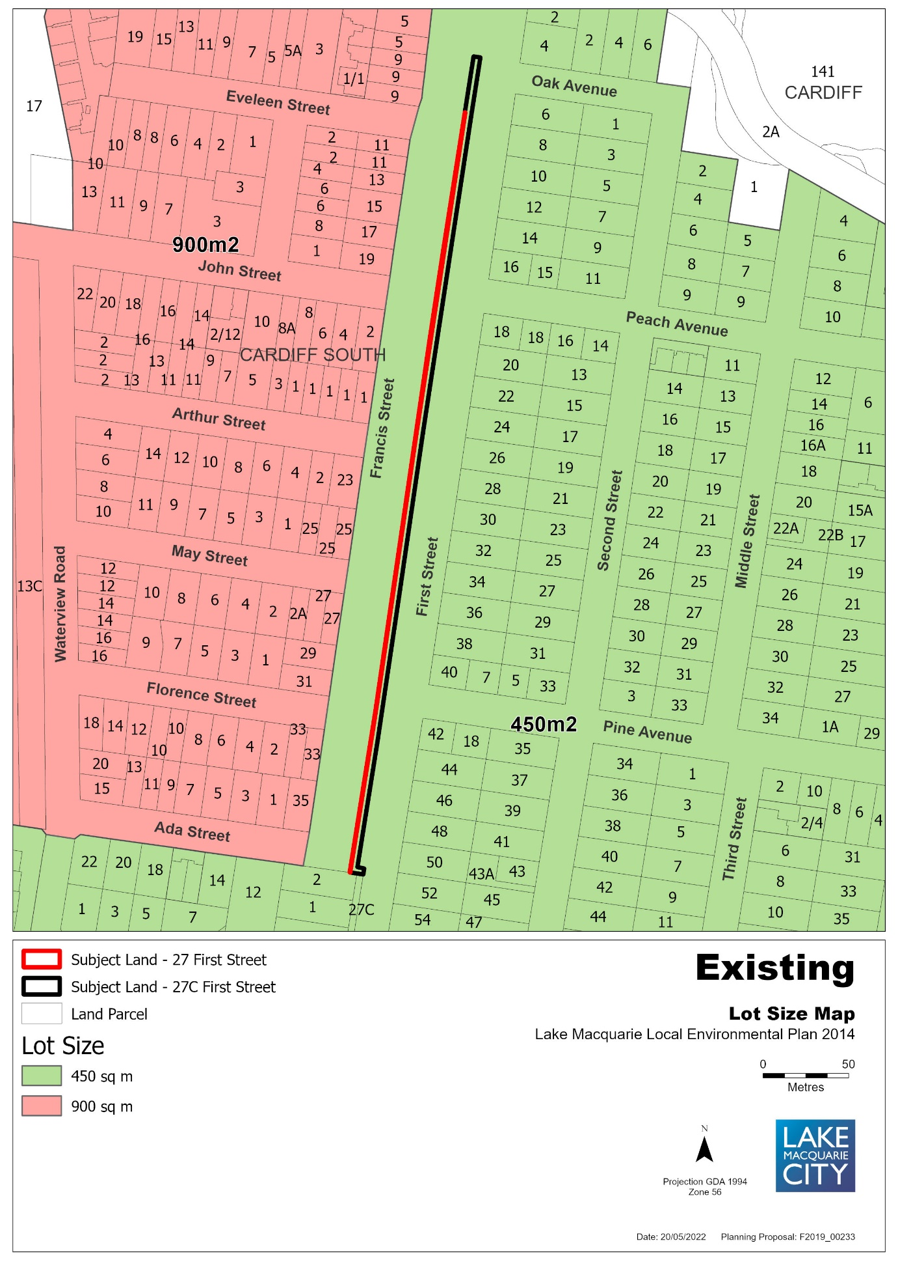

Figure 5 – Proposed Lot Size Map
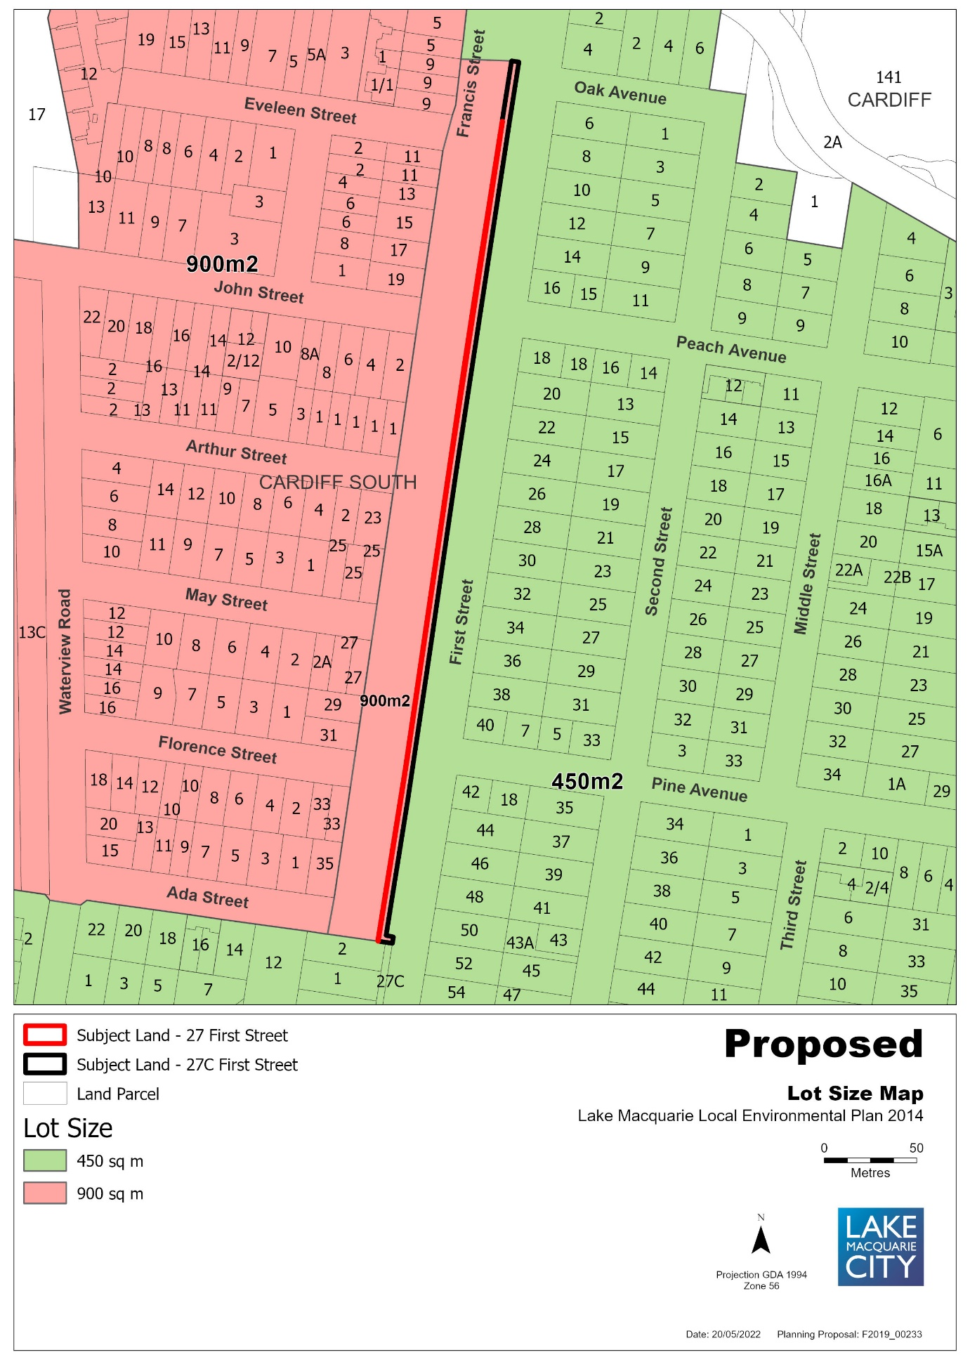

Figure 6 – Existing Height of Buildings Map
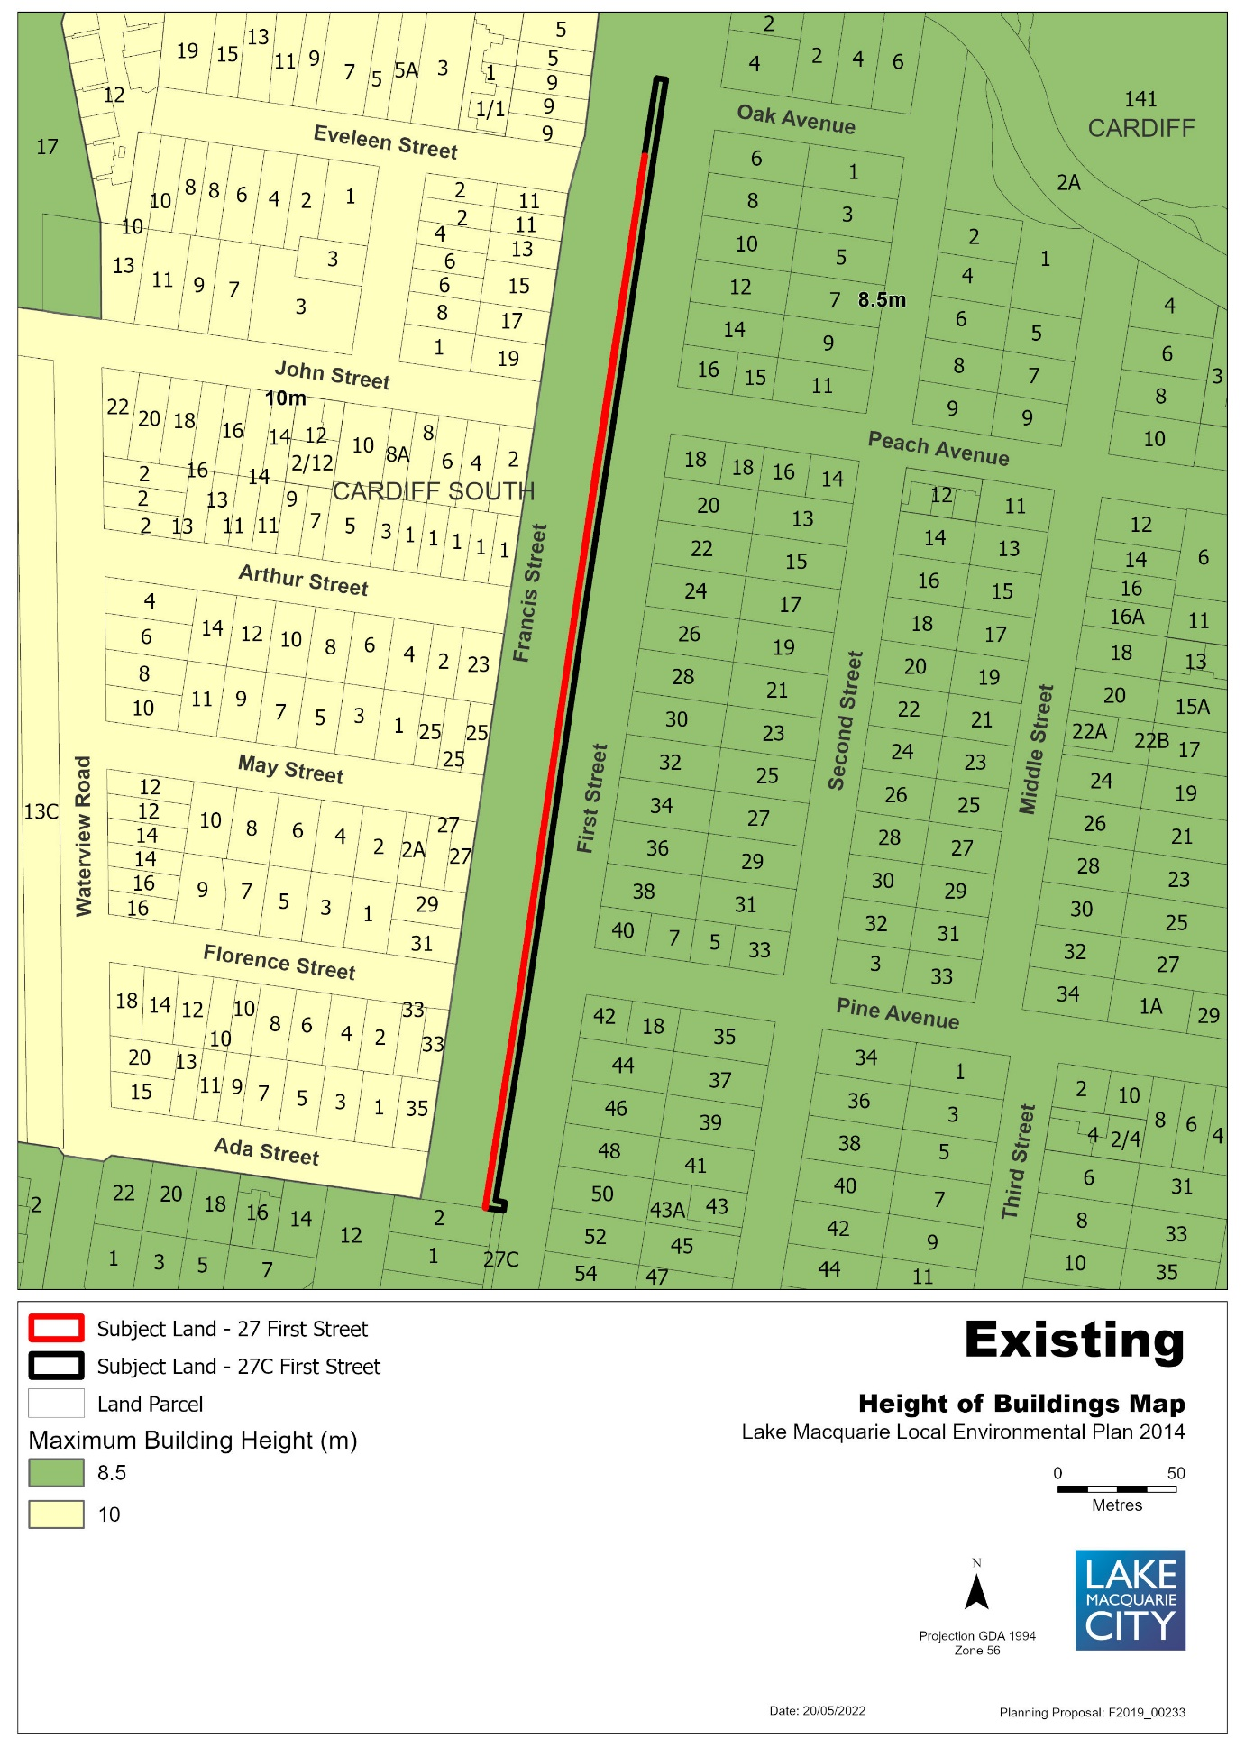

Figure 7 – Proposed Height of Buildings Map
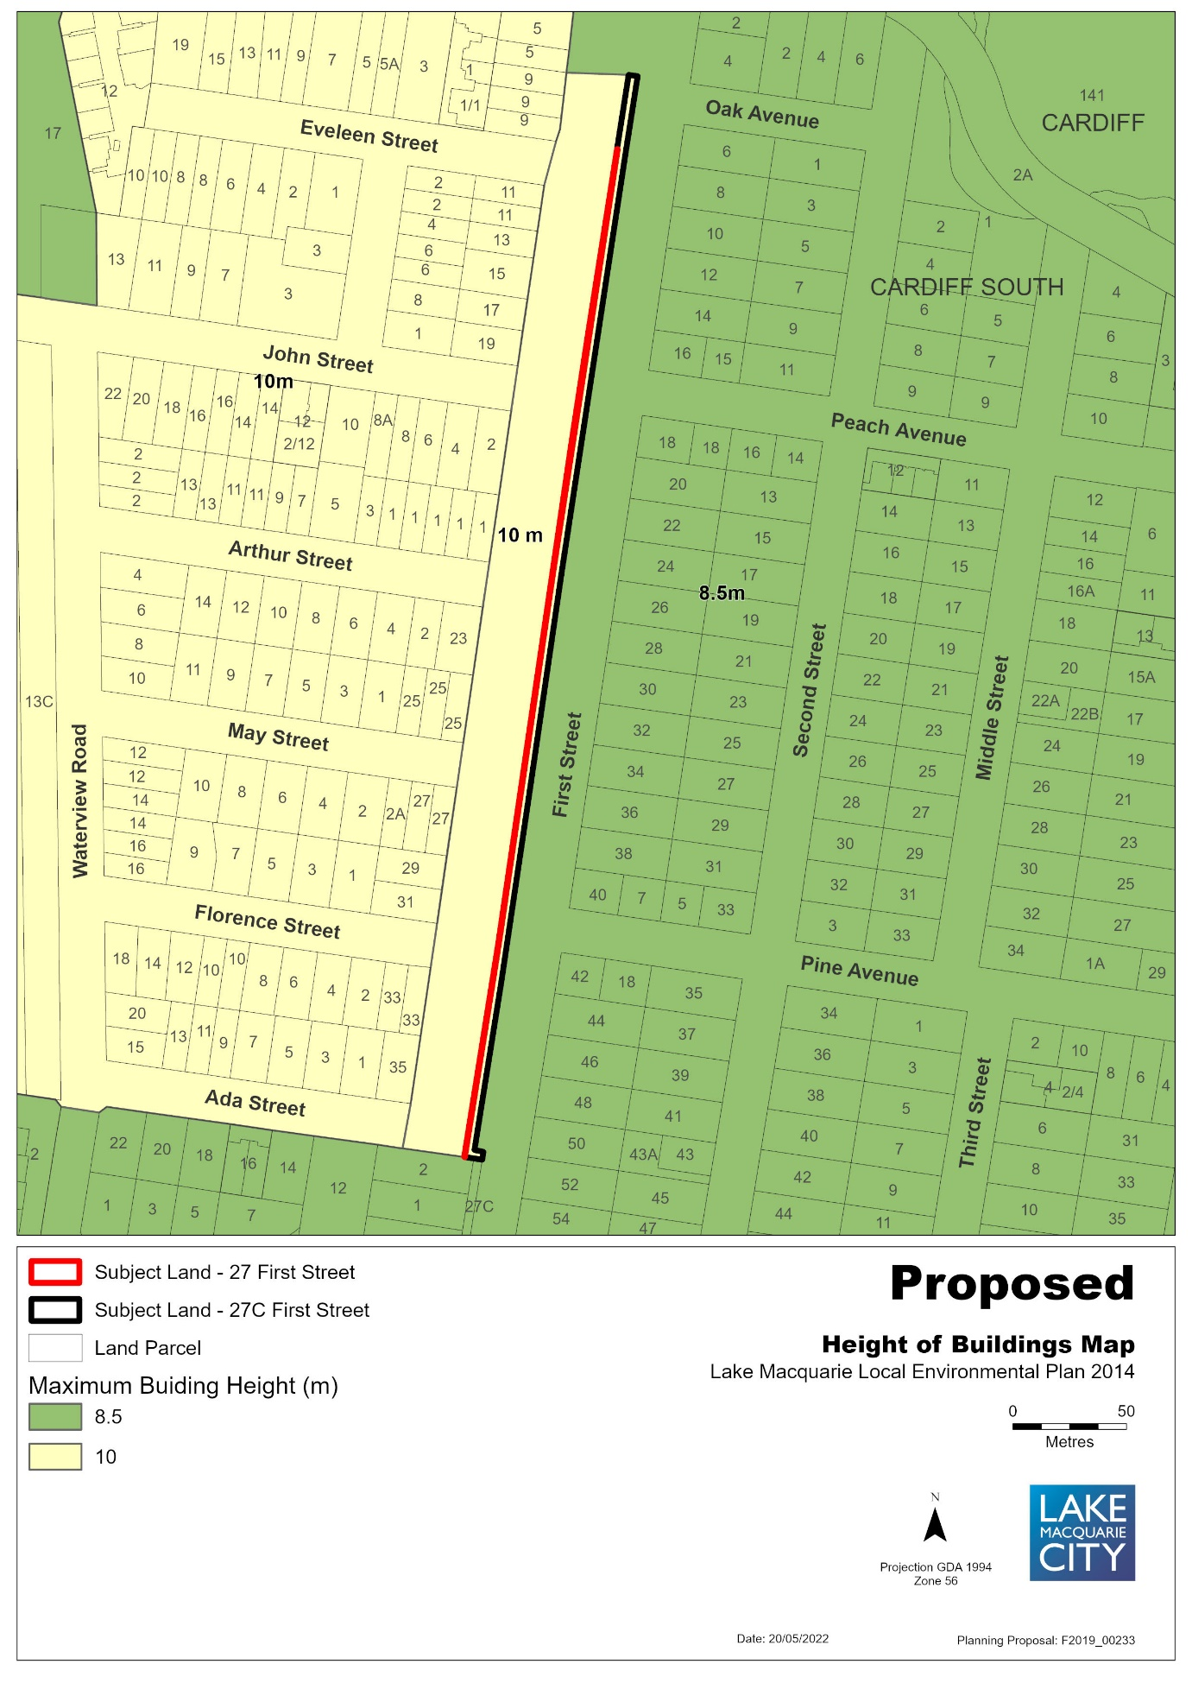

Figure 8 – Draft Land Reclassification Map under LMLEP 2014
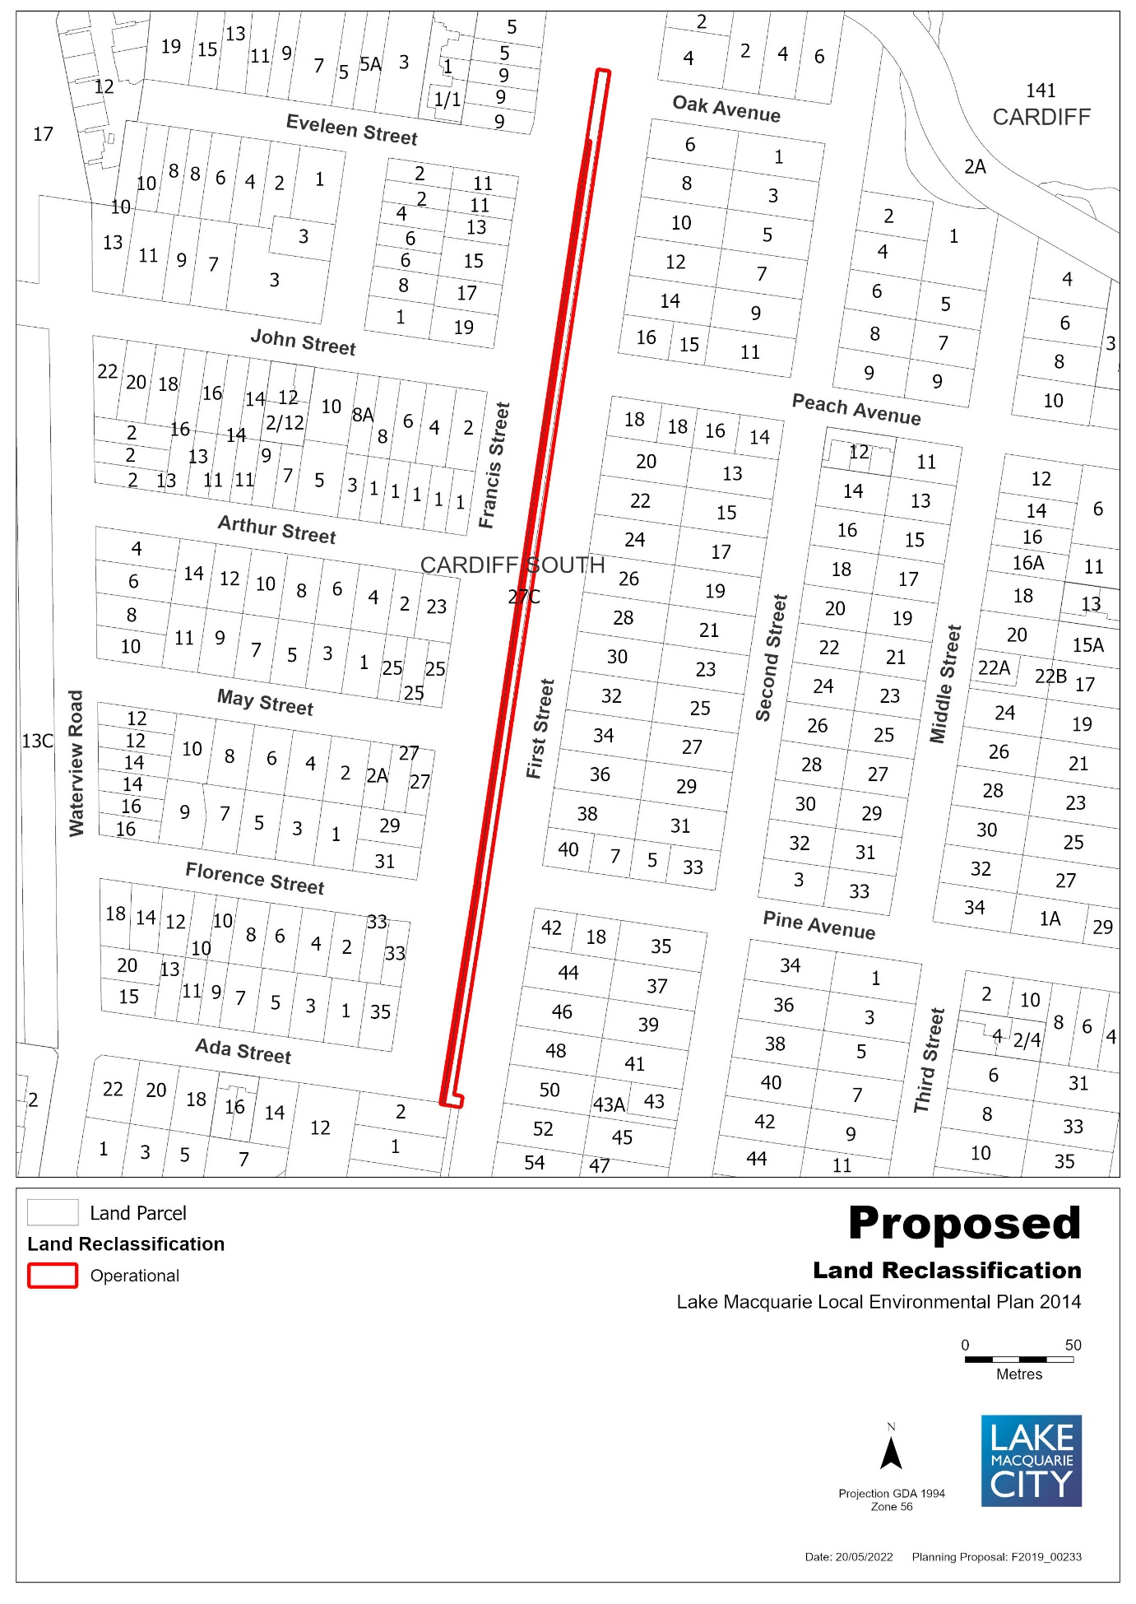

ITEM 4: 21 Narara Road, Cooranbong, Lots 4, 5, 6 & 7 Section O DP 724
Figure 1 – Aerial Map
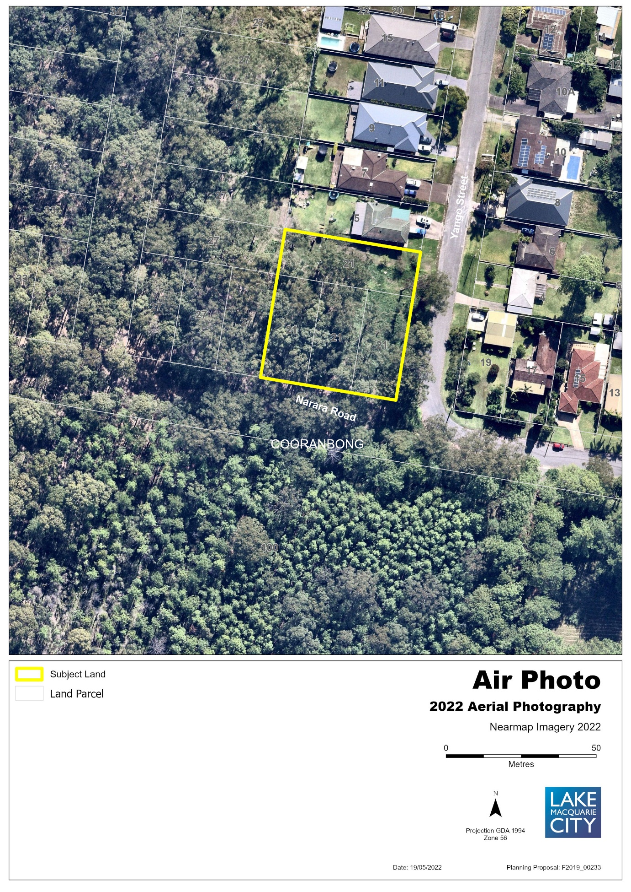

Figure 2 – Existing Zone under LMLEP 2014
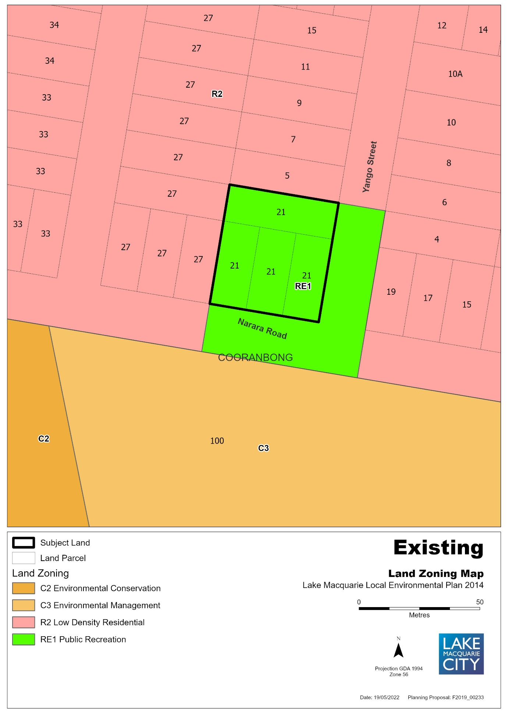

Figure 3 – Proposed Land Zoning Map
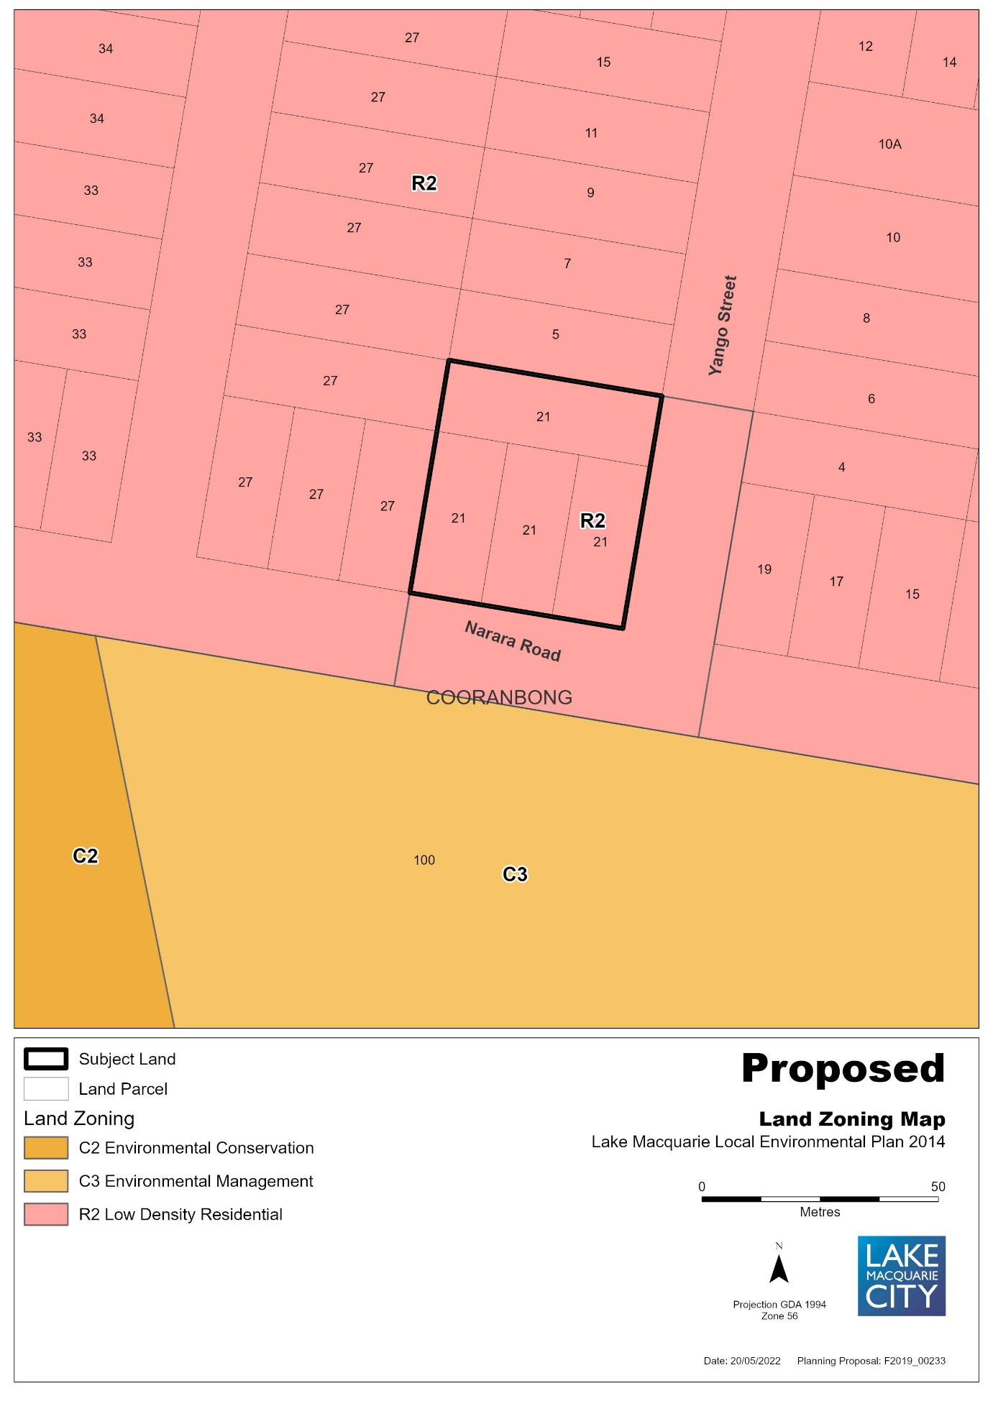

Figure 4 – Existing Lot Size Map
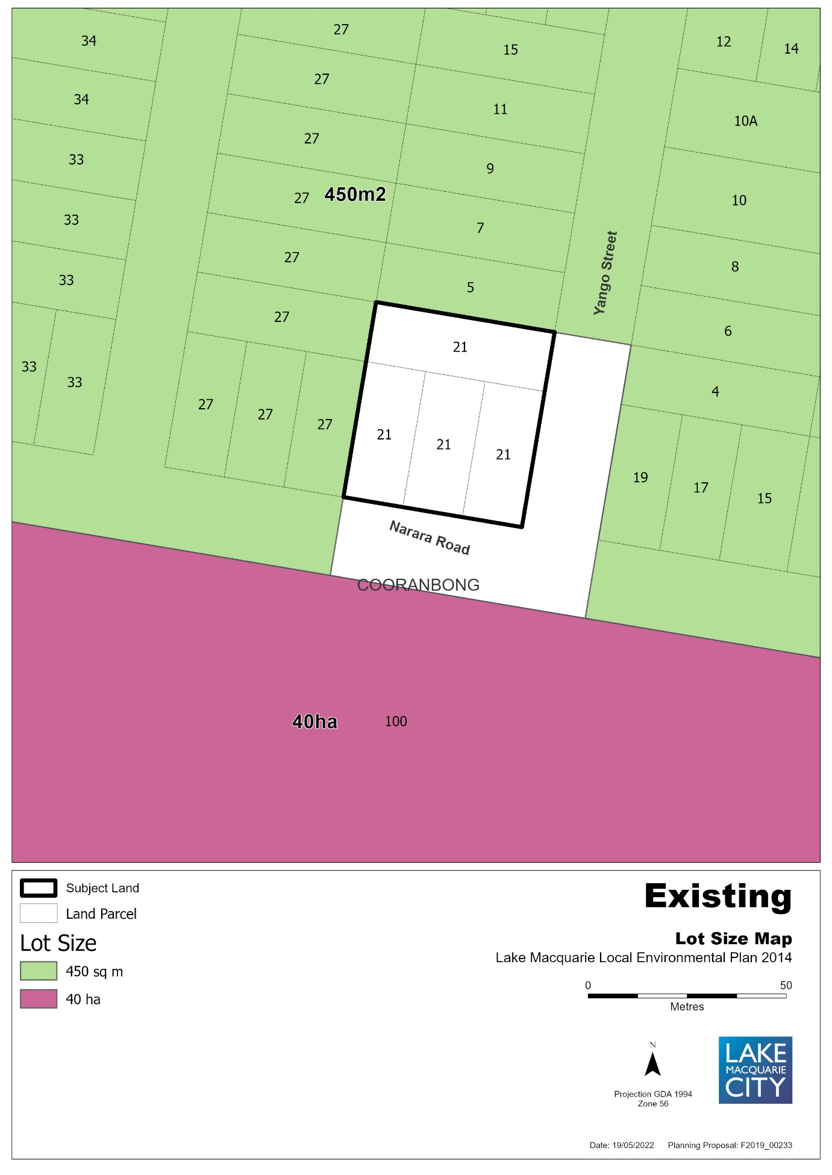

Figure 5 – Proposed Lot Size Map
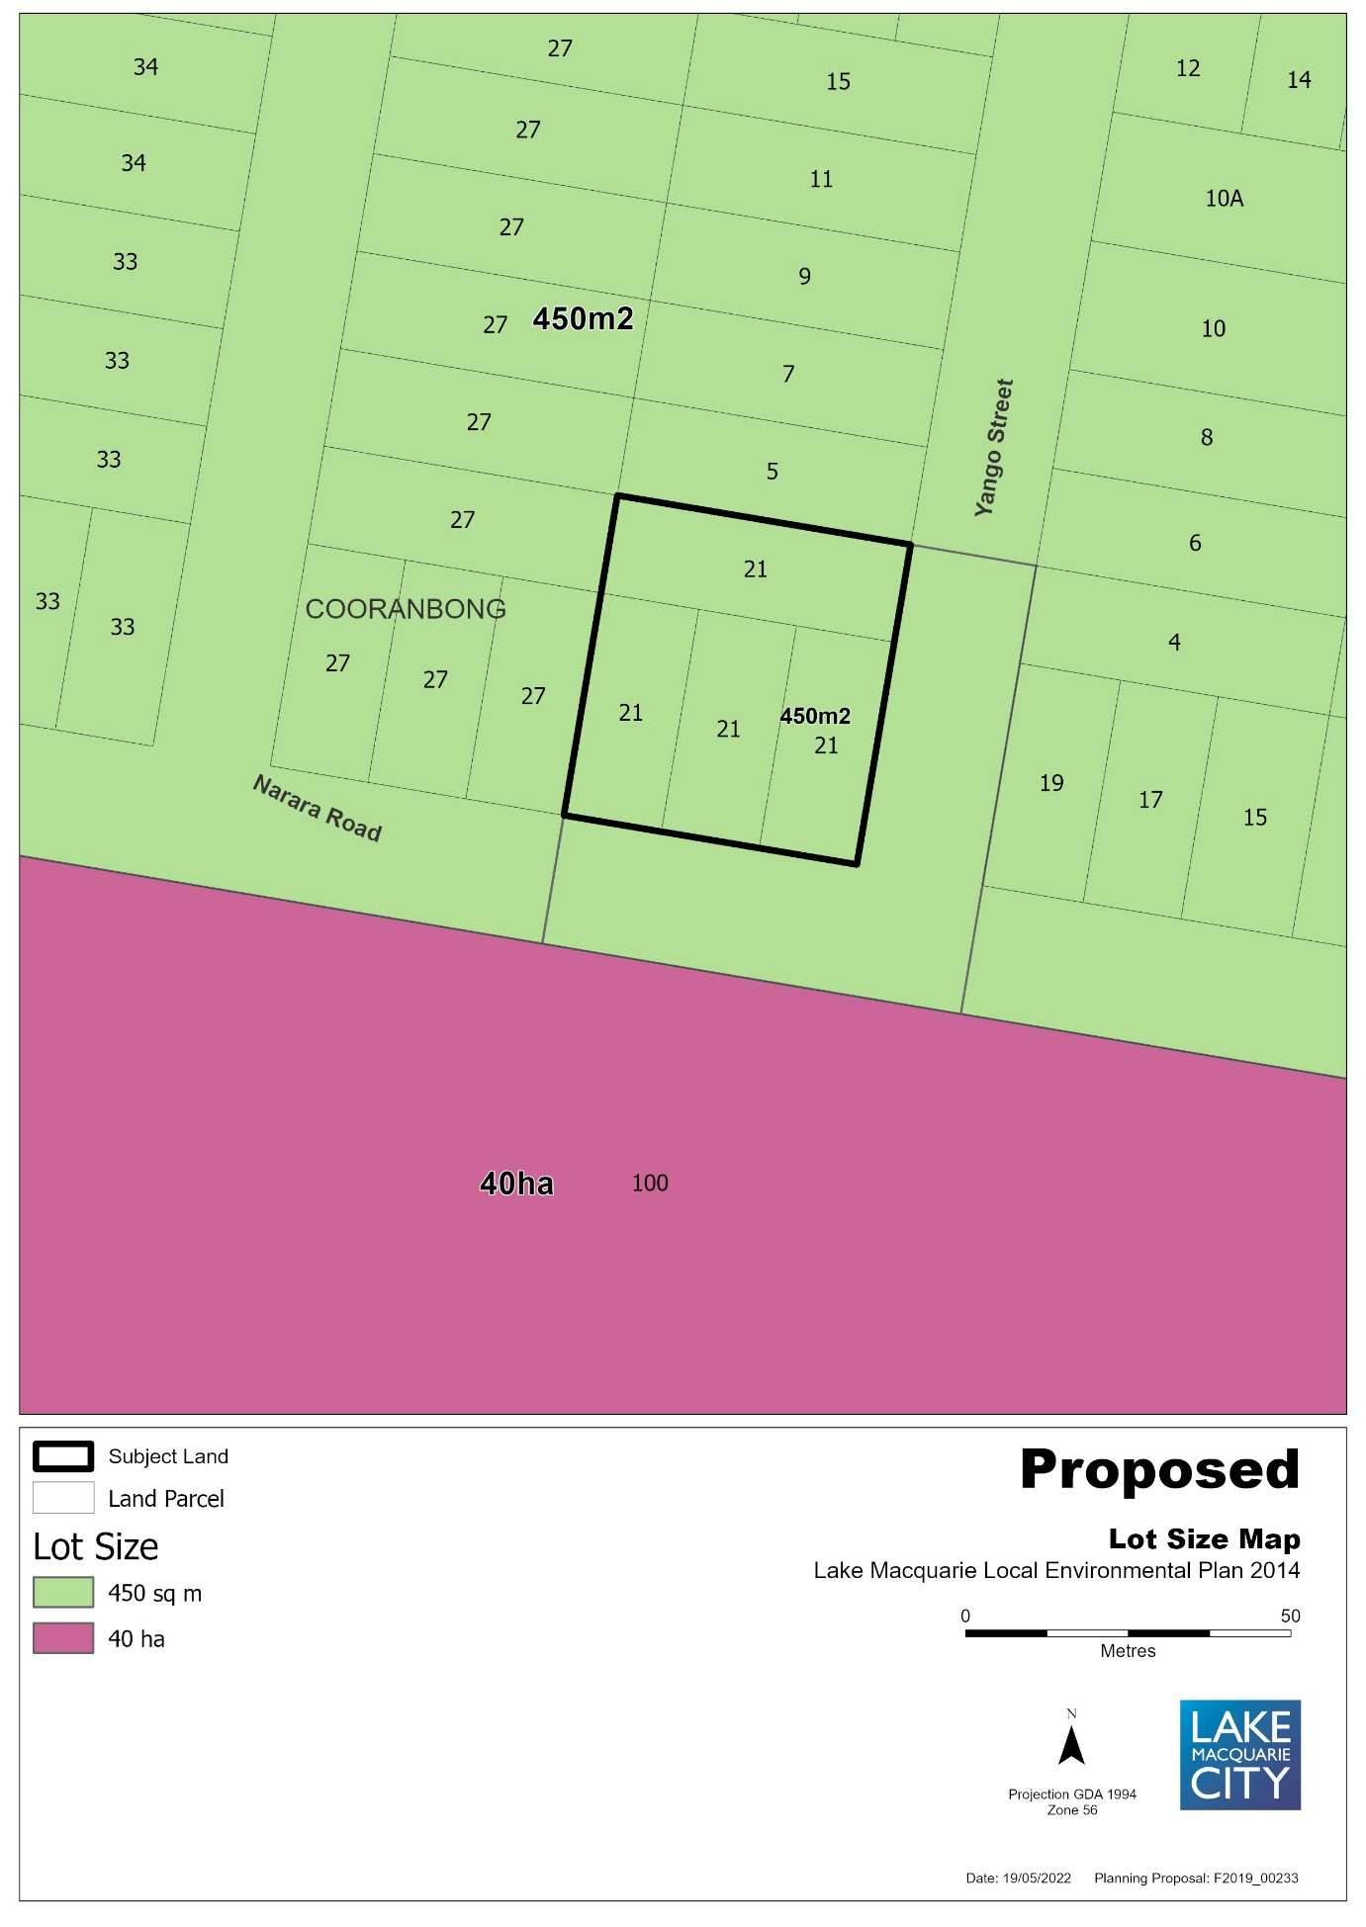

Figure 6 – Draft Land Reclassification Map under LMLEP 2014
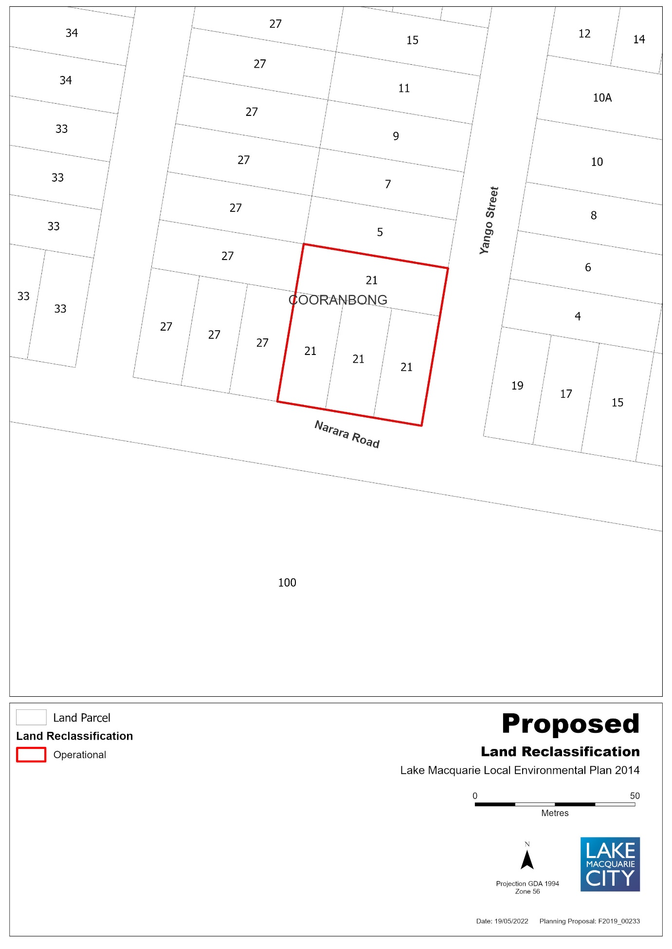

ITEM 5: 48 Oakdale Road, Gateshead, Lot 20 DP 1115790
Figure 1 – Aerial Map
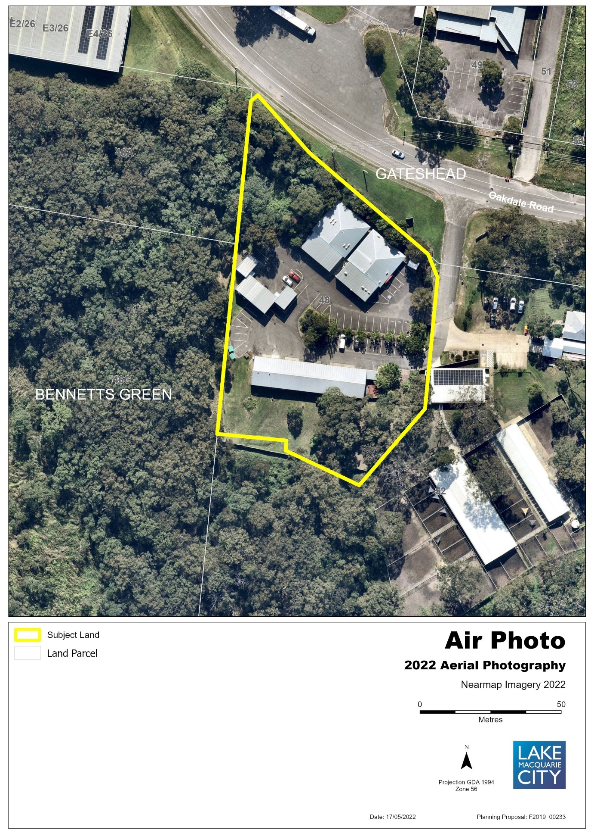

Figure 2 – Existing Zone under LMLEP 2014
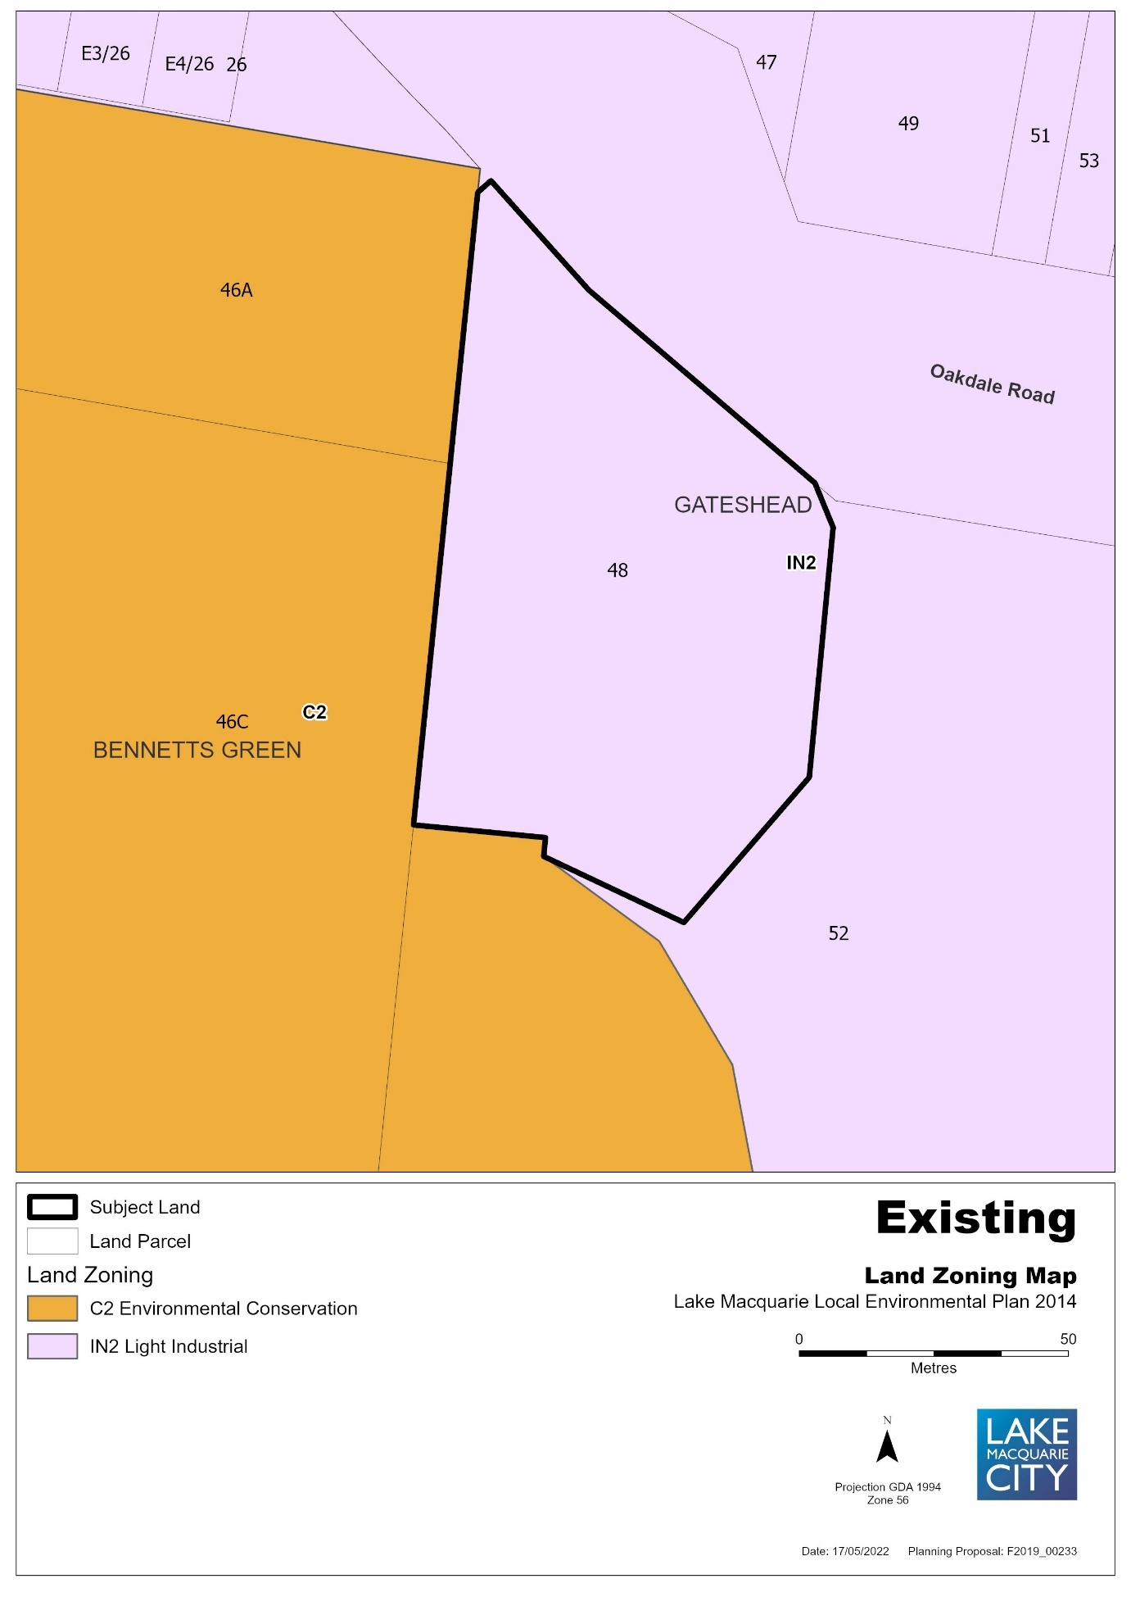

Figure 3 – Draft Land Reclassification Map under LMLEP 2014
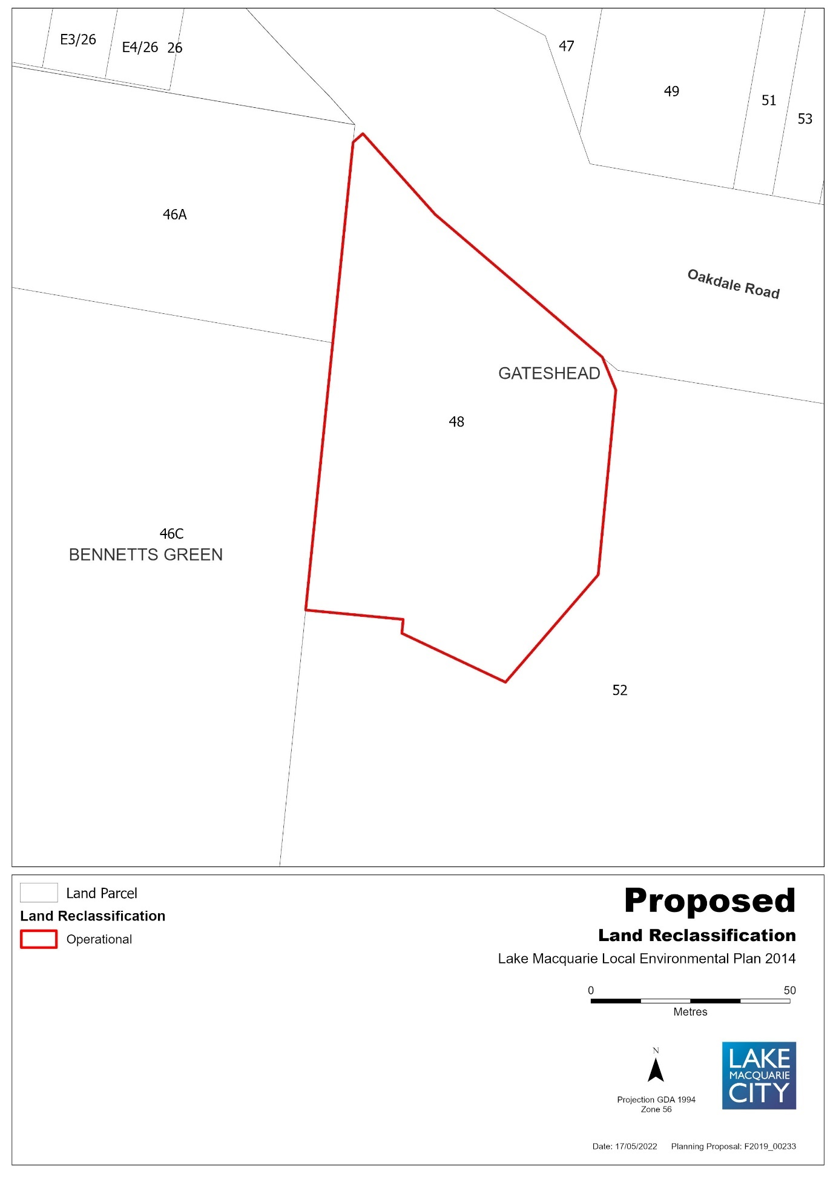

ITEM 6: 4a Clare Street, Glendale, Lot 103 DP 553828
Figure 1 – Aerial Map
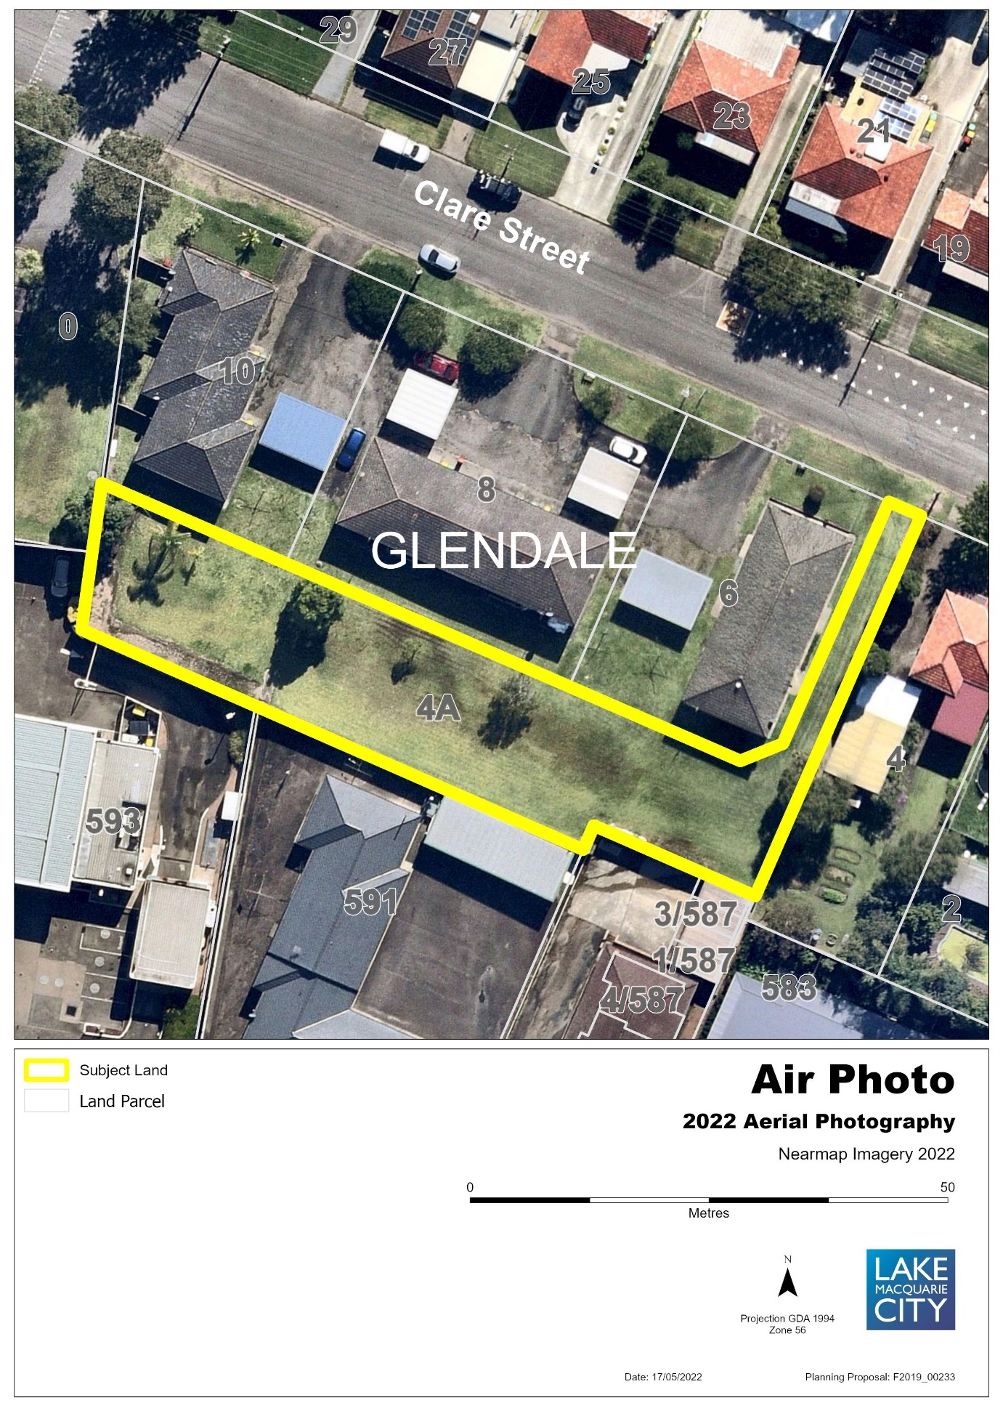

Figure 2 – Existing Zone under LMLEP 2014
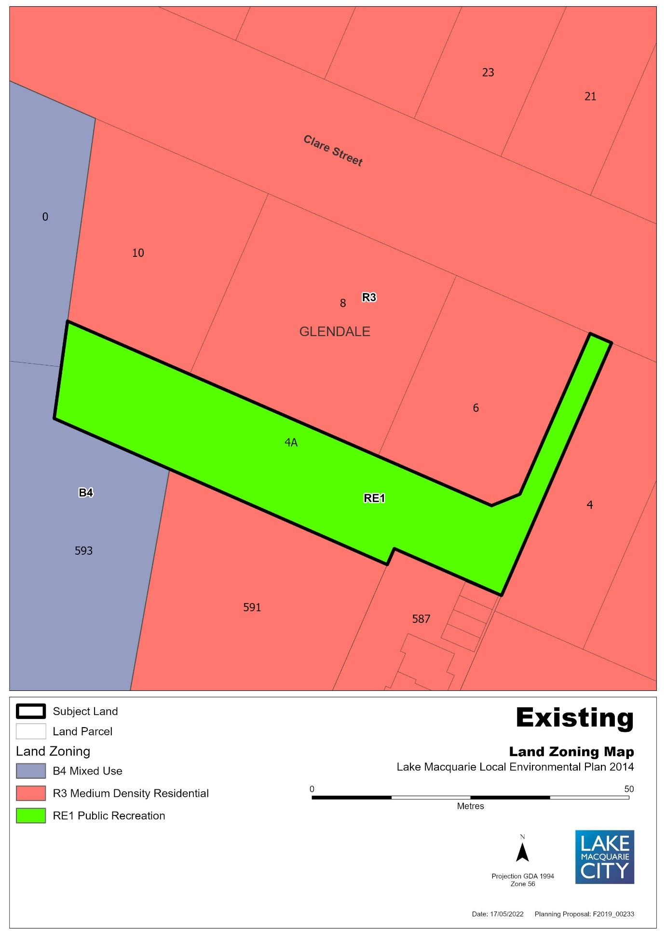

Figure 3 – Proposed Land Zoning Map
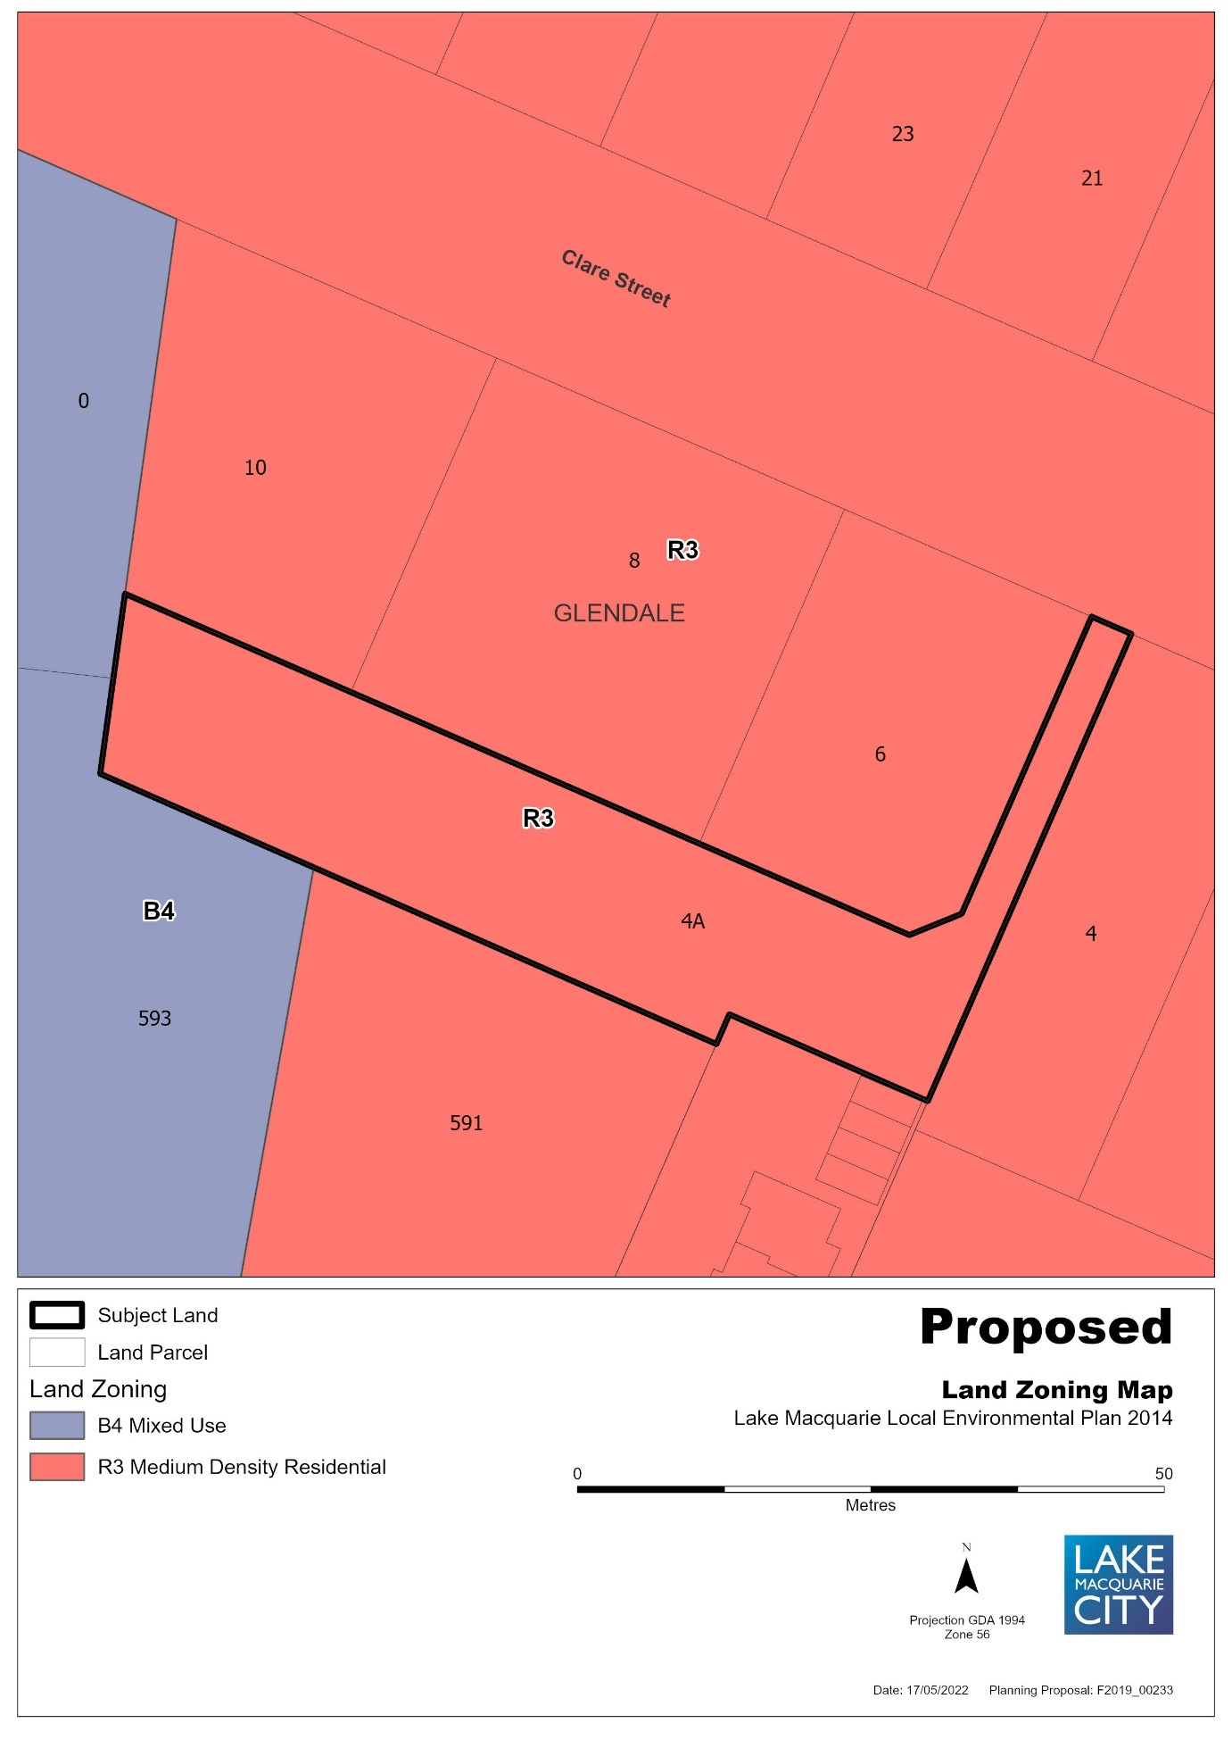

Figure 4 – Existing Lot Size Map
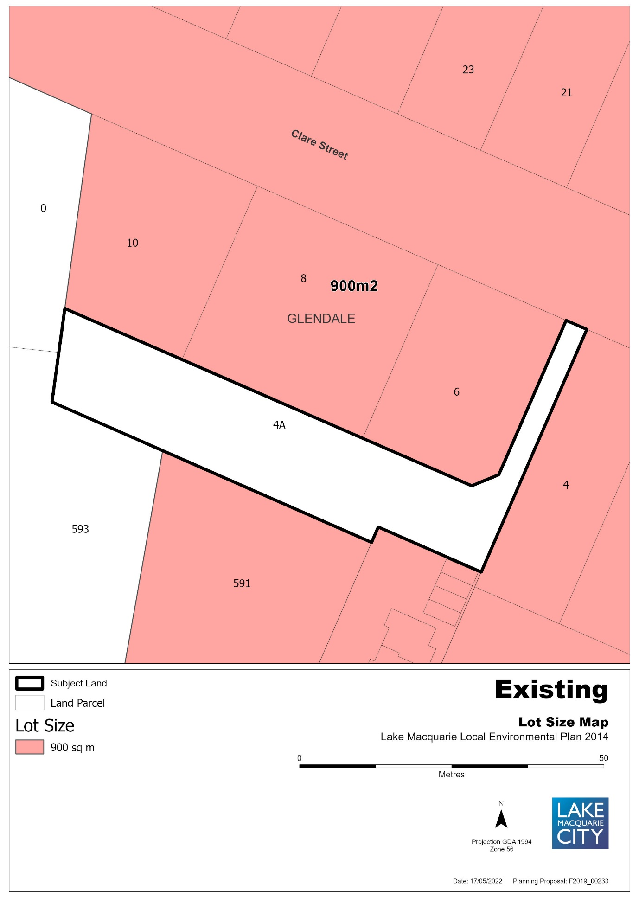

Figure 5 – Proposed Lot Size Map
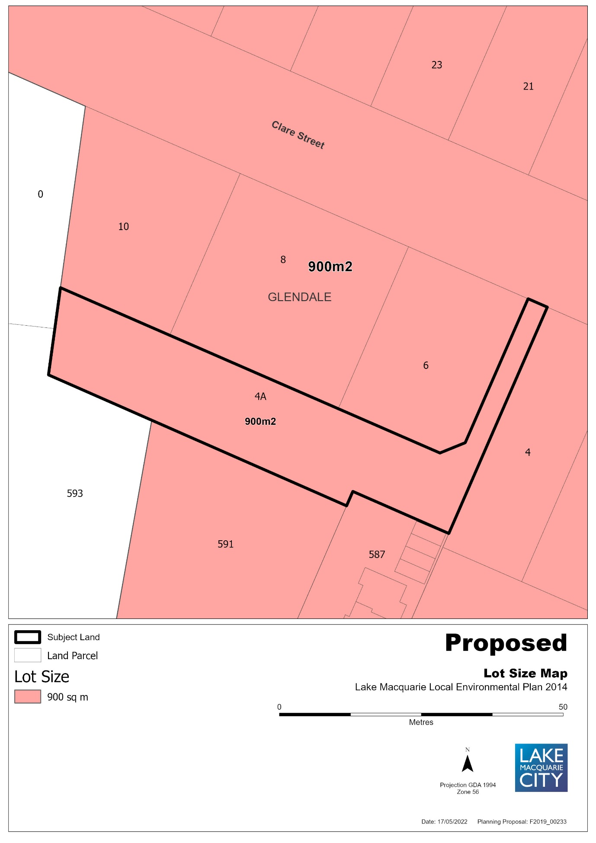

Figure 6 – Existing Height of Buildings Map
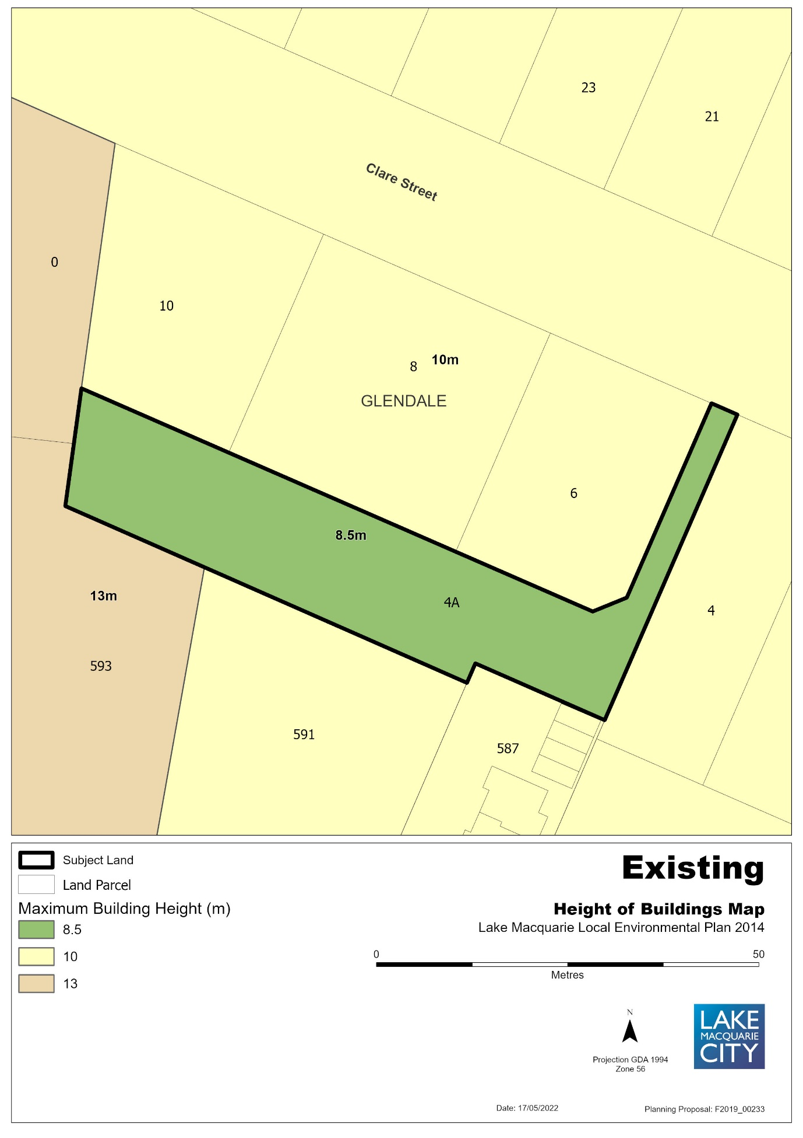

Figure 7 – Proposed Height of Buildings Map
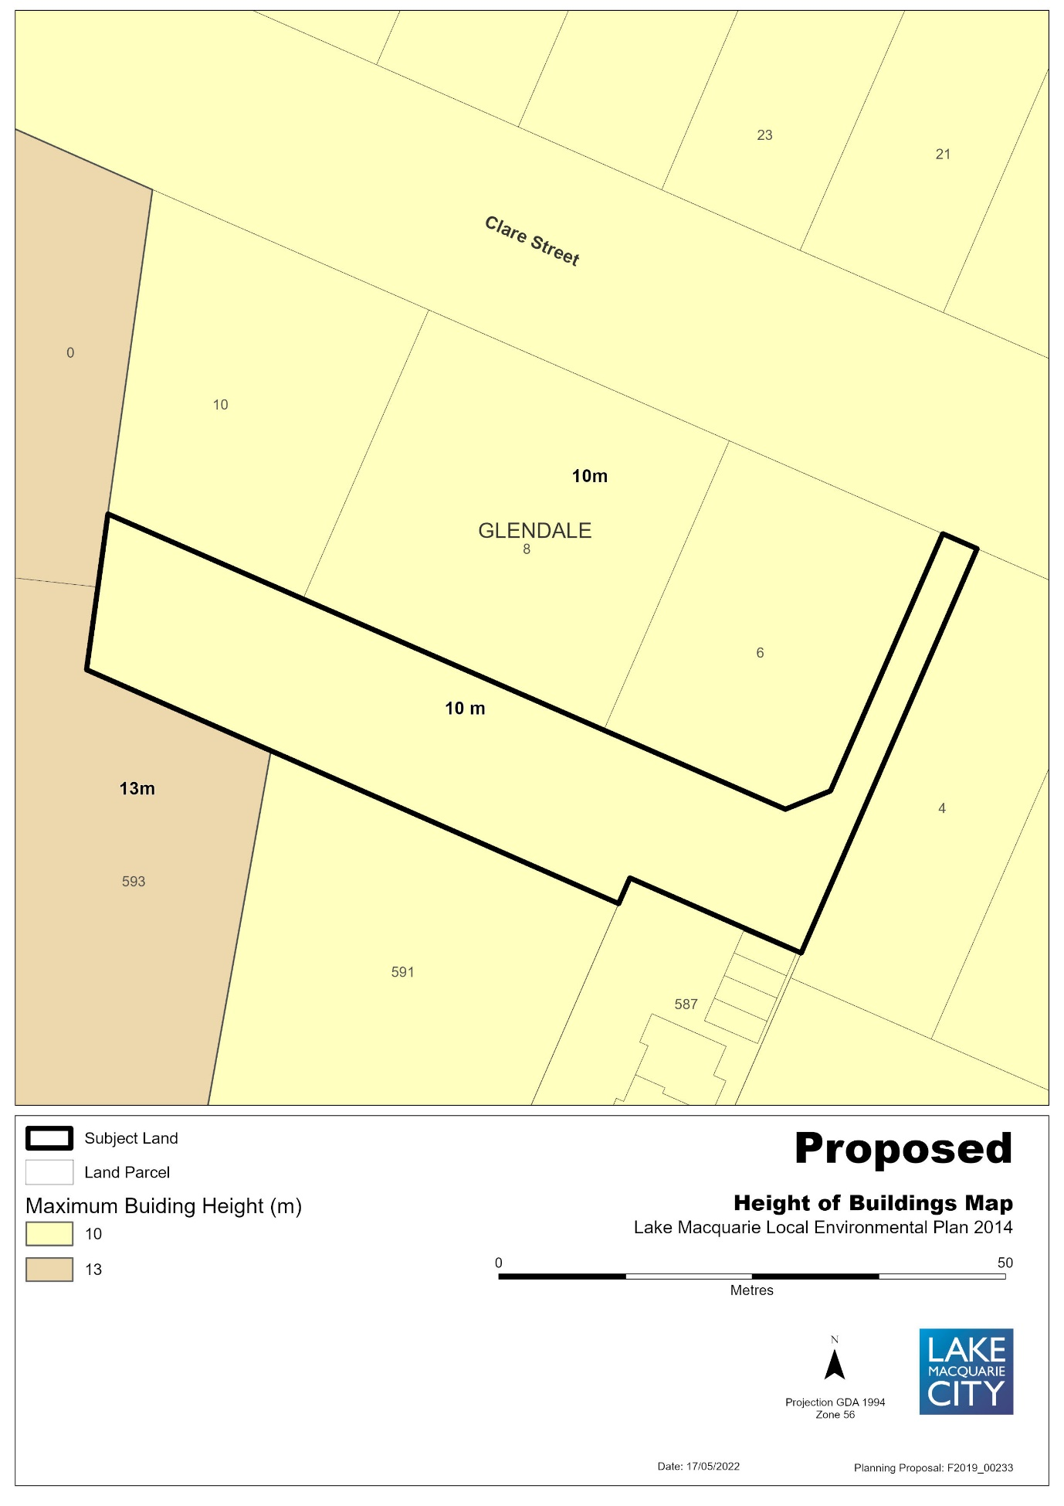

Figure 8 – Draft Land Reclassification Map under LMLEP 2014
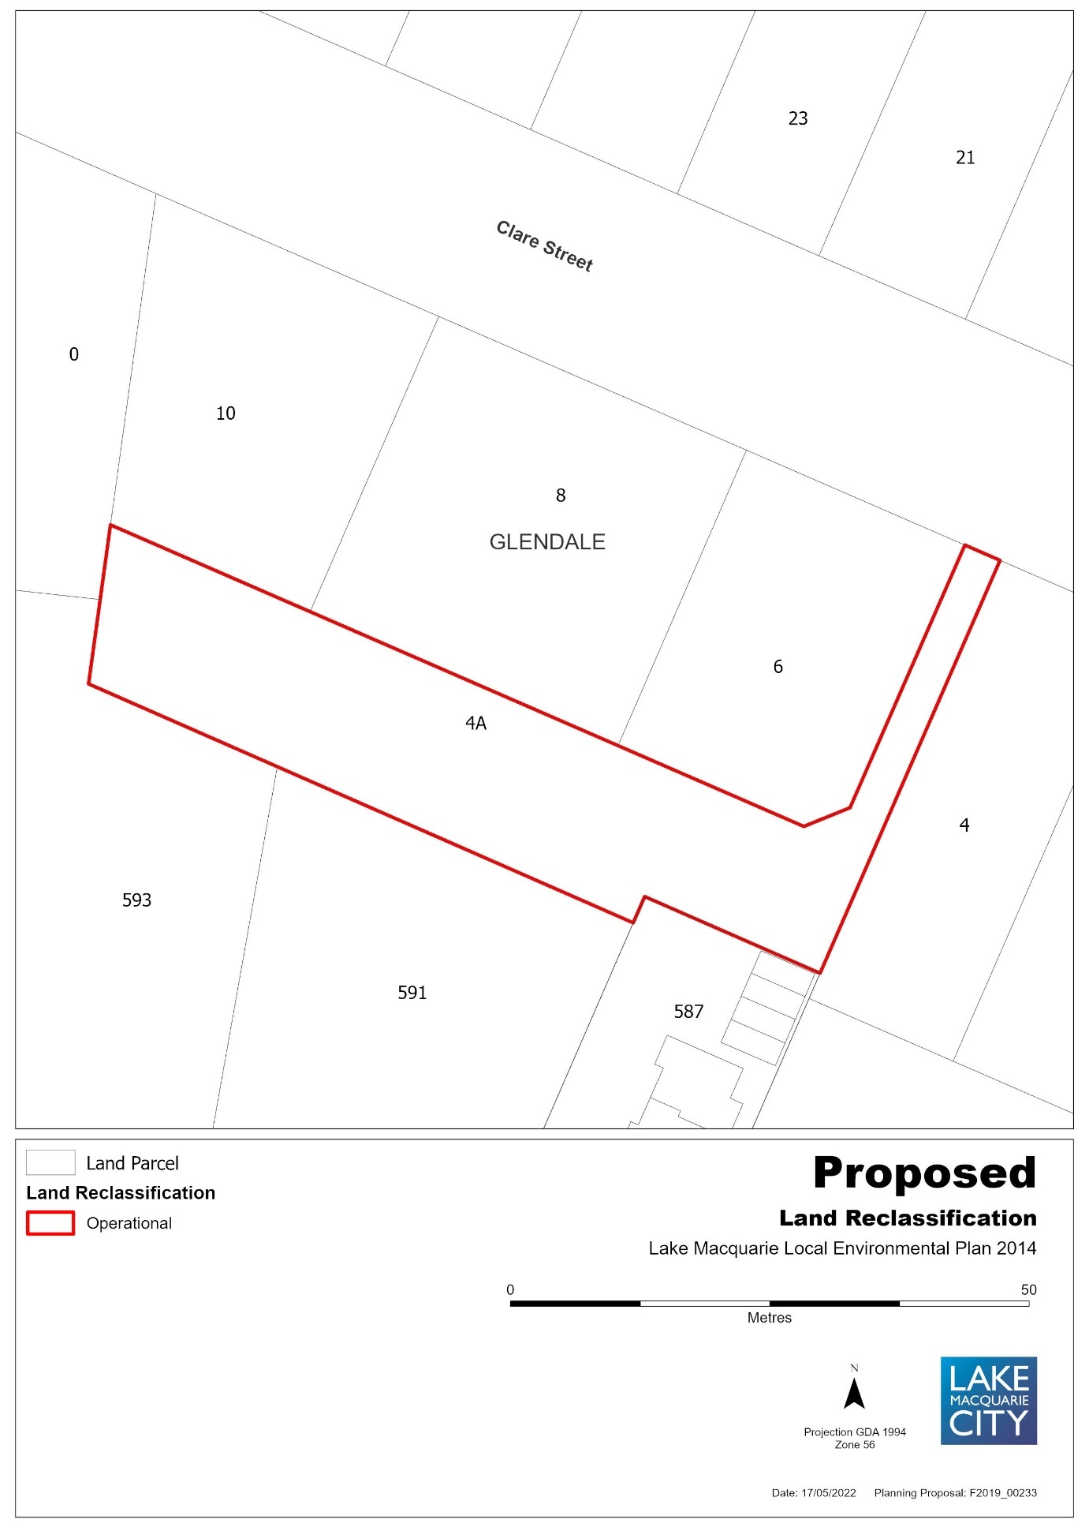

ITEM 7: 62A Graham Street, Glendale, Lot 62 DP 247342
Figure 1 – Aerial Map
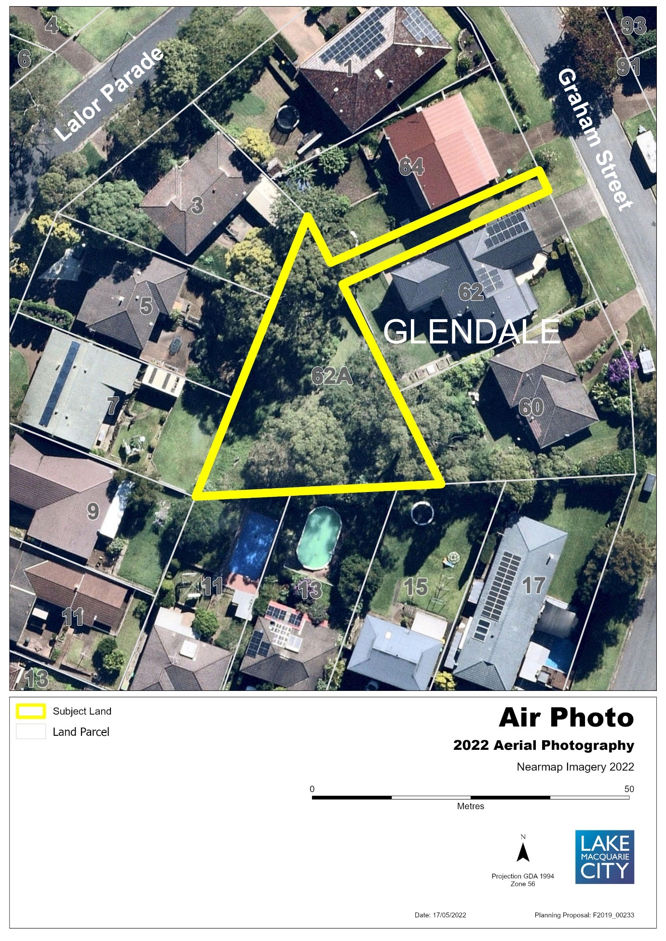

Figure 2 – Existing Zone under LMLEP 2014
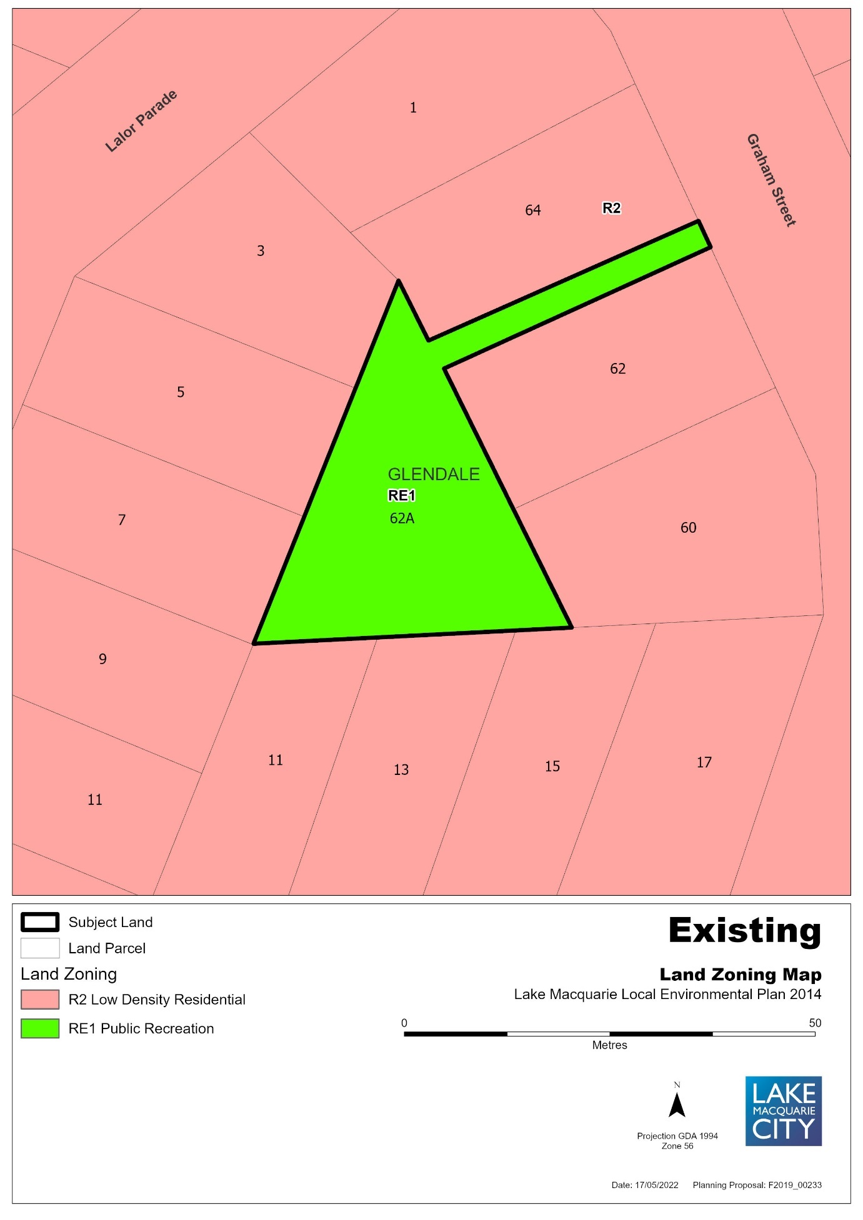

Figure 3 – Proposed Zone under LMLEP 2014
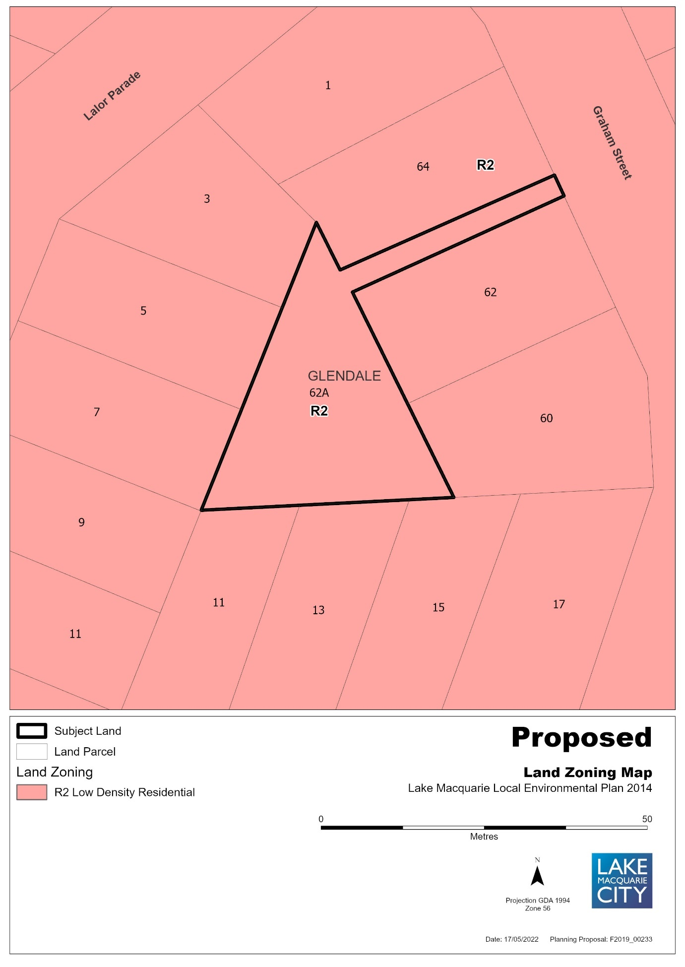

Figure 4 – Existing Lot Size Map
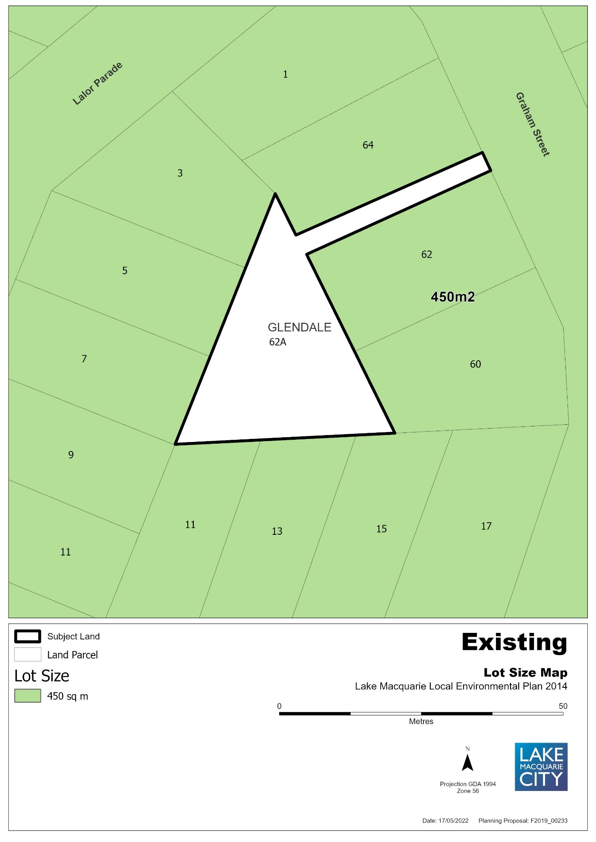

Figure 5 – Proposed Lot Size Map
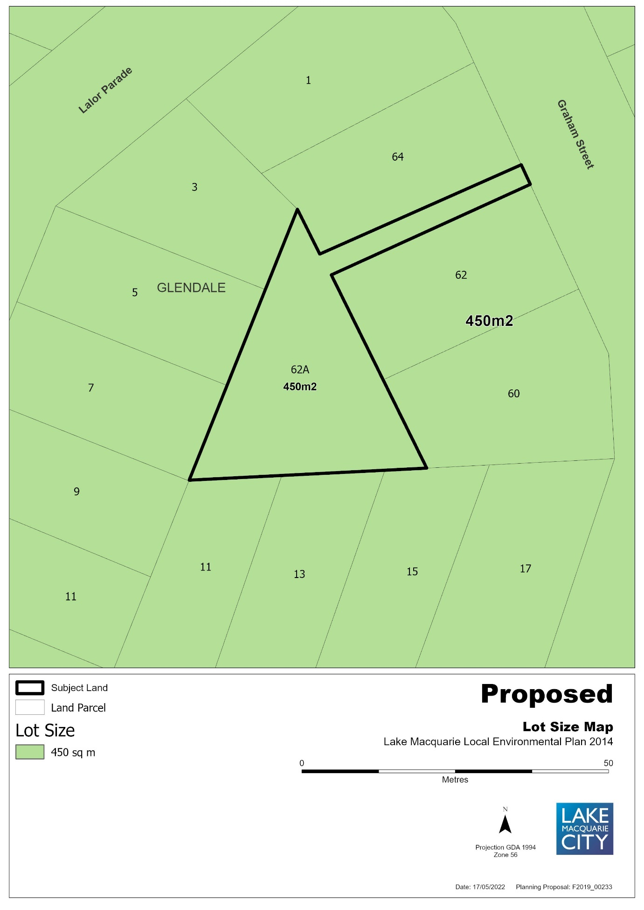

Figure 6 – Draft Land Reclassification Map under LMLEP 2014
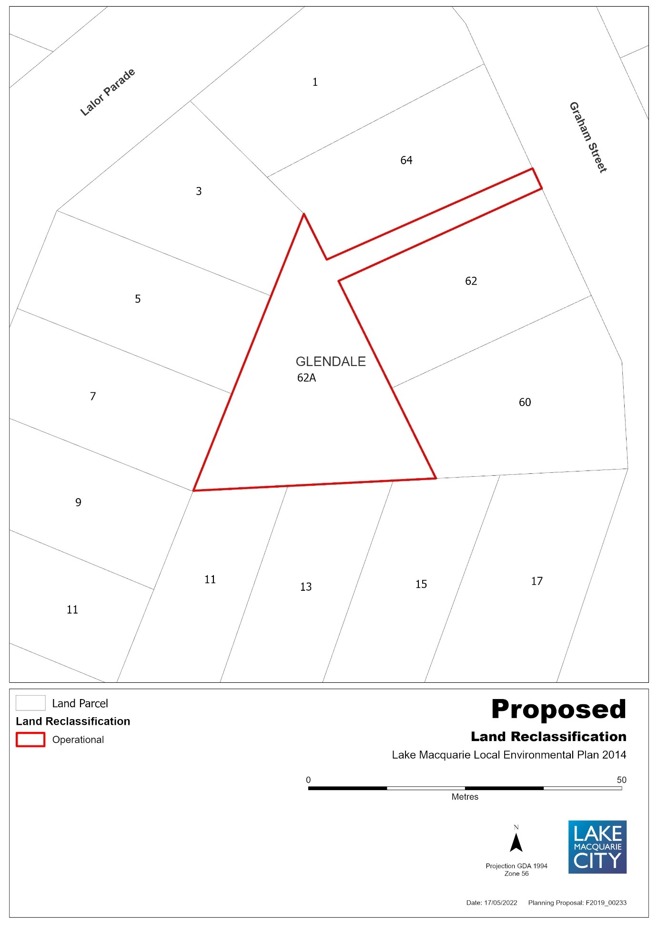

ITEM 8: 16 Skye Street, Morisset, Lot 1 Section 12 DP 758707
Figure 1 – Aerial Map
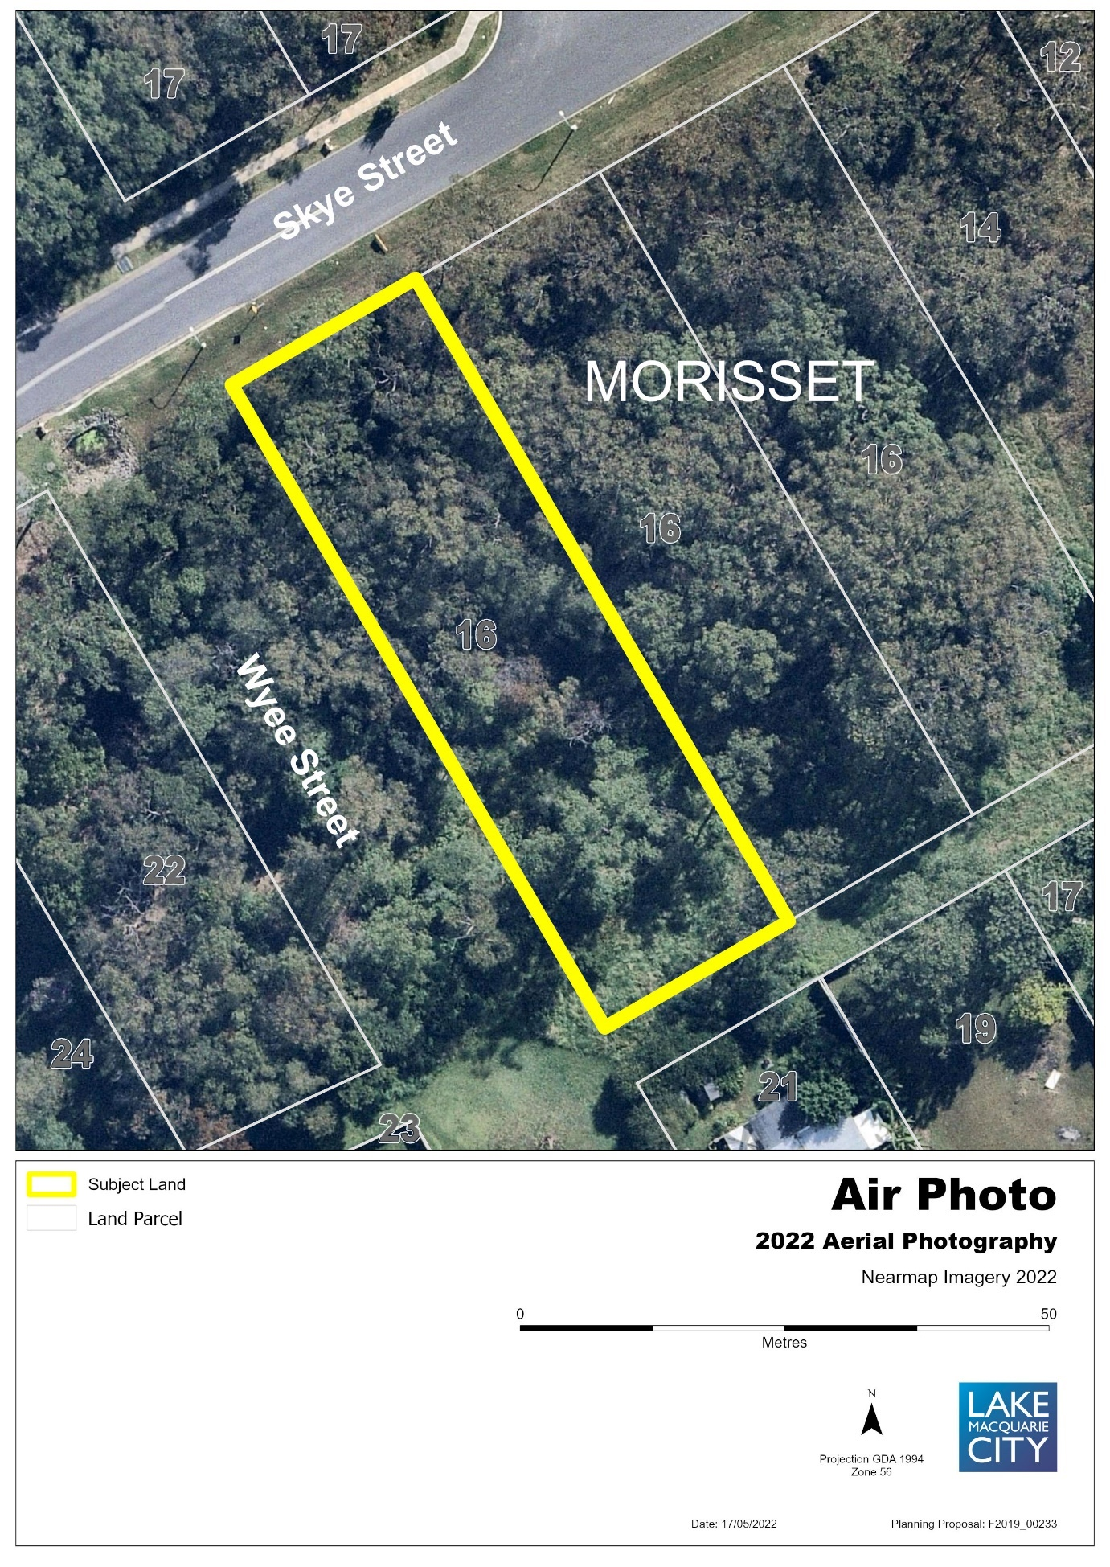

Figure 2 – Existing Zone under LMLEP 2014
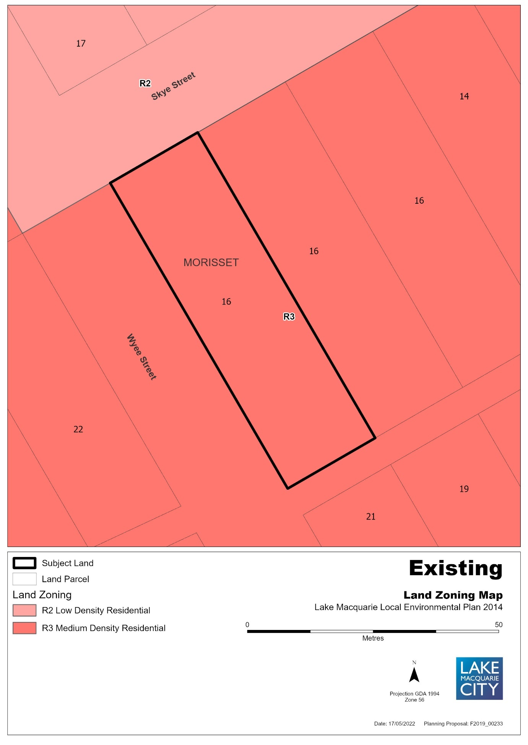

Figure 3 – Draft Land Reclassification Map under LMLEP 2014
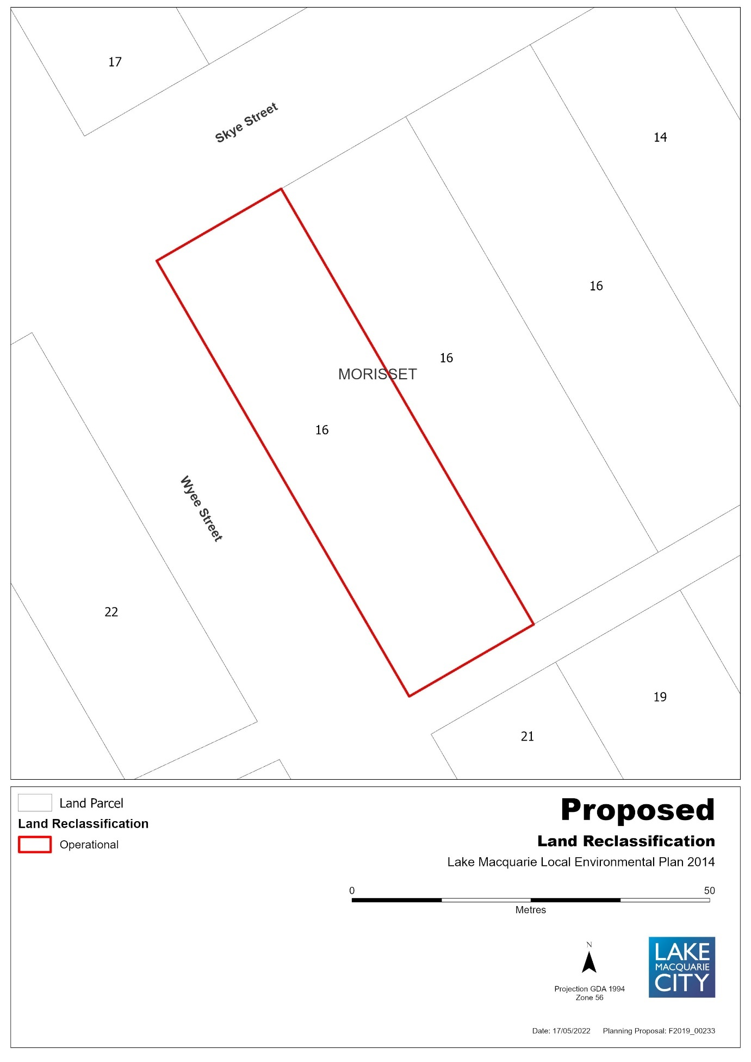

ITEM 9: 38 Alison Street, Redhead, Lot 50 DP 844457
Figure 1 – Aerial Map
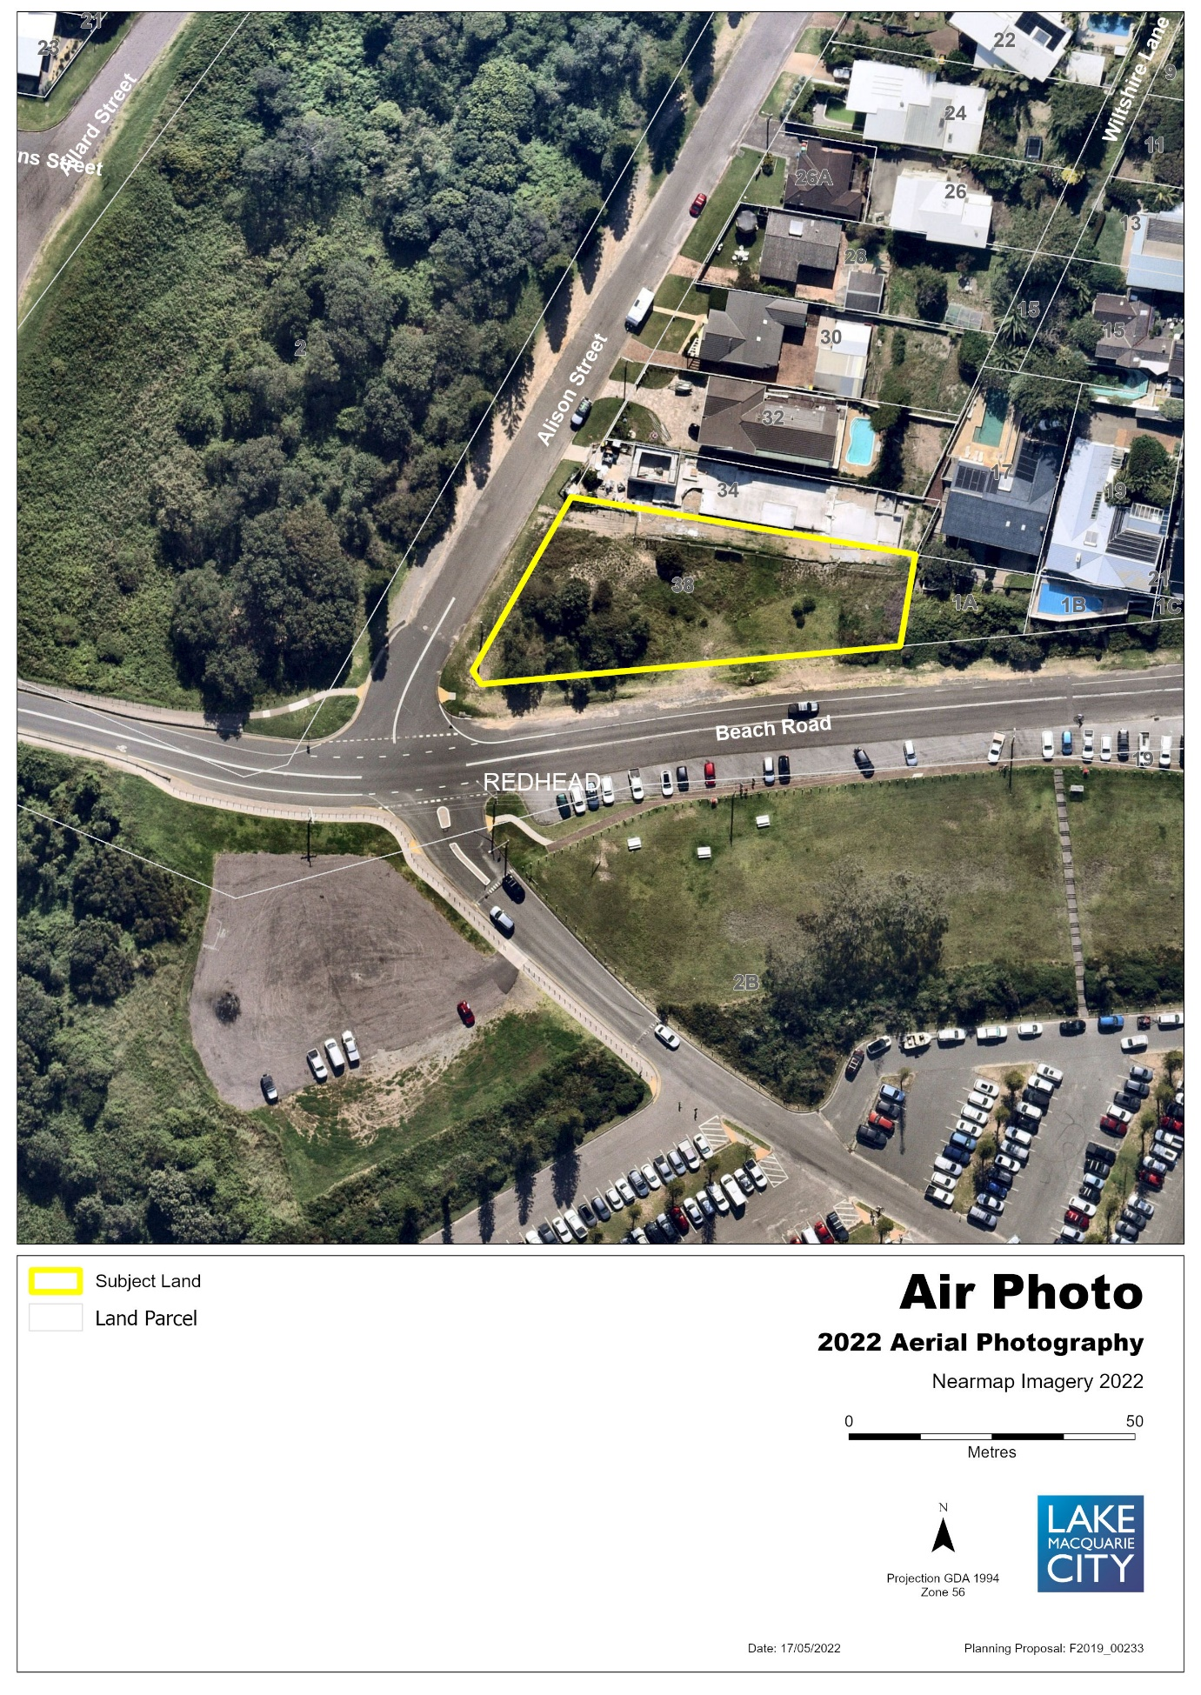

Figure 2 – Existing Zone under LMLEP 2014
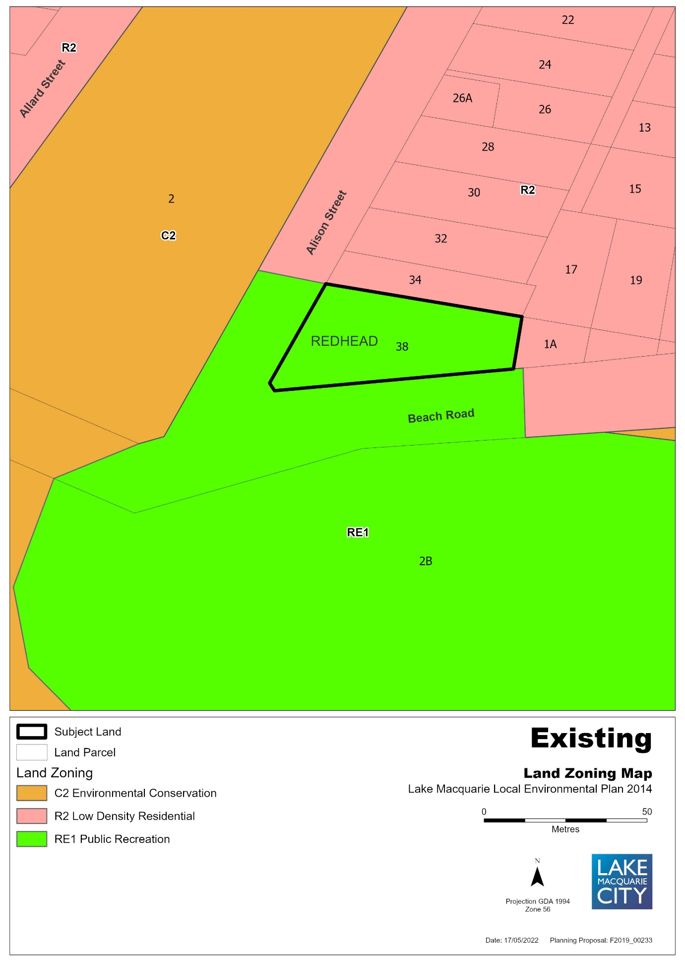

Figure 3 – Proposed Zone under LMLEP 2014
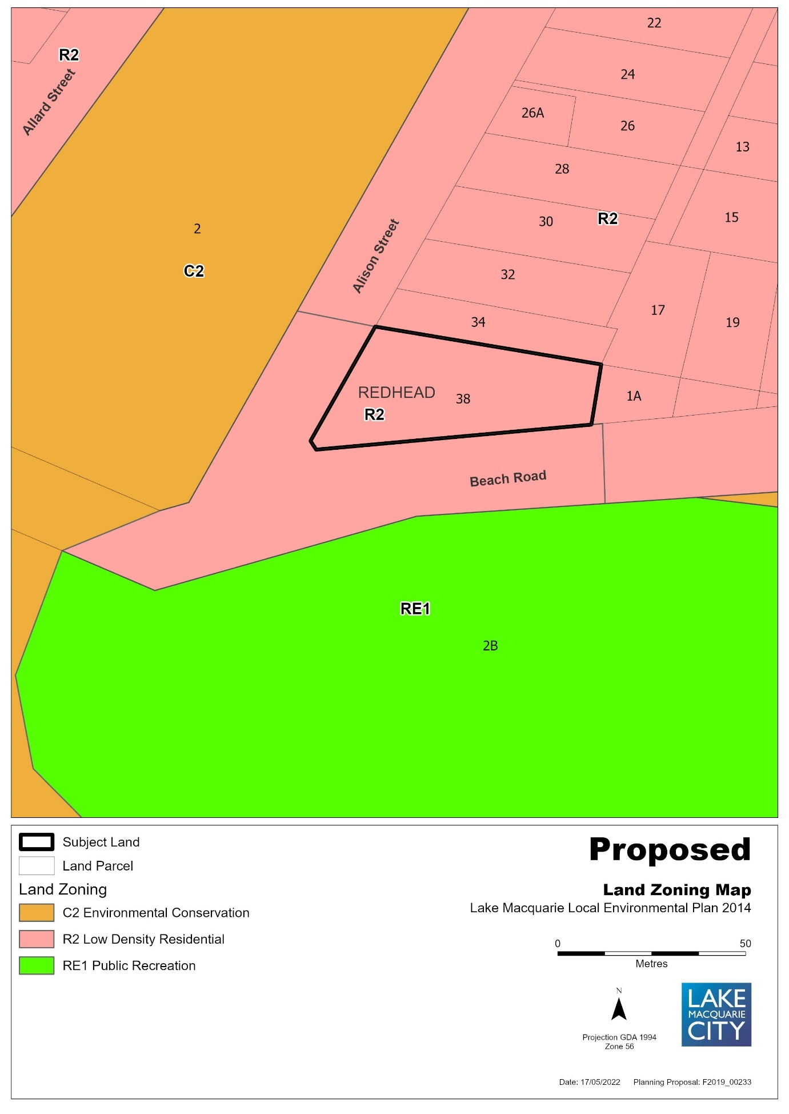

Figure 4 – Existing Lot Size Map
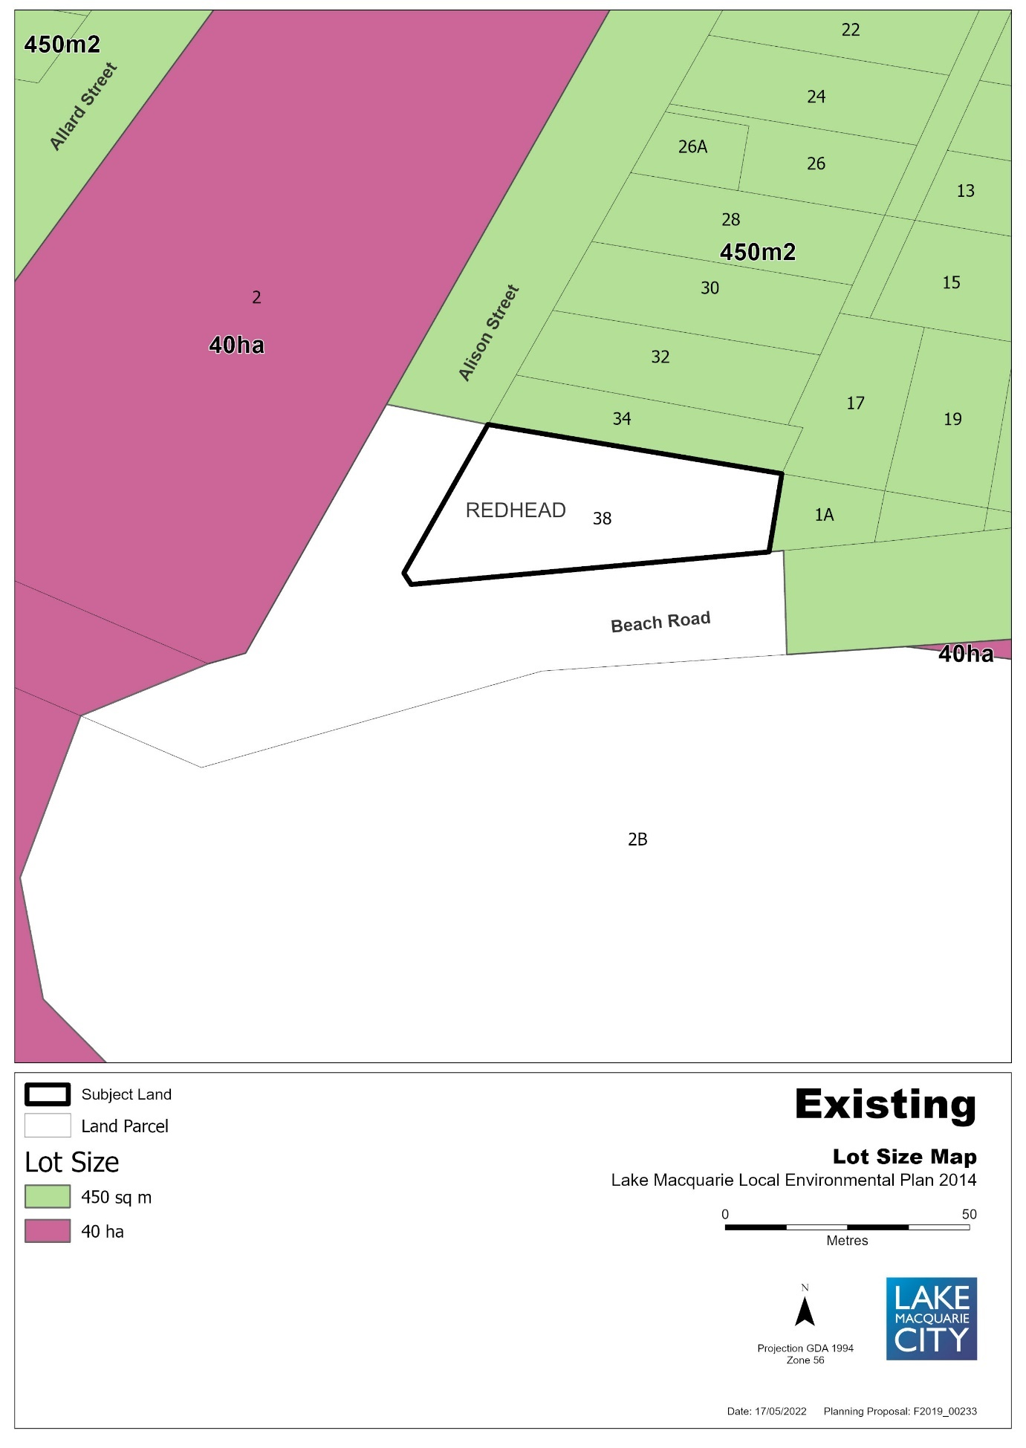

Figure 5 – Proposed Lot Size Map
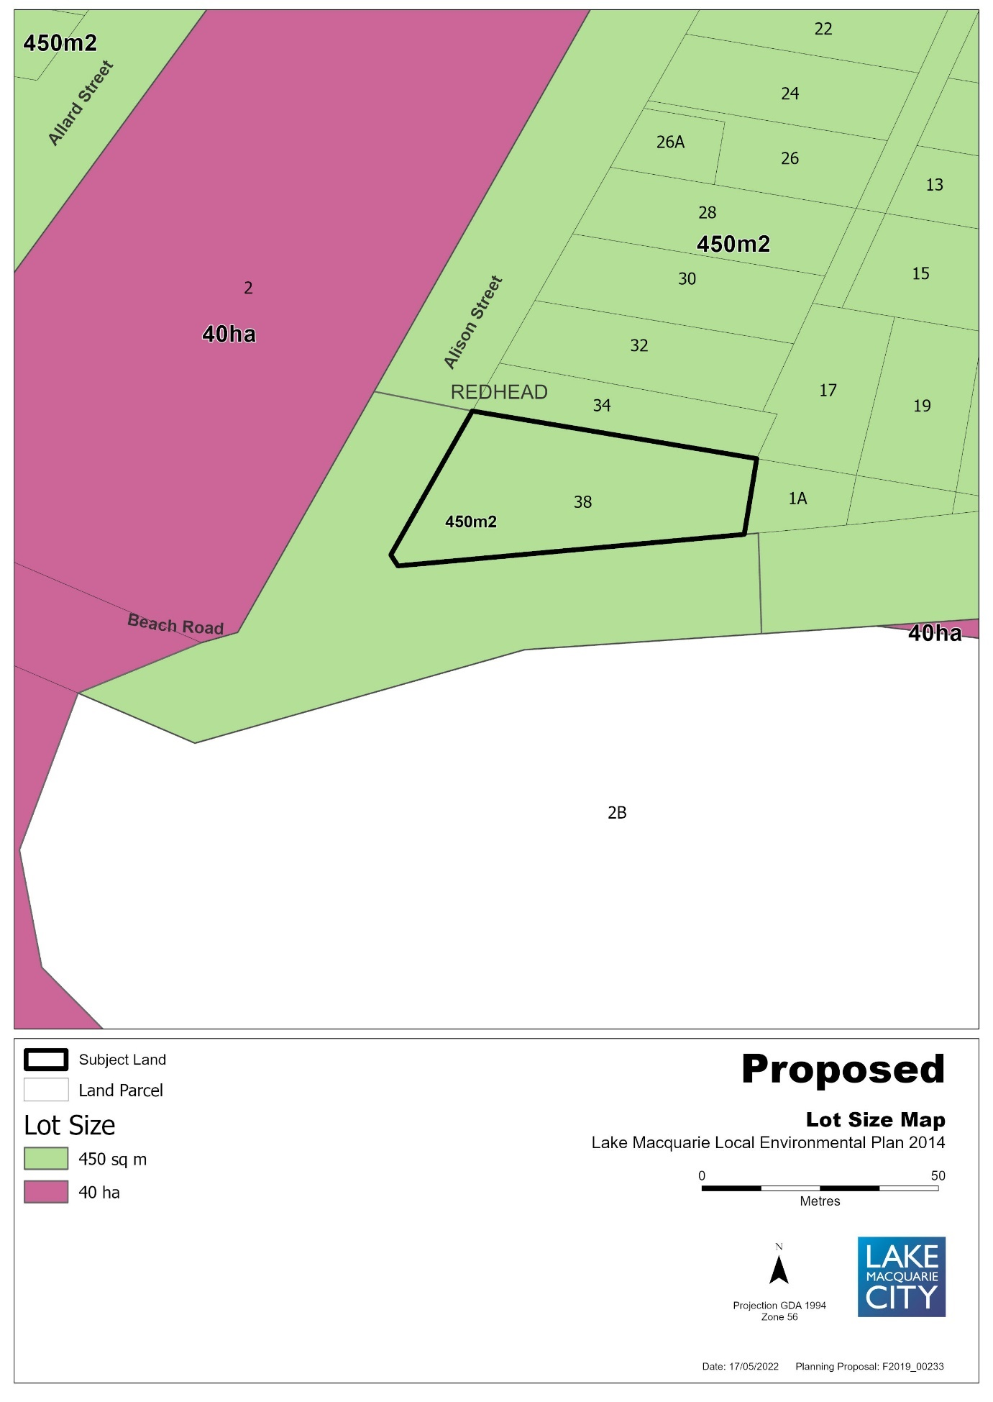

Figure 6 – Draft Land Reclassification Map under LMLEP 2014
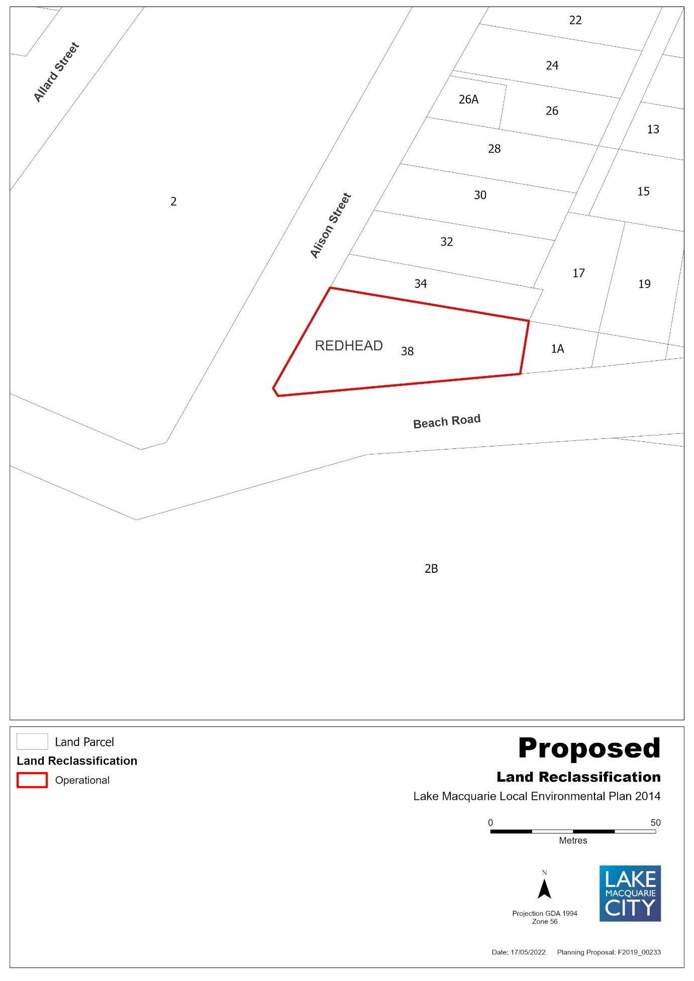

Item 10: 20 Ruttleys Road, Wyee, Lot 495 DP 755242
Figure 1 – Aerial Map
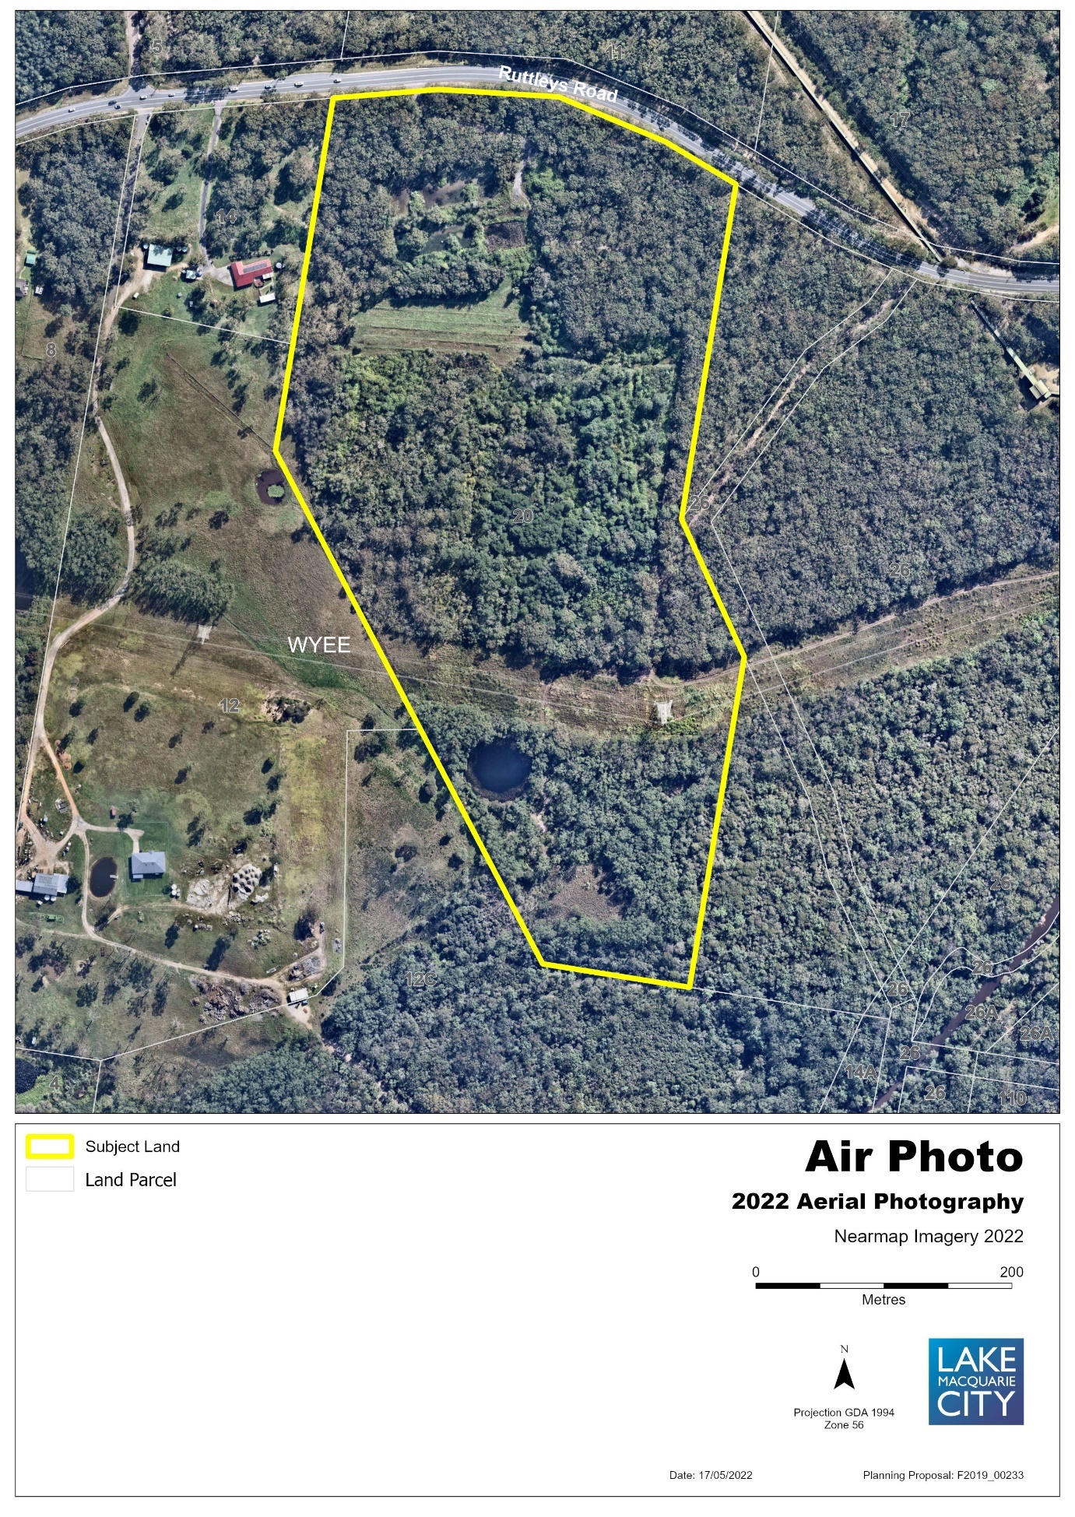

Figure 2 – Existing Zone under LMLEP 2014
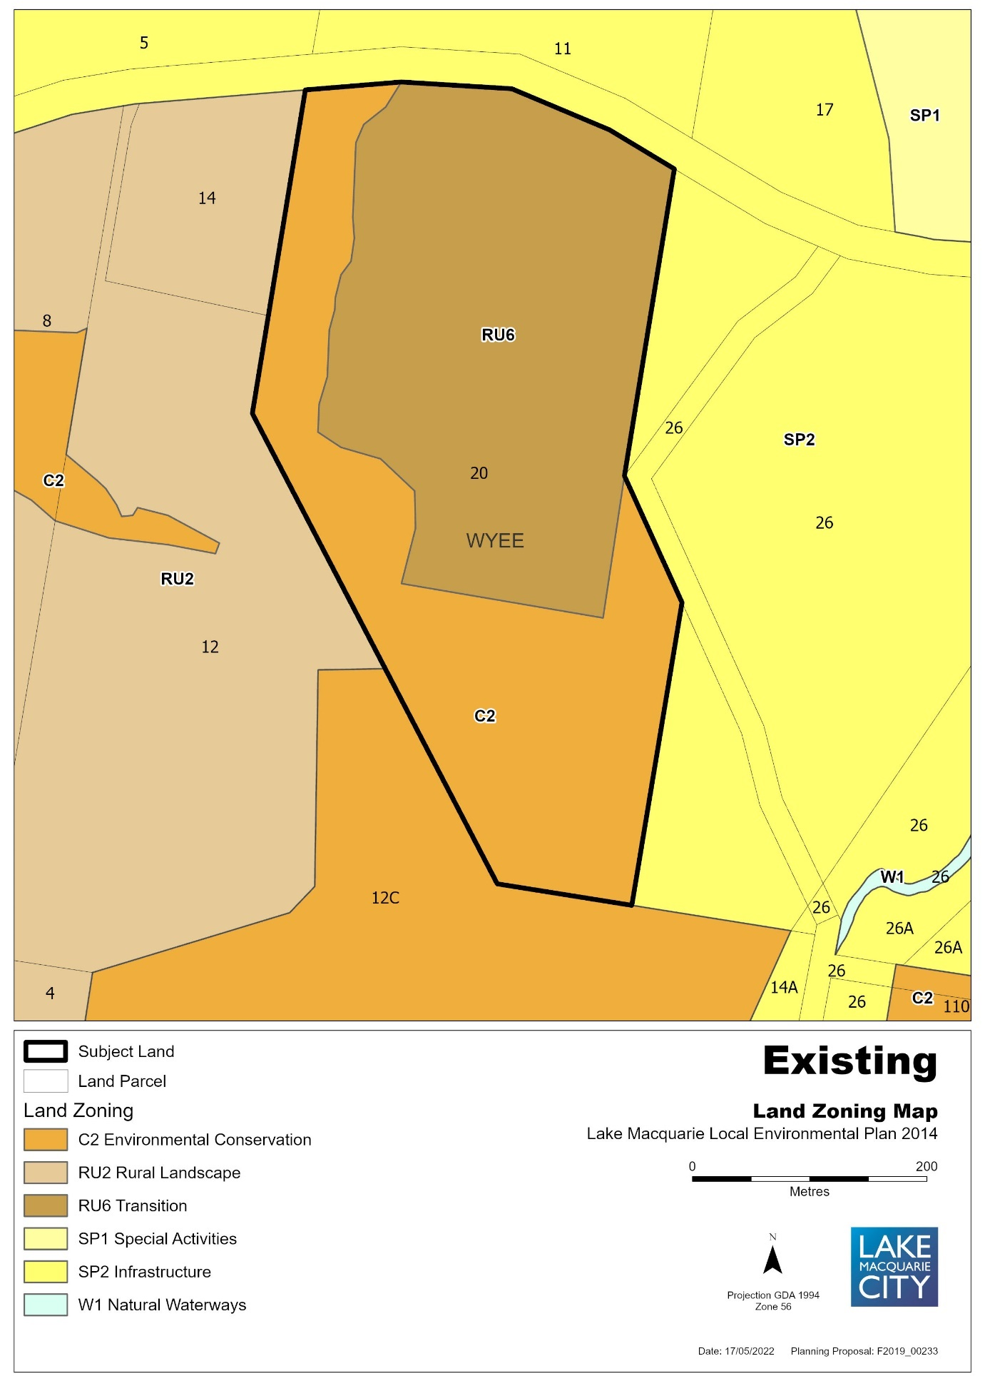

Figure 3 – Proposed Zone under LMLEP 2014
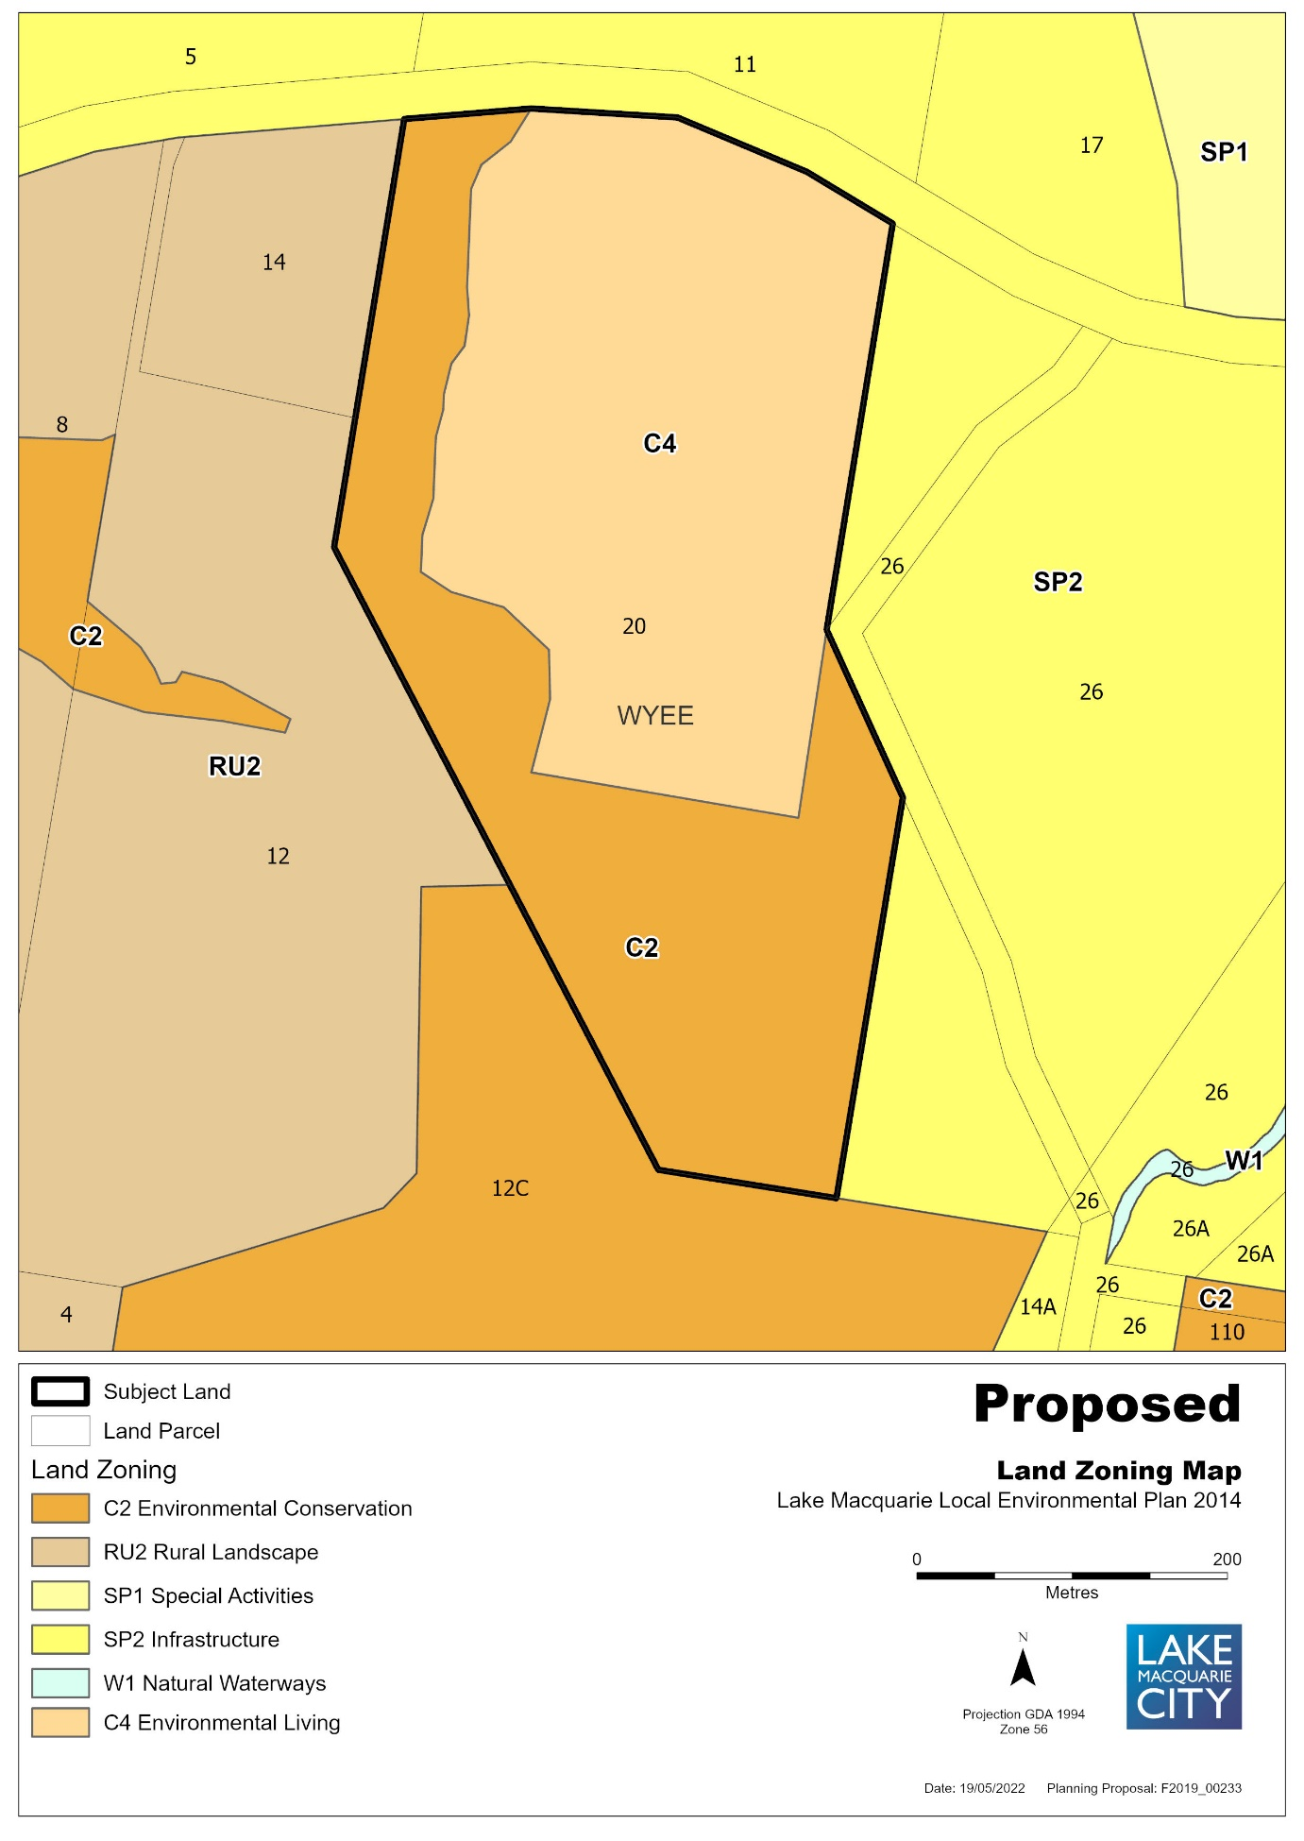

Figure 4 – Existing Lot Size Map
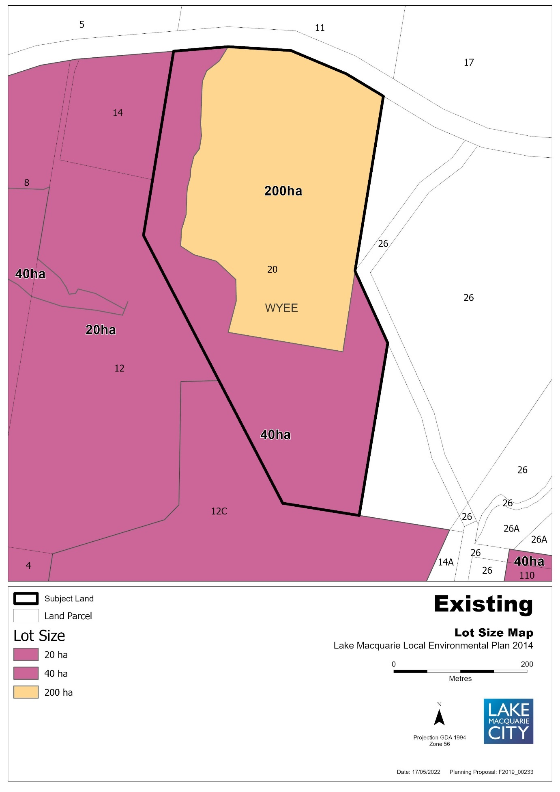

Figure 5 – Proposed Lot Size Map
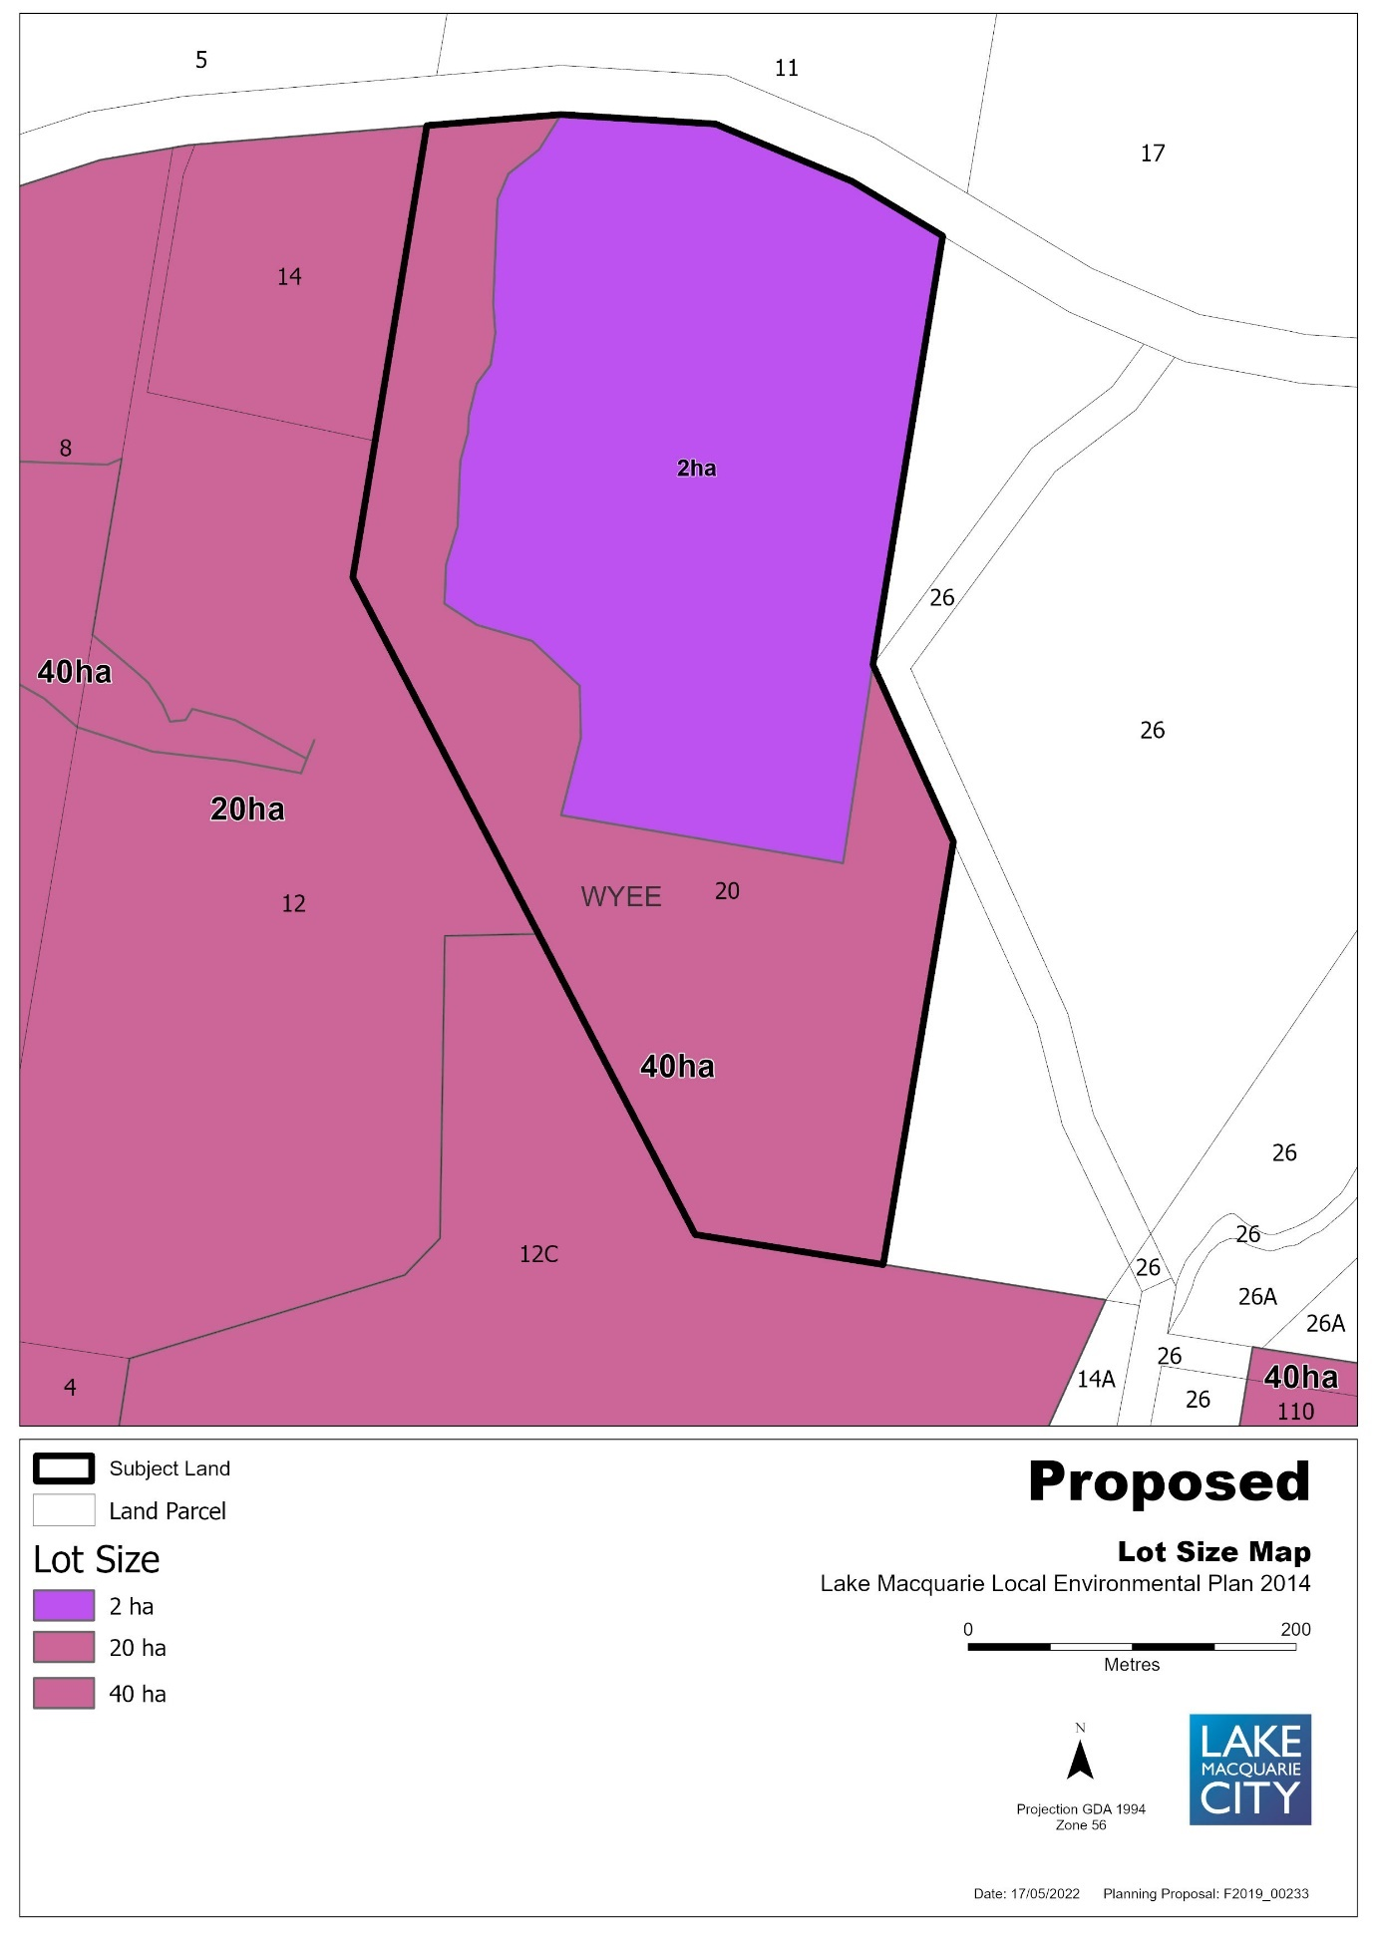

ANNEX B – SEPP ASSESSMENT
Planning Proposal’s Assessment against Applicable SEPPs
SEPP | Applicable | Consistency
State Environmental Planning Policy (Biodiversity and Conservation) 2021 | N/A | Policy does not apply to Lake Macquarie local government area
State Environmental Planning Policy (Building Sustainability Index: BASIX) 2004 | No | Planning proposal does not propose any controls that override BASIX provisions, nor does it propose any building works that require a development consent, complying development certificate or construction certificate
State Environmental Planning Policy (Exempt and Complying Development Codes) 2008 | No | Planning proposal does not propose any building works, nor any changes to this policy.
State Environmental Planning Policy (Housing) 2021 | Yes | The planning proposal is consistent with this policy.
State Environmental Planning Policy (Industry and Employment) 2021 | No | The policy identifies some land at Gateshead as deferred matters, however Item 5 - 48 Oakdale Road, Gateshead is outside that area.
State Environmental Planning Policy No 65—Design Quality of Residential Apartment Development | Yes | Planning proposal does not propose any building works, nor any changes to this policy.
State Environmental Planning Policy (Planning Systems) 2021 | No
State Environmental Planning Policy (Precincts—Central River City) 2021 | No
State Environmental Planning Policy (Precincts—Eastern Harbour City) 2021 | No
State Environmental Planning Policy (Precincts—Regional) 2021 | No | The lands the subject of this Planning Proposal are not listed within State significant or activation precincts
State Environmental Planning Policy (Precincts—Western Parkland City) 2021 | No
State Environmental Planning Policy (Primary Production) 2021 | No
State Environmental Planning Policy (Resilience and Hazards) 2021 | Yes | The following land has been identified as being within the Coastal Zone and under SEPP (Resilience and Hazards) 2021:  Item 5 - 48 Oakdale Road, Gateshead  Identified within the coastal wetland buffer, with small section in NW corner of land identified as coastal wetland.  As this item is for reclassification only, to lease out the existing premises on-site, it is not considered an intensification of the use of the site.  Item 6 – 4A Clare Street, Glendale  Identified within the coastal environmental area and the coastal use area which does not prohibit rezoning the land.  The planning proposal does propose rezoning to residential, but this is in accordance with surrounding land.  Item 9 – 38 Alison Street, Redhead  Identified within the coastal use area which does not prohibit rezoning.  SE corner is kissed by a coastal hazard line, that prohibits critical utilities, essential community and aged care facilities, but does not enter the land.  Item 10 – part of 20 Ruttleys Road, Wyee  Eastern and southern part of site is identified as coastal environmental area which does not prohibit rezoning.  Only item 5 - 48 Oakdale Road, Gateshead, has a small piece of coastal wetland identified in the north west corner of the site. All other land listed above is identified as either a coastal environmental area or coastal use area, which does not prohibit rezoning nor inhibit increased development or more intensive land-use on land.
State Environmental Planning Policy (Resources and Energy) 2021 | Yes | This planning proposal does not change any provisions or affect land for the proper management and development of mineral, petroleum and extractive material resources.  See clause 4.6 Mine Subsidence and Unstable Land, of the Ministerial Directions for land already affected by mining and extractive industries.
State Environmental Planning Policy (Transport and Infrastructure) 2021 | Yes | The planning proposal is consistent with this policy.

ANNEX C – MINISTERIAL DIRECTION ASSESSMENT
Planning Proposal’s assessment against Ministerial Directions
Focus area | Applicable | Consistency
1. Planning Systems
1.1 Implementation of Regional Plans | Yes | The planning proposal is considered consistent with the Hunter Regional Strategy 2036 and the Greater Newcastle Metropolitan Plan 2036. See section B (3) of this report.
1.2 Development of Aboriginal Land Council land | N/A
1.3 Approval and Referral Requirements | Yes | The planning proposal is considered consistent with this Ministerial Direction as it does not change any controls relating to concurrence, consultation, referral to the Minister or identification of development as designated development.
1.4 Site Specific Provisions | Yes | The planning proposal is considered consistent with this Ministerial Direction as any proposed rezonings are to existing zones already in the principal environmental planning instrument.
1.5 Parramatta Road Corridor Urban Transformation Strategy | N/A
1.6 Implementation of North West Priority Growth Area Land Use and Infrastructure Implementation Plan | N/A
1.7 Implementation of Greater Parramatta Priority Growth Area Interim Land Use and Infrastructure Implementation Plan | N/A
1.8 Implementation of Wilton Priority Growth Area Interim Land Use and Infrastructure Implementation Plan | N/A
1.9 Implementation of Glenfield to Macarthur Urban Renewal Corridor | N/A
1.10 Implementation of the Western Sydney Aerotropolis Plan | N/A
1.11 Implementation of Bayside West Precincts 2036 Plan | N/A
1.12 Implementation of Planning Principles for the Cooks Cove Precinct | N/A
1.13 Implementation of St Leonards and Crows Nest 2036 Plan | N/A
1.14 Implementation of Greater Macarthur 2040 | N/A
1.15 Implementation of the Pyrmont Peninsula Place Strategy | N/A
1.16 North West Rail Link Corridor Strategy | N/A
1.17 Implementation of the Bays West Place Strategy | N/A
2. Design and Place
No Ministerial Directions available yet under this focus area
3. Biodiversity and Conservation
3.1 Conservation Zones | Yes | Item 10 of the planning proposal – 20 Ruttleys Road, Wyee, has a split zoning with the land that is currently zoned C2 Environmental Conservation being in the southern and western edge of the land. This direction does not allow for reduction of the environmental protection standards that apply to the land. Under this planning proposal the land currently zoned C2 Environmental Conservation will remain. The remainder of the land is zoned RU6 Transition and will change to C4 Environmental Living.  As this is the only land in the planning proposal within a C2 Environmental Conservation zone, it is considered to be consistent with this Ministerial Direction
3.2 Heritage Conservation | No | The Heritage provisions of LMLEP2014 will remain unchanged.  No items are heritage listed.  However, Item 1 – 60-62 Main Road, Boolaroo, is adjacent to listed heritage item No.6 the Speers Point Steam Tram Line, which has now been paved over and used as Main Road. As this item is for reclassification only, it is considered it will not have any effect on the adjoining heritage item.
3.3 Sydney Drinking Water Catchments | N/A
3.4 Application of C2 and C3 Zones and Environmental Overlays in Far North Coast LEPs | N/A
3.5 Recreation Vehicle Area | N/A
4 Resilience and Hazards
4.1 Flooding | Yes | Only the southern part of Item 10 – 20 Ruttleys Road, Wyee, is identified as flood prone land, however this section of land is currently zoned C2 and will remain as C2.  No other land is identified on the flood prone land map.  The planning proposal is in accordance with a floodplain risk management plan, and is considered to be in accordance with this Ministerial direction.
4.2 Coastal Management | Yes | The following land has been identified as being within the Coastal Zone and under SEPP (Resilience and Hazards) 2021:  Item 5 - 48 Oakdale Road, Gateshead  Identified within the coastal wetland buffer, with small section in NW corner of land identified as coastal wetland.  As this item is for reclassification only, to lease out the existing premises on-site, it is not considered an intensification of the use of the site.  Item 6 – 4A Clare Street, Glendale  Identified within the coastal environmental area and the coastal use area which does not prohibit rezoning the land.  The planning proposal does propose rezoning to residential, but this is in accordance with surrounding land.  Item 9 – 38 Alison Street, Redhead  Identified within the coastal use area which does not prohibit rezoning.  SE corner is kissed by a coastal hazard line, that prohibits critical utilities, essential community and aged care facilities, but does not enter the land.  Item 10 – part of 20 Ruttleys Road, Wyee  Eastern and southern part of site is identified as coastal environmental area which does not prohibit rezoning.  Only item 5 - 48 Oakdale Road, Gateshead, has a small piece of coastal wetland identified in the north west corner of the site. All other land listed above is identified as either a coastal environmental area or coastal use area, which does not prohibit rezoning nor inhibit increased development or more intensive land-use on land.  Item 5 variation is considered to be inconsistent with the Ministerial direction, but of minor significance. All other items are consistent.
4.3 Planning for Bushfire Protection | Yes | The following lands:  Item 4 – 21 Narara Road, Cooranbong (red)  Item 5 - 48 Oakdale Road, Gateshead (yellow)  Item 8 - 16 Skye Street, Morisset (red)  Item 9 - 38 Alison Street, Redhead (yellow)  Item 10 – 20 Ruttleys Road, Wyee (red & yellow)  have been identified as Vegetation Category 1 (red) or Vegetation Buffer (yellow) under the Bushfire prone land map. The proposal to reclassify and/or rezone these lands will require consultation with the Rural Fire Service in accordance with this direction.
4.4 Remediation of Contaminated Land | Yes | The following land has been identified as being within an investigation area or containing previous development that may have contaminated the land:  Item 1 – 60-62 Main Road, Boolaroo  Identified within the Pasminco Grid  Only reclassification of the land with no rezoning proposed  Considered suitable use in its current state  Item 6 - 4a Clare Street, Glendale  Adjoining property at 593 Main Road, Glendale, is an existing service station, with regular contamination checks.  Subject land is uphill of service station, so even if spill occurs, this land will not be affected.  Item 10 – 20 Ruttleys Road, Wyee  Was an old night soil site.  Remediation report has been undertaken  Site considered suitable for rural-residential use if remediated in accordance with the report.  It is considered appropriate to proceed with the planning proposal without further contamination studies being required.
4.5 Acid Sulfate Soils | Yes | The following lands are identified as being on the Acid Sulphate Soils map:  as Class 5 land:  Item 1 – 60-62 Main Road, Boolaroo  Item 4 – 21 Narara Road, Cooranbong  Item 6 - 4a Clare Street, Glendale  Item 9 - 38 Alison Street, Redhead  Two-thirds of the western side of the land  Item 10 – part of 20 Ruttleys Road, Wyee  Northern area recommended for rezoning  Southern part is Class 4 but will remain untouched  Council has mapped its acid sulfate soils and this planning proposal does not propose any changes to that mapping or the controls relating to acid sulfate soils. As all the above mentioned land (except Item 10) is contained within existing residential areas, the inconsistency with the Ministerial direction is considered to be of minor significance.
4.6 Mine Subsidence and Unstable Land | Yes | The following lands:  Item 2 – Part of 27C First Street, Cardiff South, South of Ada Street  Item 3 - 27 First Street, Cardiff South & part of 27C First Street, Cardiff South, North of Ada Street  Item 5 - 48 Oakdale Road, Gateshead  Item 6 - 4a Clare Street, Glendale  Item 7 - 62A Graham Street, Glendale  Item 9 - 38 Alison Street, Redhead  are identified on the Lake Macquarie Subsidence Advisory map.  Item 8 - 16 Skye Street, Morisset  Item 10 – 20 Ruttleys Road, Wyee  are identified on the West Lake Subsidence Advisory map.  Accordingly, the proposal should be referred to the Subsidence Advisory NSW for consultation in accordance with the direction.
5: Transport and Infrastructure
5.1 Integrating Land Use and Transport | Yes | The planning proposal is considered consistent with this Ministerial Direction.
5.2 Reserving Land for Public Purposes | No | None of the land identified within this planning proposal is identified or proposes to identify land for acquisition by a public authority. Accordingly, the planning proposal is considered consistent with this Ministerial Direction.
5.3 Development Near Regulated Airports and Defence Airfields | N/A
5.4 Shooting Ranges | N/A
6: Housing
6.1 Residential zones | Yes | The following items are located within existing residential zones R2 or R3:  Item 2 – Part of 27C First Street, Cardiff South, Lot 30 DP 196, South of Ada Street  Item 3 – 27 First Street, Cardiff South, Lot 1 DP 190522 & 27C First Street, Cardiff South, Lot 30 DP 196, North of Ada Street  Item 8 - 16 Skye Street, Morisset  The following items will be rezoned to residential zones R2 or R3:  Item 4 – 21 Narara Road, Cooranbong  Item 6 – 4a Clare Street, Glendale  Item 7 – 62A Graham Street, Glendale  Item 9 - 38 Alison Street, Redhead  As all the above land is located within urban areas, it is considered to be infill development and all land is adequately serviced. Accordingly, the planning proposal is considered consistent with this Ministerial Direction.
6.2 Caravan Parks and Manufactured Home Estates | N/A
7: Industry and Employment
7.1 Business and Industrial Zones | Yes | The following items are located within existing business and industrial zones:  Item 1 – 60-62 Main Road, Boolaroo – B1 Neighbourhood Centre  Item 5 - 48 Oakdale Road, Gateshead – IN2 Light Industrial  As these two properties are for reclassification only, the zone boundaries and provisions within the zone, will not change. Accordingly, the planning proposal is considered consistent with this Ministerial Direction.
7.2 Reduction in non-hosted short term rental accommodation period | N/A
7.3 Commercial and Retail Development along the Pacific Highway, North Coast | N/A
8: Resources and Energy
8.1 Mining, Petroleum Production and Extractive Industries | N/A
9: Primary Production
9.1 Rural Zones | Yes | Item 10 – 20 Ruttleys Road, Wyee, is within an RU6 Transition zone. Preliminary studies have indicated that this land is now suitable to rezone to C4 Environmental Living which will not increase its permissible density and will maintain the sites environmental sensitivities.  Accordingly, the planning proposal is considered consistent with this Ministerial Direction.
9.2 Rural Lands | N/A
9.3 Oyster Aquaculture | N/A
9.4 Farmland of State and Regional Significance on the NSW Far North Coast | N/A

ANNEX D – COUNCIL RESOLUTIONS
22OS015 | Reclassification of Various Sites - 2022 Housekeeping Amendment to Lake Macquarie Local Environmental Plan 2014

Key focus area | 8. Organisational support
Objective | 8.2 Governance
File | F2019/00233 - D10633483
Author | Statutory Property Officer - Joanne Marshall
Responsible manager | Executive Manager Future City Precincts - David Antcliff

Executive Summary
As part of its administrative functions, Council regularly does a housekeeping review of its properties to determine if it is meeting the needs of residents and achieving best use out of its land.
Ten parcels of land have been identified through the housekeeping review, and each parcel has been investigated.

Nine of the parcels of land referred to in this report are classified as community land under the Local Government Act 1993 (NSW) (LG Act). The use of community land is strictly governed by the LG Act as land intended for public access and use by the community. Commercial leasing, sale or use as road of community land is generally not permitted, or is subject to significant constraints.

Reclassification of those nine parcels of land as operational land is considered to be appropriate, having regard to the current and/or proposed use of each parcel, together with other associated amendments such as zoning or development standard amendments.

One parcel of land is already classified as operational land, but it was identified that an amendment to zoning and development standards relevant to that land would be appropriate, having regard to its current and/or proposed use.

This report seeks Council’s approval for the initial processes required to make these changes, primarily being a planning proposal for amendments to be made to the Lake Macquarie Local Environmental Plan 2014 (LMLEP).

Recommendation
Council:
- approves amendments to the Lake Macquarie Local Environmental Plan 2014 (LMLEP) for the reclassification of community land as operational land, and amendments to zoning and development standards, in accordance with Table 1 of this report, in relation to the following properties:
Item 1 - 60-62 Main Road, Boolaroo, Lot 4 and 5 Sec E DP 3494
Item 2 – Part of 27C First Street, Cardiff South, Lot 30 DP 196, south of Ada Street
Item 3 – 27 First Street, Cardiff South, Lot 1 DP 190522 and 27C First Street, Cardiff South, Lot 30 DP 196, north of Ada Street
Item 4 - 21 Narara Road, Cooranbong, Lots 4, 5, 6 and 7 Section O DP 724
Item 5 - 48 Oakdale Road, Gateshead, Lot 20 DP 1115790
Item 6 - 4a Clare Street, Glendale, Lot 103 DP 553828
Item 7 - 62A Graham Street, Glendale, Lot 62 DP 247342
Item 8 – Part of 16 Skye Street, Morisset, Lot 1 Section 12 DP 758707
Item 9 - 38 Alison Street, Redhead, Lot 50 DP 844457
Item 10 - 20 Ruttleys Road, Wyee, Lot 495 DP 755242,
- approves a planning proposal, for the purpose of reclassification and/or amendments to the LMLEP of the land referred to in part A of the recommendation, to be forwarded to the Minister for Planning for a Gateway Determination to be made pursuant to section 3.34 of the Environmental Planning and Assessment Act 1979 (NSW) (EP&A Act),
C. undertakes consultation with State Government agencies and service authorities and prepares any required studies in accordance with the Gateway Determination,
D. places the draft planning proposal on exhibition, subject to the outcome of the Gateway Determination,
E. notifies stakeholders and affected landowners of the public exhibition,
F. undertakes a public hearing in accordance with section 29 of the Local Government Act 1993, and
G. receives a further report on the matter following public exhibition and the public hearing.

Discussion
The LG Act requires Council to classify all its public land as either operational or community land. Operational land can be used by Council for its operational purposes and to facilitate the carrying out of Council functions, for example, depots, quarries, commercially leased land, public roads, etc. Community land is subject to significant restrictions on its use and management under the LG Act, and is intended for public access and community uses, for example, parks, bushland, community halls, etc.
Nine of the ten parcels of land referred to in this report are classified as community land, but it has been identified that they would be more appropriately classified as operational land, having regard to their current and/or proposed use. Some of the parcels also require associated amendments to zoning and/or development standards in order to achieve the intended outcomes and best reflect the current and/or proposed use.
The remaining parcel of land is already classified as operational land, but requires amendments to applicable zoning and/or development standards in order to achieve the intended outcomes and best reflect the current and/or proposed use for that land.
The provisions of the LG Act, Environmental Planning and Assessment Act 1979 (NSW) (EP&A Act), Roads Act 1993 (NSW) (Roads Act) and other relevant legislation mean a number of steps are required to implement the changes proposed to achieve the intended outcomes.
The initial step is a planning proposal for the reclassification and any amendments required to zoning or development standards, through amendment to the LMLEP under the EP&A Act. This report seeks Council’s approval for the submission of a planning proposal to amend the LMLEP accordingly.
A summary of the proposed changes and intended outcomes of the reclassification for each parcel of land is set out in Table 1 below.
Table 1 – Proposed changes
Item No. | Address | Intended outcomes | Proposed changes to the LMLEP
1 | 60-62 Main Road, Boolaroo  Lot 4 and 5 Sec E DP 3494 | Commercially lease the whole of the property. | - Reclassify as operational land.
2 | Part of 27C First Street, Cardiff South, Lot 30 DP 196, south of Ada Street | Dedicate as road. | - Reclassify as operational land.
3 | 27 First Street, Cardiff South, Lot 1 DP 190522 and  27C First Street, Cardiff South, Lot 30 DP 196, north of Ada Street | Close the road, redevelop for residential use and sell to the public. | - Reclassify as operational land.  - Rezone from R2 Low Density Residential to R3 Medium Density Residential.  - Change Height of Buildings Map (HBM) from 8.5m to 10m.  - Change Lot Size Map (LSM) from 450sqm to 900sqm.
4 | 21 Narara Road, Cooranbong  Lots 4, 5, 6 and 7 Section O DP 724 | Sell to the public for residential use. | - Reclassify as operational land.  - Rezone from RE1 Public Recreation to R2 Low Density Residential.  - Add to LSM at 450sqm.
5 | 48 Oakdale Road, Gateshead  Lot 20 DP 1115790 | Commercially lease the whole of the property. | - Reclassify as operational land.
6 | 4a Clare Street, Glendale  Lot 103 DP 553828 | Sell to adjoining owners for residential use. | - Reclassify as operational land.  - Rezone from RE1 Public Recreation to R3 Medium Density Residential.  - Change HBM from 8.5m to 10m.  - Add to LSM at 900sqm.
7 | 62A Graham Street, Glendale  Lot 62 DP 247342 | Redevelop and sell to the public for residential use. | - Reclassify as operational land.  - Rezone from RE1 Public Recreation to R2 Low Density Residential.  - Add to LSM at 450sqm.
8 | 16 Skye Street, Morisset  Lot 1 Section 12 DP 758707 | This is one lot of three lots to be sold together for residential use. This lot is constrained due to an Asset Protection Zone (APZ) and riparian zone required for the development of the other two lots. | - Reclassify as operational land.
9 | 38 Alison Street, Redhead  Lot 50 DP 844457 | Redevelop and sell to the public for residential use. | - Reclassify as operational land.  - Rezone from RE1 Public Recreation to R2 Low Density Residential.  - Add to LSM at 450sqm.
10 | 20 Ruttleys Road, Wyee  Lot 495 DP 755242 | Redevelop and sell to the public for residential use. | - Rezone from RU6 Transition to C4 Environmental Living.  - Change LSM from 200ha to 2ha.
The reclassification process is governed by part 3, division 3.4 of the Environmental Planning and Assessment Act 1979 (EP&A Act). A planning proposal has been prepared in accordance with the legislative requirements, including:
- a statement of the intended outcomes
- the justification for those outcomes having regard to each individual parcel of land
- details of the community consultation and public hearing proposed in relation to the planning proposal
- the proposed process for implementing the outcomes of the planning proposal.
A detailed summary of the planning proposal, which provides further information in relation to the justification for the intended outcomes, is provided in Attachment 1.
In accordance with the requirements of the EP&A Act, the planning proposal will be forwarded to the Minister for Planning for a Gateway Determination to be made.
Upon completion of the requirements set out in the Gateway Determination, including any public exhibition, public hearing and consultation process, a further report will be submitted to Council. That report will include information regarding any submissions received, and make further recommendations as to proceeding with the planning proposal to achieve the intended outcomes.
Subsequent to the planning proposal process, further proposals in relation to the land to achieve the intended outcomes, such as commercial leasing, sale, or dedication or closure of the land as road pursuant to the Roads Act, may also be brought back before Council for further consideration if necessary (either individually or in groups), or may be undertaken by Council.

Assessment of options
It is recommended to proceed with the reclassification of the land, rezoning and any changes relevant to the development standards for each parcel of land as outlined in Table 1 above. The planning proposal outcomes will rectify the anomalies in the current classification, zoning and development standards for the parcels of land, having regard to their current or proposed future use.
If the reclassification of the parcels of land does not proceed, the land will remain classified, zoned and/or subject to development standards which are considered inappropriate for their current or proposed use.

Community engagement and internal consultation
As part of the process to determine if the reclassification should commence, the matters are submitted to Council’s Rezoning Advisory Panel (RAP). The RAP is made up of representatives from relevant Council departments and considers proposals based on the expertise of each department, and the merits of the proposal. Table 2 (below) sets out the date on which each proposal was considered and any key issues the RAP addressed.
Table 2 – RAP consultation
Item No. | Address | RAP date | Issues raised | Resolution
1 | 60-62 Main Road, Boolaroo | 31 March 2022 | None | Proceed with reclassification.
2 | Part of 27C First Street, Cardiff South, south of Ada Street | 21 October 2021 | None | Proceed with reclassification and rezoning.
3 | 27 First Street, Cardiff South, and 27C First Street, Cardiff South, north of Ada Street | 21 October 2021 | Tree loss | This will be further assessed during the consultation period. However, there is no threatened species or wildlife corridors and existing tree cover is highly disturbed with no understorey.
 |  |  | New road layout | To be assessed at subdivision stage.
4 | 21 Narara Road, Cooranbong | 30 November 2021 | Loss of open space | To overcome this, Council will reclassify another Council-owned site nearby to community land, which has a higher environmental value.
 |  |  | Bushfire | It will be easier to provide an APZ if the land is swapped, as this can be extended behind existing houses.
5 | 48 Oakdale Road, Gateshead | 25 February 2020 | None | Proceed with reclassification.
6 | 4a Clare Street, Glendale | 31 March 2022 | Council’s development of this land is not considered viable due to poor access (land only 4m wide). | Proceed with reclassification and rezoning and offer land to adjoining owners in accordance with Council’s Acquisition and Divestment of Land policy.
7 | 62A Graham Street, Glendale | 21 October 2021 | Possible future loss of trees | This will be further assessed during the consultation period. However, there is no threatened species or wildlife corridors and it is an isolated site.
8 | 16 Skye Street, Morisset | 25 August 2021 | Flooding | Not identified on Council’s current flooding maps.
 |  |  | Ecology, APZ and riparian zone | Can be accommodated if this site is sold with the adjoining two, but not built upon.
9 | 38 Alison Street, Redhead | 21 October 2021 | Land under adjoining roads should also be rezoned | Noted and applied.
10 | 20 Ruttleys Road, Wyee | 30 November 2021 | Most suitable zone without varying minimum lot sizes | Zone C2 was considered best.
 |  |  | Should land be retained as an off-set site | Off-set for this development can be accommodated on site. Would have low value elsewhere due to historic contamination issues (night soil site).

Council’s Financial Planning and Legal teams were also consulted in the preparation of this report.
Community engagement, including a public hearing, will be undertaken in accordance with the requirements of the Gateway Determination made by the Minister for Planning.

Key considerations
Economic impacts | Reclassification of the following land is expected to unlock housing supply/infill housing opportunities:  Item 3 – 27 and 27C First Street, Cardiff  Item 4 – 21 Narara Road, Cooranbong  Item 6 – 4A Clare Street, Glendale  Item 7 – 62A Graham Street, Glendale  Item 8 – 16 Skye Street, Morisset  Item 9 – 38 Alison Street, Redhead  Item 10 - 20 Ruttleys Road, Wyee.
Environment | Items 5, 8 and 10 all have threatened or endangered species on the land.  Item 5 - 48 Oakdale Road, Gateshead, will be retained in Council’s ownership and the natural bushland will remain untouched.  Item 8 - 16 Skye Street, Morisset, is already partially cleared and will be sold with the two adjoining lots to the east. Development is subject to significant restrictions as it is required as both a riparian zone and APZ.  At item 10 - 20 Ruttleys Road, Wyee, only the disturbed areas will be subdivided and sold.
Community | The proposal is consistent with current usage for the land, and/or infill development of surrounding land, therefore the community impact is minimal. This will be further determined through community consultation and public hearing processes.
Civic leadership | The exhibition of the planning proposal and subsequent public hearing will satisfy statutory requirements and ensure consultation with the community and stakeholders.
Financial | Costs associated with advertising and holding a public hearing will be met by Council. Funds are available in the 2022-2023 budget.  The future intended proceeds from the reclassifications will go to the following Council budgets:  - No proceeds expected: Item 2 – land to be dedicated as road, Item 3 – land south of Ada St to be dedicated as road, Item 4 - proposed land swap, and Item 8 – land will have minimal value due to its constraint as an APZ and riparian zone.  - Strategic Property Reserve: Items 1, 5 and 10.  - Roads and Drainage Fund: Approximately 6500m² of Item 3.  - Community Land Reserve: Approximately 1190m² of Item 3, as well as Items 6, 7 and 9.
Infrastructure | No work is required to the existing infrastructure during the reclassification stage. Any infrastructure required before the land can be developed or sold will be assessed at subdivision or development application stage.
Risk and insurance | Risks associated with preparation of a reclassification are minimised by following due processes under the Environmental Planning and Assessment Act 1979, the Local Government Act 1993 and Council procedures, as noted. Additionally, this action is covered by Council’s professional indemnity insurance as a standard activity.

Legislative and policy considerations

Environmental Planning and Assessment Act 1979 (NSW)
Local Government Act 1993 (NSW)
Roads Act 1993 (NSW)
Local Environmental Plan Making Guideline, Dec 2021 - Department of Planning, Industry and Environment
LEP Practice Note PN 19-001 – NSW Department of Planning
Council’s Amending Local Environmental Plan to Reclassify Land Procedure

Attachments
1. | Summary of Planning Proposal - Maps and Justification - 2022 Housekeeping Amendment |  | D10669411

Attachment 1:
Summary of Planning Proposal - Maps and Justification - 2022 Housekeeping Amendment
2022 Housekeeping Amendment

Reclassification only of the following Council owned sites from Community Land to Operational Land:
Item 1 - 60-62 Main Road, Boolaroo, Lot 4 & 5 Sec E DP 3494
Item 2 – Part of 27C First Street, Cardiff South, Lot 30 DP 196, South of Ada Street
Item 5 - 48 Oakdale Road, Gateshead, Lot 20 DP 1115790
Item 8 - 16 Skye Street, Morisset, Lot 1 Section 12 DP 758707
Reclassification of the following Council owned sites from Community Land to Operational Land and make a range of associated zoning and development standard changes:
Item 3 – 27 First Street, Cardiff South, Lot 1 DP 190522 & 27C First Street, Cardiff South, Lot 30 DP 196, North of Ada Street
Item 4 - 21 Narara Road, Cooranbong, Lots 4, 5, 6 & 7 Section O DP 724
Item 6 - 4a Clare Street, Glendale, Lot 103 DP 553828
Item 7 - 62A Graham Street, Glendale, Lot 62 DP 247342
Item 9 - 38 Alison Street, Redhead, Lot 50 DP 844457
Rezone the following Council owned site and make a range of associated zoning and development standard changes:

Item 10 - 20 Ruttleys Road, Wyee, Lot 495 DP 755242

Part 3 – Justification of Strategic and Site-specific Merit
Section A - Need for the Planning Proposal
- Is the planning proposal a result of an endorsed LSPS, strategic study or report?
The Planning Proposal has not been prepared following any outcomes of a Local Strategic Planning Statement (LSPS), a study or report relevant to the subject properties. These properties have been identified through routine administrative tasks as either administrative anomalies, or as being inappropriate for their current classification, such as difficulties which have been identified relating to access, the size of land having regard to its proposed use (eg. for residential purposes or as public open space), or to align development standards appropriately with the use of the land.
Investigations were undertaken in relation to each property to determine their appropriateness for reclassification. The outcomes of these investigations and reasoning to pursue the proposed amendments are outlined below.
- ITEM 1: 60-62 Main Road, Boolaroo Lot 4 & 5 Sec E DP 3494

This land, which is comprised of lots 4 and 5 as shown in diagram A below, was originally acquired in 1948.

Diagram A – Lots 4 & 5

When the Local Government Act 1993 (the “LG Act”) commenced, part of Lot 4 was vacant open space, and the remainder of Lots 4 and 5 were leased partly as a cinema and partly as a pensioner’s hall. The lease for a cinema has continued since that time, and the part formerly leased as a pensioner’s hall is now leased for use by a disability aid and services provider. A diagram showing the various uses of the land is shown in diagram B below.

Diagram B – Uses on land

When the LG Act commenced, land which was not classified by Council as operational land became classified as community land automatically under the provisions of that legislation.

Following Council resolution made on 26 July 1993, a statutory notice was published on 1 September 1993 to classify various lands as operational. That notice included reference to the following land:
Part 4/E/3494 60 Main Road, Speers Point
Part 4/3494 60 Main Road, Boolaroo
Part 4/E/3494 62 Main Road, Boolaroo

The references as published contain typographical errors in the title references, and do not adequately describe the land having regard to the use of the land at the time. This has resulted in uncertainty regarding the classification of the land. It is considered likely that the error in the references as published may have resulted from attempting to cater for the different parts of the land (vacant land, cinema and pensioners hall).

Accordingly, this proposal seeks to confirm the classification of both lots 4 and 5 as operational in order to rectify such administrative anomaly, and to appropriately reflect the classification of the land having regard to the existing and proposed continuing use of the land.

- ITEM 2: 27C First Street, Cardiff South, Part of Lot 30 DP 196, South of Ada Street.

The land comprises part of a long narrow strip being the piece south of Ada Street, which is located along the western edge of DP 196, subdivided in 1888, less than 4m wide x 180m long.

Subject Land
Extract of DP 196 Aerial 2022

It is believed that this land may have been originally formed as part of a spite strip to stop adjoining subdivisions from using the adjoining registered roads thus maximising their housing yields. As the land was unclassified, in 1993 by default it has now automatically become a Community Land classification.

Today, however, this land is now effectively land locking the properties south of Ada Street that face First Street, Cardiff. It is now proposed to reclassify the land from Community Land to Operational Land, then dedicate it as road.

- ITEM 3: 27 First Street, Lot 1 DP 190522 & part of 27C First Street, Lot 30 DP 196, Cardiff South, North of Ada Street

The land comprises of two long narrow strips as follows:
- Part of DP 196, less than 4m wide x 483m long, runs down the western edge of DP 196.
- DP 2742, just over 0.3m wide x 450m long, runs down eastern edge of DP 2742 (now DP 190522)
Historically, these strips of land have prevented east/west vehicular movements and resulted in two roads, Francis and First Street, running parallel with each other. If the strips are removed, then some of the streets can run through to First Street, making Francis Street redundant and freeing up residential land for future development.
DPs Showing Proposed Land:
Subject Land
27c First St
DP 196
Subject Land
27 First St-Green
27c First St-Red
Subject Land
27 First Street
DP 190522
DP 190522 DP196 Current Cadastre plan

It is now proposed to close part of Francis Street, between Ada and John Streets, extending the residential land to the east to First Street for sale and/or future development. This will require reclassification of the land from Community Land to Operational Land, and rezoning changes to these strips of land to be compatible with the adjoining R3 residential land.

Possible new residential subdivision, shown in red below:
New residential land

- ITEM 4: 21 Narara Road, Cooranbong - Lots 4, 5, 6 and 7 Section O DP 724.

The land was transferred to Council in 2008 from the Federal Government, on the basis that “the lands are to be made available for the use and benefit by the people of Australia as a reserve for the preservation and study of wildlife and retained substantially in its natural state as a retreat for meditation and contemplation.” See Annex H.
The land has been subject to significant disturbance and weed proliferation and being 2,270 m², does not satisfy the minimum area recommended for local parks (5,000m²). It has been identified that the land is not specifically required for recreational purposes for the area.

Accordingly, Council is now considering a land swap for other land it owns nearby at 33 Narara Road which is currently operational land (shown orange) and adjoins community land (shown yellow).

This reclassification land swap would enable the following:

- a single holding of community land with a total area of 7,322.4m², large enough to be developed into a local park. This would be a net increase of community land holding in the area by 354m², being one housing lot.
- the residential development of the southern block between Yango and Gala Streets. After the formation of the southern end of Gala Street and part of Narara Road, this would provide thirteen new residential blocks, and assist in resolving bushfire and land management issues for the existing houses in that block.

The reclassification land swap will result in, and facilitate improved development, larger and more usable local open space and environmental outcomes.

- ITEM 5: 48 Oakdale Road, Gateshead, Lot 20 DP 1115790

Council purchased the land in 1994 (now known as 48 & 52 Oakdale Road) for a waste transfer station which was never developed. Instead a small business centre was developed on the site. Later Council subdivided the land and sold half the site to a private purchaser.
The subject land is now used by the Central Coast Community College. It contains several buildings housing an Administrative Centre which contains two training rooms, three office spaces, reception area, kitchen and toilet amenities. Also located on the land is 10 separate office/classroom spaces, 12 industrial sheds varying in size and approximately 41 carparking spaces.
It has recently been discovered that Council never classified the land upon its purchase in 1994, and accordingly the classification has reverted to Community land. It was clearly intended and has been used as Operational land and does not appear in Council’s generic Plan of Management (PoM) either.
Unfortunately, Council is not authorised to undertake any dealings on the land until it is either classified as Operational land or included in a Plan of Management. Council now proposes to reclassify the land from Community Land to Operational Land to facilitate the current leasing arrangements.

- ITEM 6 - 4a Clare Street, Glendale Lot 103 DP 553828.

This land was dedicated as public reserve under DP 553828 which was registered in 1971. It is unsure why this land was dedicated as public reserve with such a small access handle, being only 4m wide.
The land has been categorised as General Community Use, but no facilities have been provided on it. The properties to the north remain unfenced so it appears that the land is part of their yards. There is a row of scattered shrubs delineating the approximate boundary line and some temporary garden beds, thought to be owned by the residences in front, which are located in the south east corner.
Subject land
Outlined in red
Adjoining owners
Garden beds
4m Access
This land is now surplus to Council’s recreational needs for the area and is proposed to be sold to adjoining owners for residential development. This will require a rezone of the land from RE1 Public Recreation to R3 Medium Density Residential and a reclassification of the land from Community to Operational land.

Subject Land

- ITEM 7: 62A Graham Street, Glendale, Lot 62 DP 247342.

The land was dedicated as public reserve under DP 247342. It is a triangular piece of land having an area of 840sqm and fenced in by nine adjoining owners. Its only access is via a long narrow handle, 4m wide by 36m long, between houses with no indication of public land at its end. It is vacant and contains several large trees with mown lawns beneath.

The land is considered surplus to Council’s needs. Due to its poor street frontage it is not considered suitable as a pocket park and would not satisfy the safer by design guidelines. It is also disjointed from other reserves making it unsuitable as a bushland reserve or wildlife corridor.
Accordingly, it is proposed to rezone the land for residential use in accordance with the surrounding area for sale or redevelopment. This will require a rezone of the land from RE1 Public Recreation to R2 Low Density Residential and a reclassification of the land from Community to Operational land.

Subject land

- ITEM 8: 16 Skye Street, Morisset, Lot 1 Section 12 DP 758707

Council acquired the land known as 16 Skye Street, Morisset (Lots 1, 2 & 3, Section 12, DP 758707), over the period from 1966 through 1969, for non-payment of rates.
Until recently, the land had no road access and no services available to the site. Council has now approved a residential subdivision in the same street that has now provided both street access and services along the road corridor.

All three lots are surplus to Council’s requirements and were intended to be listed as Operational land in 1993. Unfortunately, Lot 1 Section 12 DP 758707 was not included in the advertisement and as a result automatically defaulted to Community Land classification. This administrative error is now proposed to be addressed through reclassification of Lot 1, Section 12, DP 758707 from Community Land to Operational Land, which will allow for sale and/or development of the land by Council.

Recent subdivision
Subject land
Council owned land shown coloured. Yellow – Community land. Orange – Operational land.

As Lot 1 adjoins the unformed road of Wyee Street, it has several constraints that may stop construction on this land, but could aid in developing the adjoining two lots to the east if all sold together. These constraints include a riparian zone for water course running down Wyee Street, the need for an Asset Protection zone (bushfire threat shown by red arrows) and threatened ecological communities (shown black hatched):

- ITEM 9: 38 Alison Street, Redhead Lot 50 DP 844457

This land originally was part of Scrubby Street which formed the southern extremity of the original subdivision plan created in 1894 being the Redhead Township plan DP 3109. In 1965 DP 3109 was connected to the adjoining subdivision DP 13639 on the western side of Freshwater Creek via Beach Road which was located further to the south at its Alison Street intersection. Later, around 1980, Scrubby Street was closed which left this residue piece of land, which by default has become community land as it was unclassified.
Extract from DP 844457 showing Beach Road and public reserve
This land is now surplus to Council’s recreational needs for the area and is proposed to be sold for residential development. This would require the land to be rezoned from RE1 Public Recreation to R2 Low Density Residential and reclassified from Community Land to Operational Land, which will allow for sale and/or development of the land by Council.
Subject land

- ITEM 10: 20 Ruttleys Road, Wyee, Lot 495 DP 755242

The land was acquired by Council in the 1980s, and used as a septic tank effluent disposal area until the mid-1990s. It contained a ponding system and absorption beds located within the RU6 zoned land. These two areas are heavily disturbed with heavy weed infested regrowth.

Subject land
Current zoning - RU6 Zone over previously disturbed area 1993 aerial showing septic tank effluent disposal area
The land has frontage to Ruttleys Road and has a sealed bitumen road linking the two disturbed areas. A transmission line easement (60.96m wide) crosses the land east/west, about 450m south of Ruttleys Road, separating the rear 180m of the site.
Outside of the disturbed areas, the northern part (closest to Ruttleys Road) contains Angophora inopina and Tetratheca juncea, while the southern part of the land contains EEC (Swamp Sclerophyll Forest over Floodplains). These areas are not impacted by the proposal.
A bushfire hazard assessment determined that future development on the site would be able to provide sufficient APZs within the disturbed areas to achieve BAL 29, without impacting valuable native vegetations areas around the disturbed areas.
A contamination assessment (including DSI and site audit) has determined the site is potentially suitable for rural residential development, subject to appropriate remediation.

This land is already operational land, however it is now proposed to rezone the land from RU6 Transition to C4 Environmental Living, which will maintain the land as a transition area between Wyee and Wyee Point. The C2 zoning on the land will remain.

Council Resolution:
Council Minute Item
Action
Ordinary Council | 27/06/2022

TRIM Ref: | D10633483
Subject: | Reclassification of Various Sites - 2022 Housekeeping Amendment to Lake Macquarie Local Environmental Plan 2014
Date to be Completed by: | 25/07/2022
Instructions to User
This TRIM action is assigned to you to complete. Record all actions taken in TRIM using InfoCouncil’s process to add a note, and then complete the TRIM action via InfoCouncil.
Council Decision:
Council:
A. approves amendments to the Lake Macquarie Local Environmental Plan 2014 (LMLEP) for the reclassification of community land as operational land, and amendments to zoning and development standards, in accordance with Table 1 of this report, in relation to the following properties:
Item 1 - 60-62 Main Road, Boolaroo, Lot 4 and 5 Sec E DP 3494
Item 2 – Part of 27C First Street, Cardiff South, Lot 30 DP 196, south of Ada Street
Item 3 – 27 First Street, Cardiff South, Lot 1 DP 190522 and 27C First Street, Cardiff South, Lot 30 DP 196, north of Ada Street
Item 4 - 21 Narara Road, Cooranbong, Lots 4, 5, 6 and 7 Section O DP 724
Item 5 - 48 Oakdale Road, Gateshead, Lot 20 DP 1115790
Item 6 - 4a Clare Street, Glendale, Lot 103 DP 553828
Item 7 - 62A Graham Street, Glendale, Lot 62 DP 247342
Item 8 – Part of 16 Skye Street, Morisset, Lot 1 Section 12 DP 758707
Item 9 - 38 Alison Street, Redhead, Lot 50 DP 844457
Item 10 - 20 Ruttleys Road, Wyee, Lot 495 DP 755242,
B. approves a planning proposal, for the purpose of reclassification and/or amendments to the LMLEP of the land referred to in part A of the recommendation, to be forwarded to the Minister for Planning for a Gateway Determination to be made pursuant to section 3.34 of the Environmental Planning and Assessment Act 1979 (NSW) (EP&A Act),
C. undertakes consultation with State Government agencies and service authorities and prepares any required studies in accordance with the Gateway Determination,
D. places the draft planning proposal on exhibition, subject to the outcome of the Gateway Determination,
E. notifies stakeholders and affected landowners of the public exhibition,
F. undertakes a public hearing in accordance with section 29 of the Local Government Act 1993, and
G. receives a further report on the matter following public exhibition and the public hearing.

End
The minutes of Ordinary Council on 27/06/2022 is located in TRIM folder titled ‘GOVERNANCE - COUNCIL MEETINGS - Minutes and Agenda - Council Agendas & Minutes - PDF Version’

ANNEX E – CHANGES TO SCHEDULE 4 OF LAKE MACQUARIE LOCAL ENVIRONMENTAL PLAN 2014

Lake Macquarie Local Environmental Plan 2014
Schedule 4 Classification and reclassification of public land
(Clause 5.2)
Part 1 Land classified, or reclassified, as operational land—no interests changed
Column 1 | Column 2
Locality | Description
27 First Street, Cardiff South | Lot 1 DP 190522
27C First Street, Cardiff South | Lot 30 DP 196
21 Narara Road, Cooranbong | Lot 4 Section O DP 724
21 Narara Road, Cooranbong | Lot 5 Section O DP 724
21 Narara Road, Cooranbong | Lot 6 Section O DP 724
21 Narara Road, Cooranbong | Lot 7 Section O DP 724
16 Skye Street, Morisset | Lot 1 Section 12 DP 758707
20 Ruttleys Road, Wyee | Lot 495 DP 755242

Part 2 Land classified, or reclassified, as operational land—interests changed
Column 1 | Column 2 | Column 3
Locality | Description | Any trusts etc not discharged
60-62 Main Road, Boolaroo | Lot 4 & 5 Sec E DP 3494 | Reservations and conditions in the Crown Grant  Rights to mine (340997), rights to mine (569262) and lease (AH466262), as noted on Certificate of Title Folio Identifier 4/E/3494 and 5/E/3494
48 Oakdale Road, Gateshead | Lot 20 DP 1115790 | Land excludes Minerals (s171 Crown Lands Act 1989) and land below to 20 metres as noted and numbered 1 and 2 on Certificate of Title Folio Identifier 20/1115790  Right of carriageway (DP 1115790) and easement to drain water (DP1217693), as noted on Certificate of Title Folio Identifier 20/1115790
4a Clare Street, Glendale | Lot 103 DP 553828 | Reservations and conditions in the Crown Grant  Exclusion of minerals and rights to mine, as noted and numbered 2 (D392881) and 3 (D439903) on Certificate of Title Folio Identifier 103/553828
62A Graham Street, Glendale | Lot 62 DP 247342 | Reservations and conditions in the Crown Grant  Exclusion of minerals and rights to mine, as noted and numbered 2 (A926932) on Certificate of Title Folio Identifier 62/247342
38 Alison Street, Redhead | Lot 50 DP 844457 | Reservations and conditions in the Crown Grant

ANNEX H – SUPPORTING INFORMATION
See separate attachment

ANNEX J – GATEWAY APPROVAL AND ACCOMPANYING LETTER

